**School of Computing**

**ST0505 Enterprise System Development**

**2021/2022 Semester 1**

**Diploma in Information Technology**

**Assignment (Part 2 – Cloud Computing)**

Woon Hai Jie (P2037815)

**Deploy and test the web application on AWS**

1. Login to aws educate

* Click on ‘Sign in to AWS Educate’

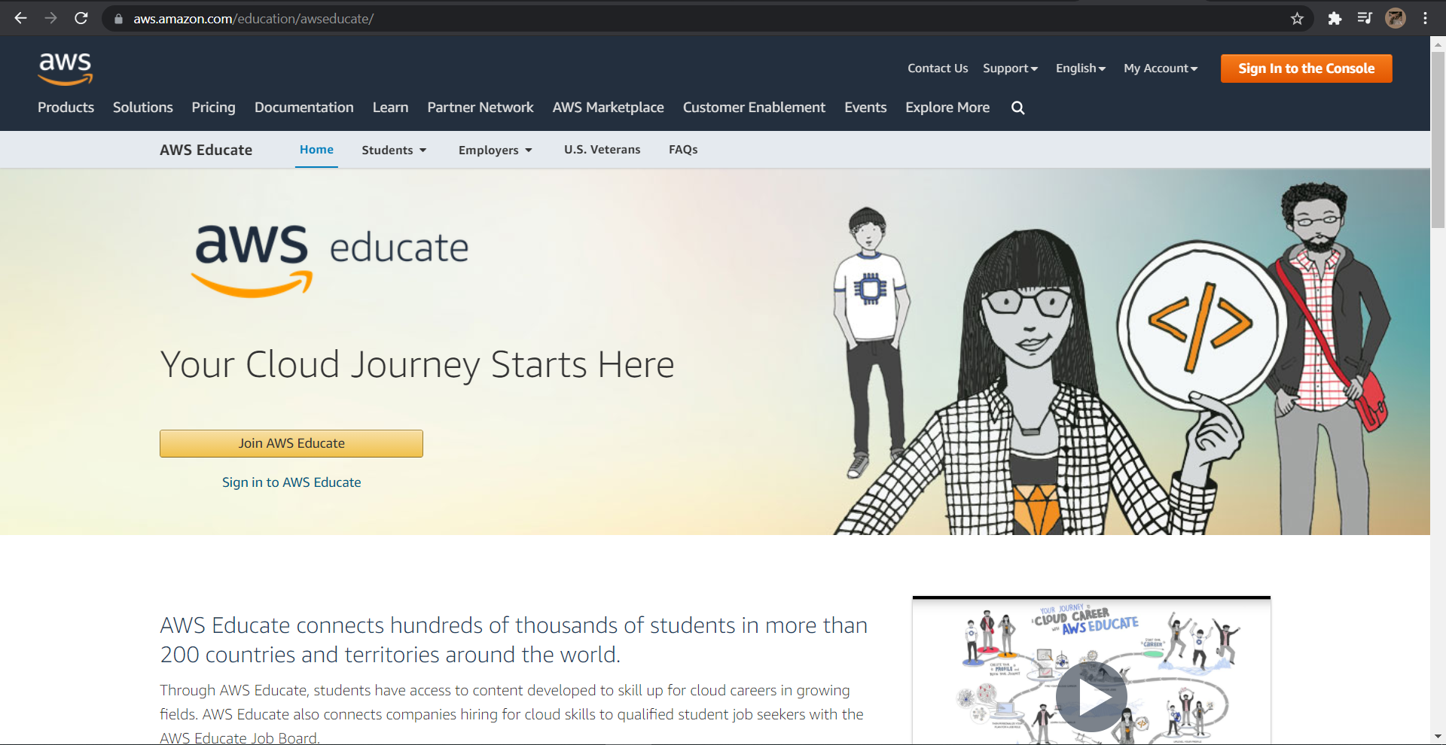

* Input the email and password

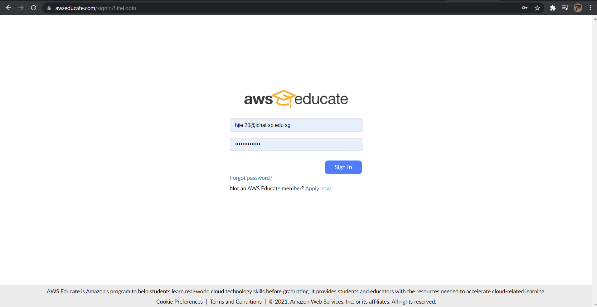

* Click on the ‘Classrooms’ button

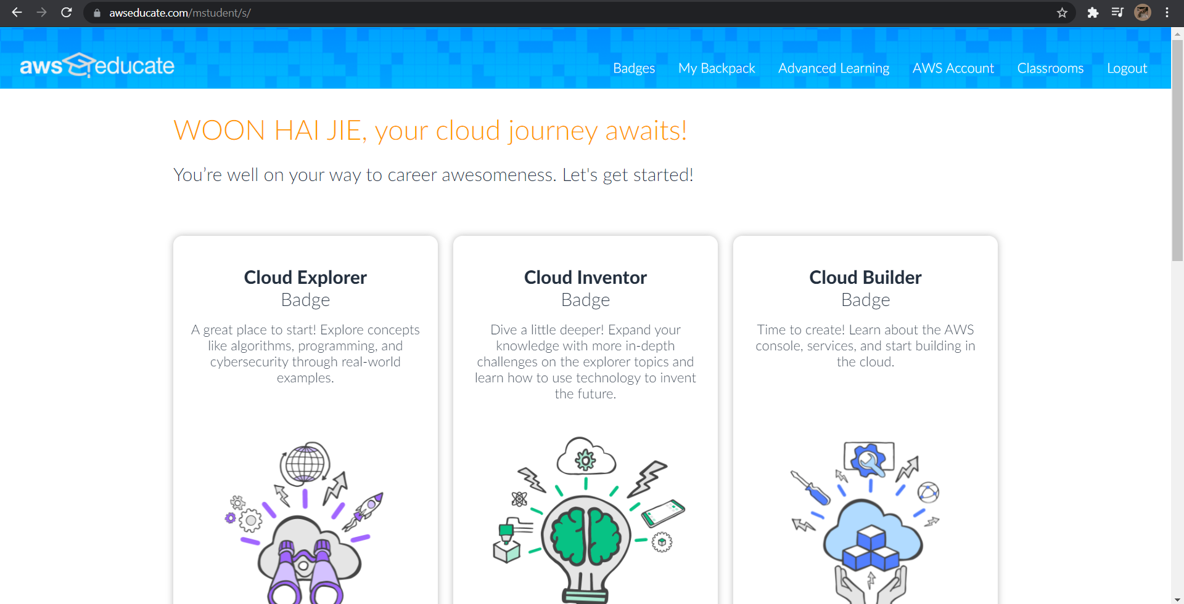

* Click on the ‘Go to classroom’ button

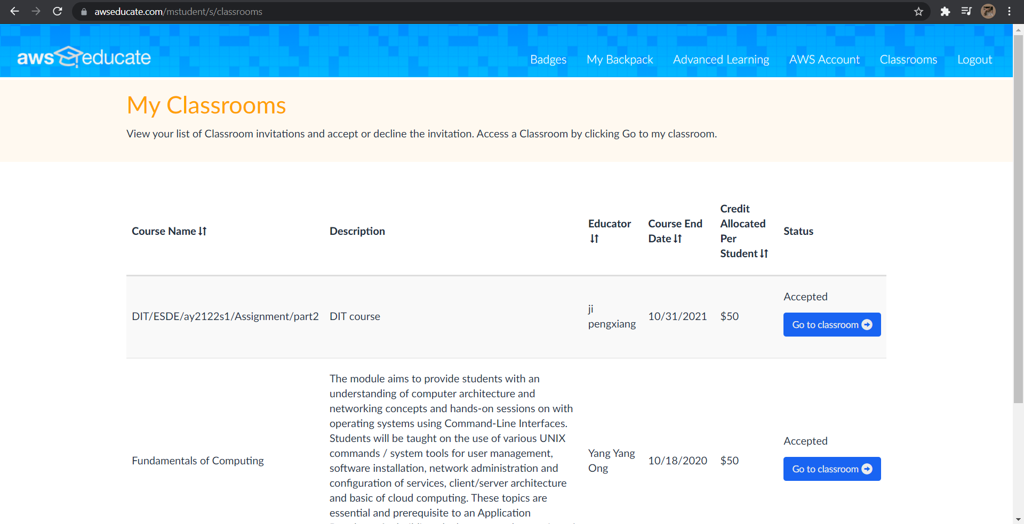

* Click on ‘Continue’ button

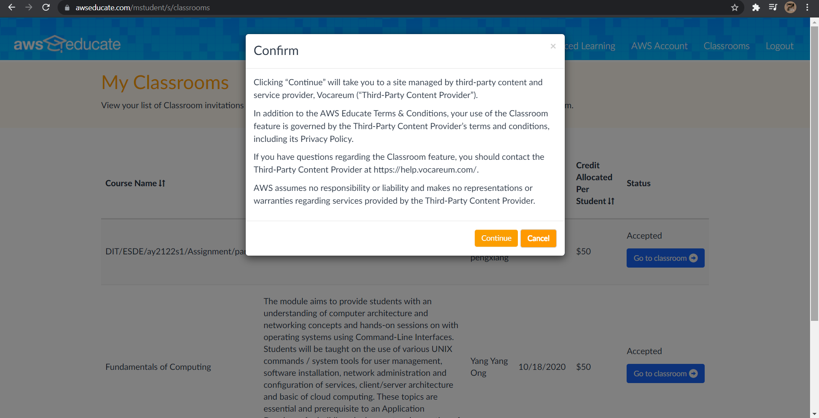

* Click on ‘AWS Console’ button

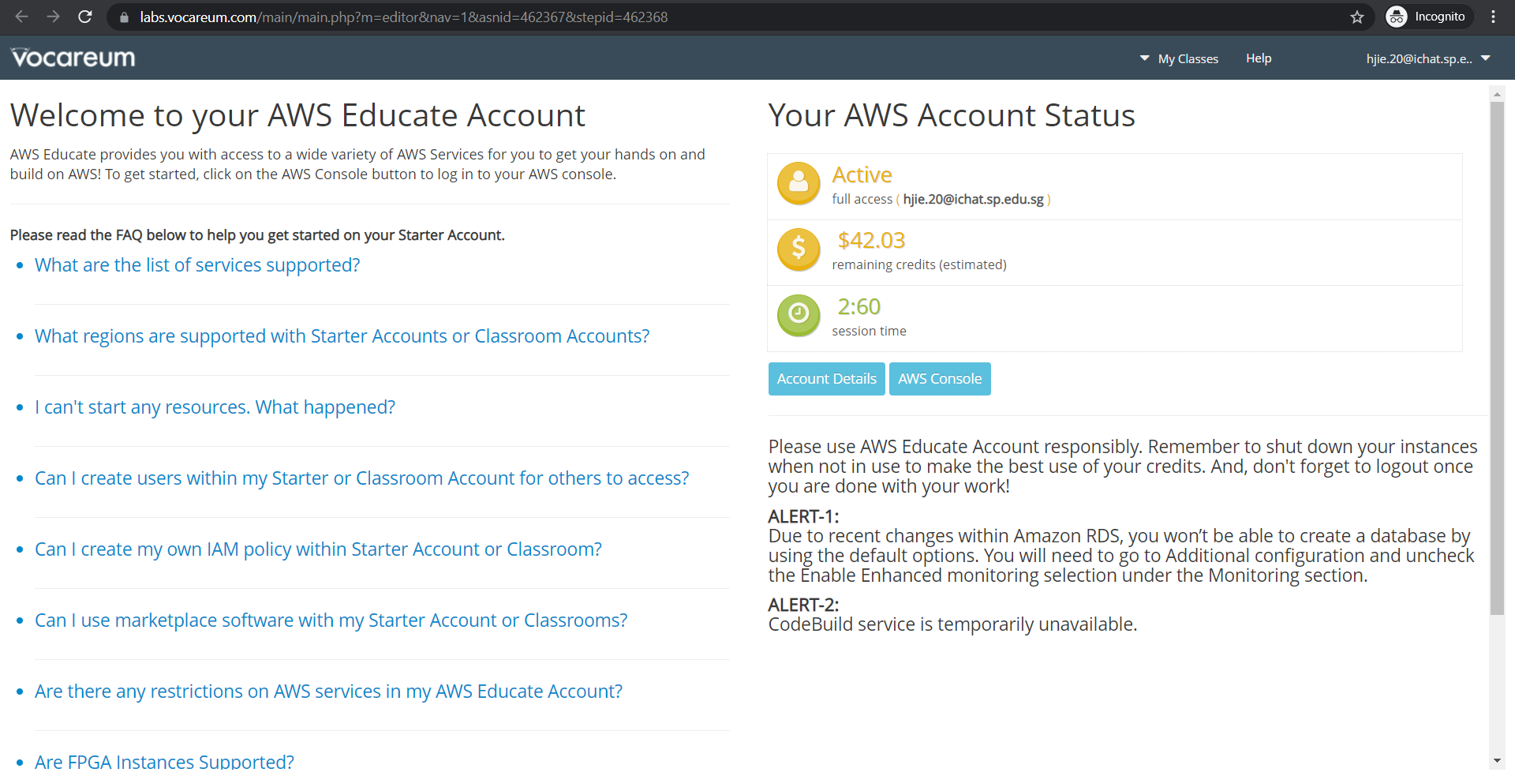

1. Create EC2 instance

* Click on the search bar to search for EC2

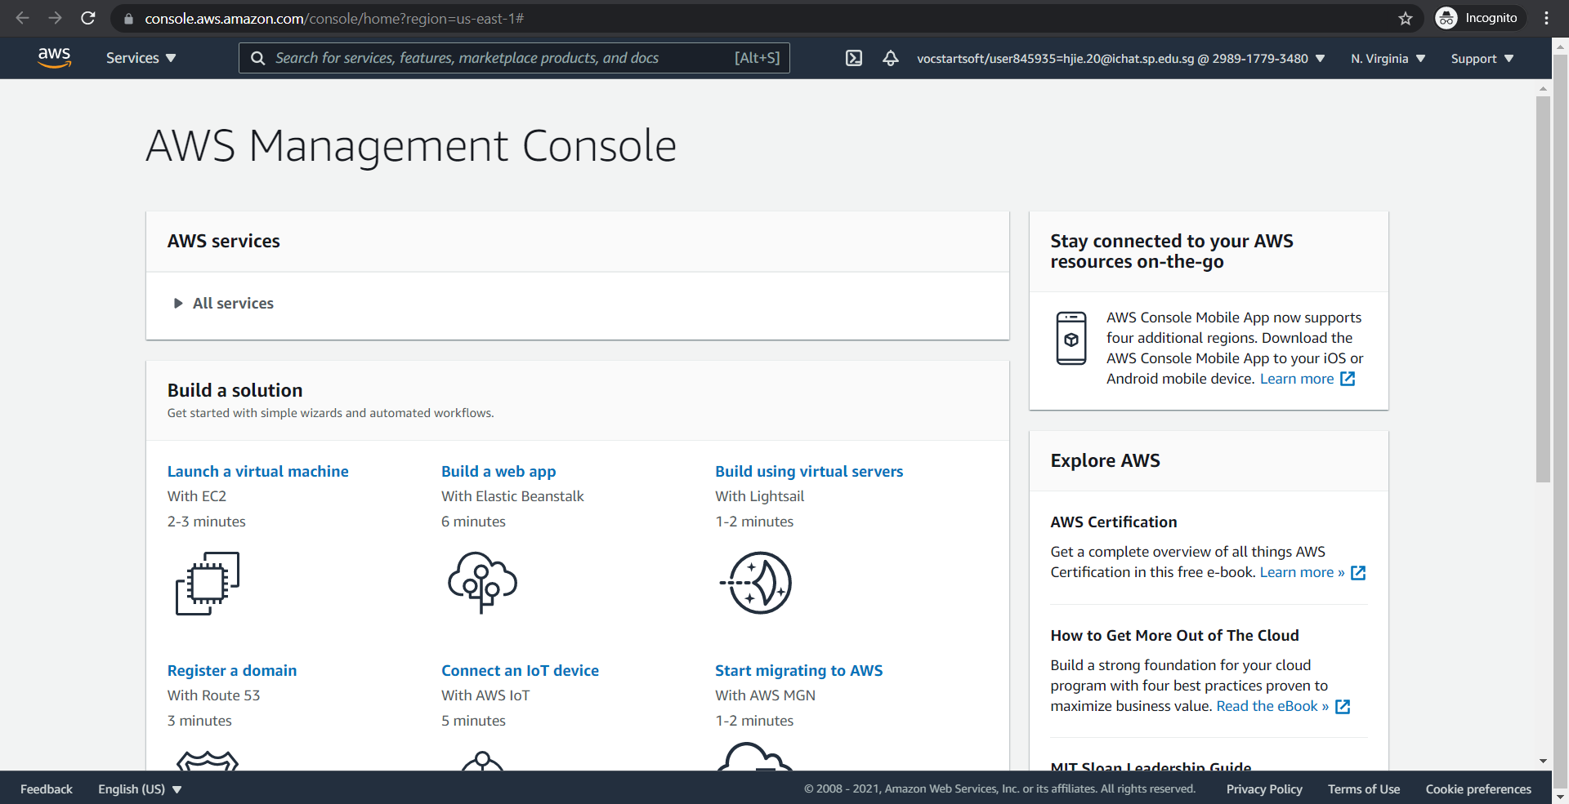

* Input and click on EC2

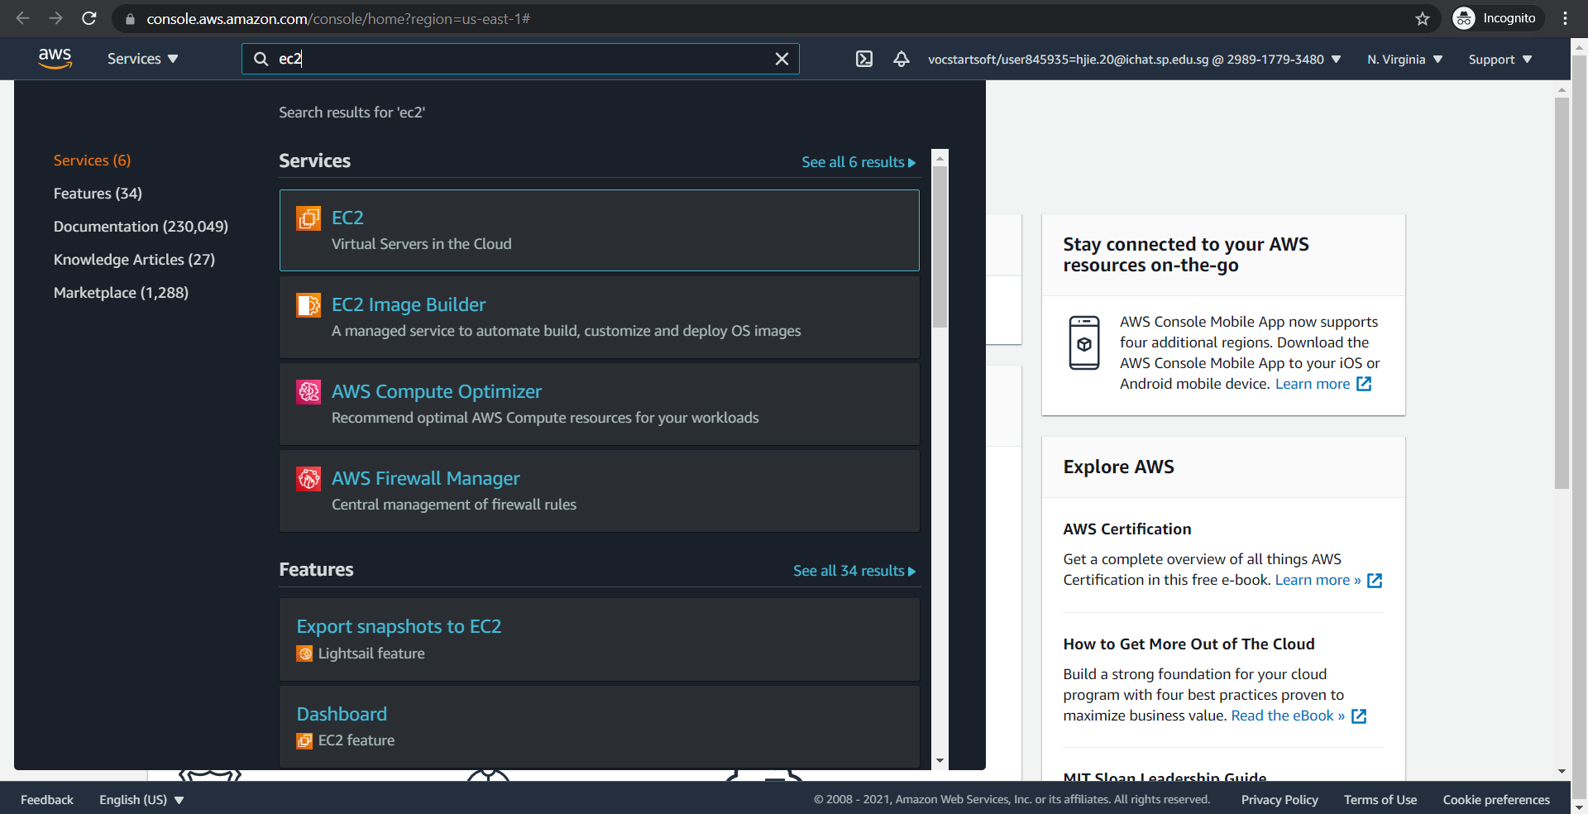

* Click on the ‘Launch instance’ button

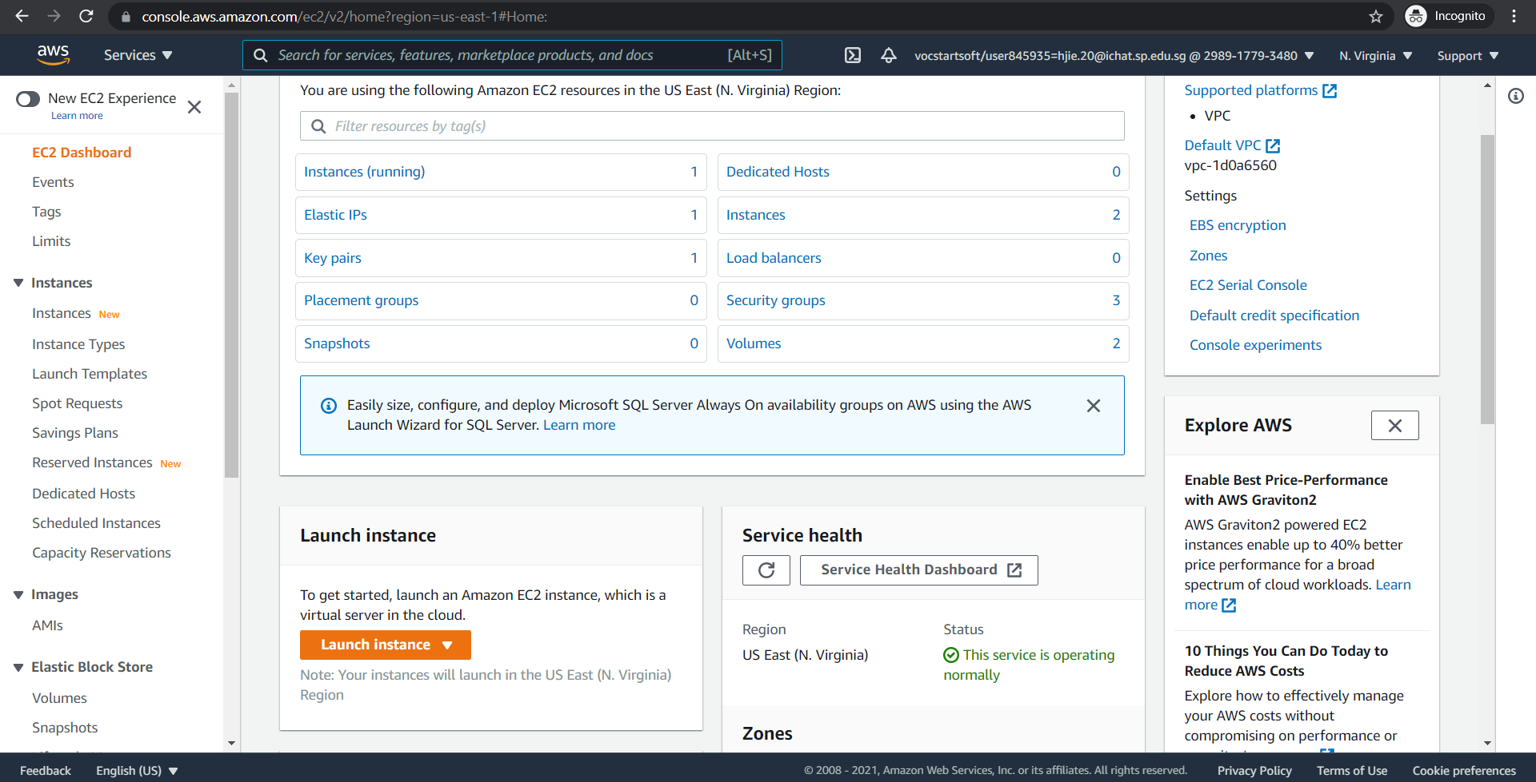

* Choose Ubuntu Server 18.04

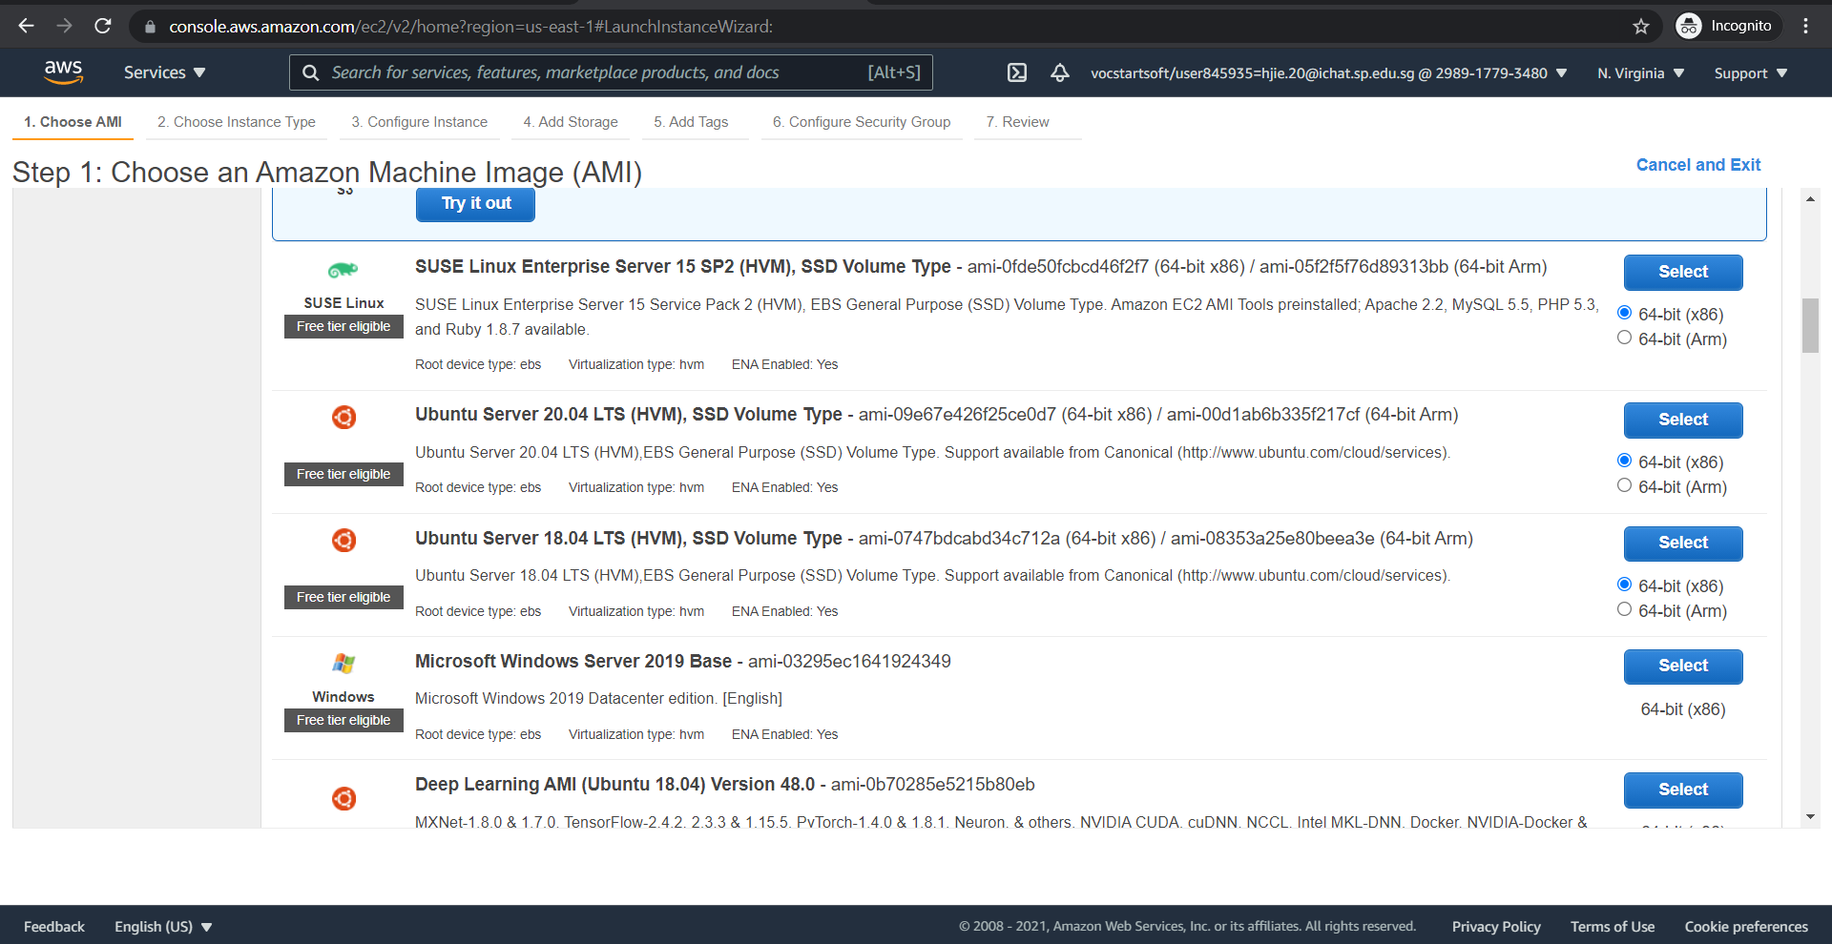

* Choose t2 micro for Instance Type and click Next

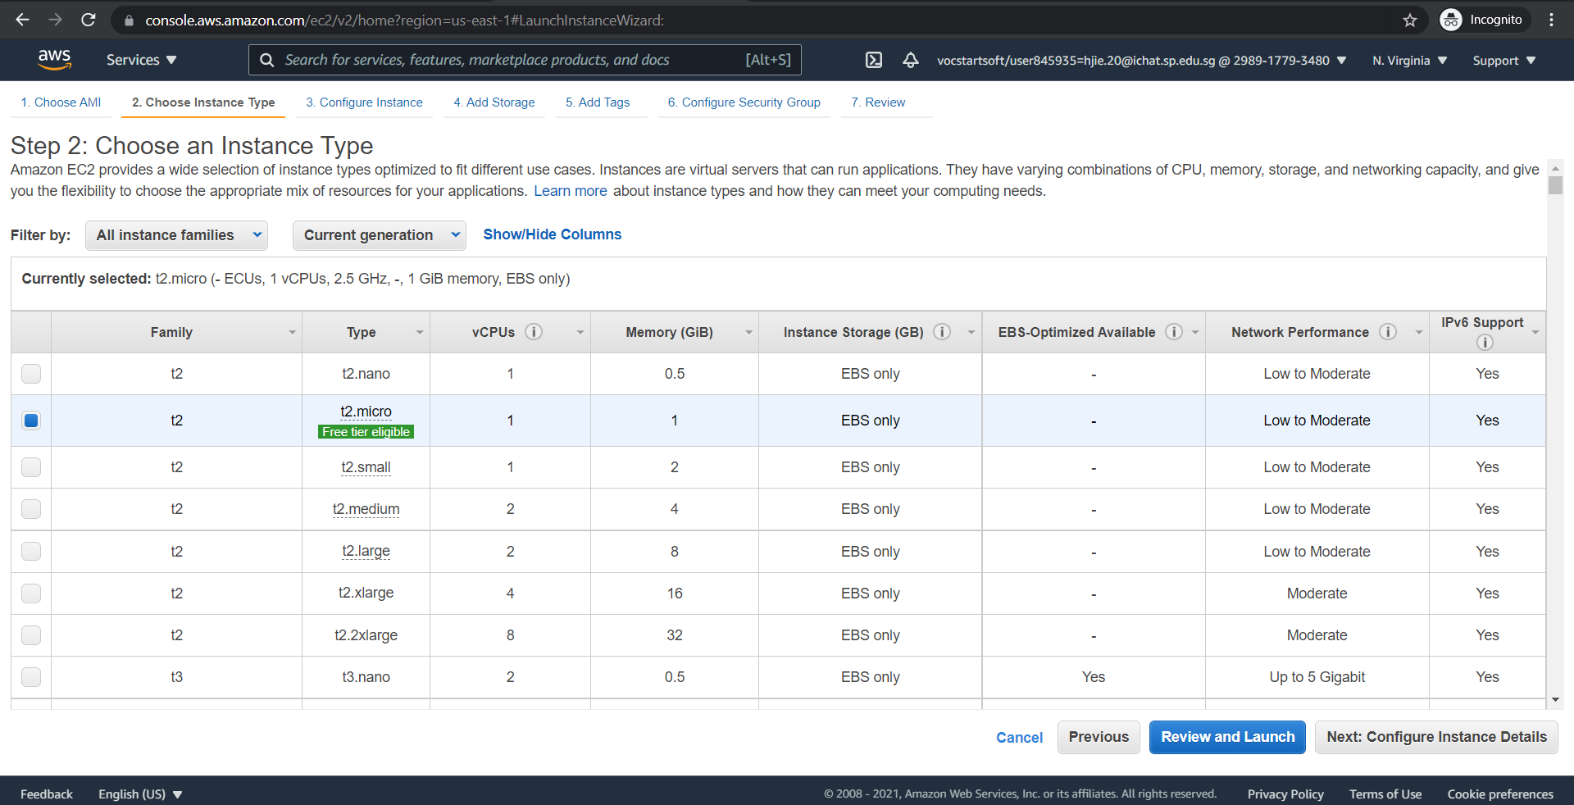

* At Auto-assign Public IP : select Enable and click Next

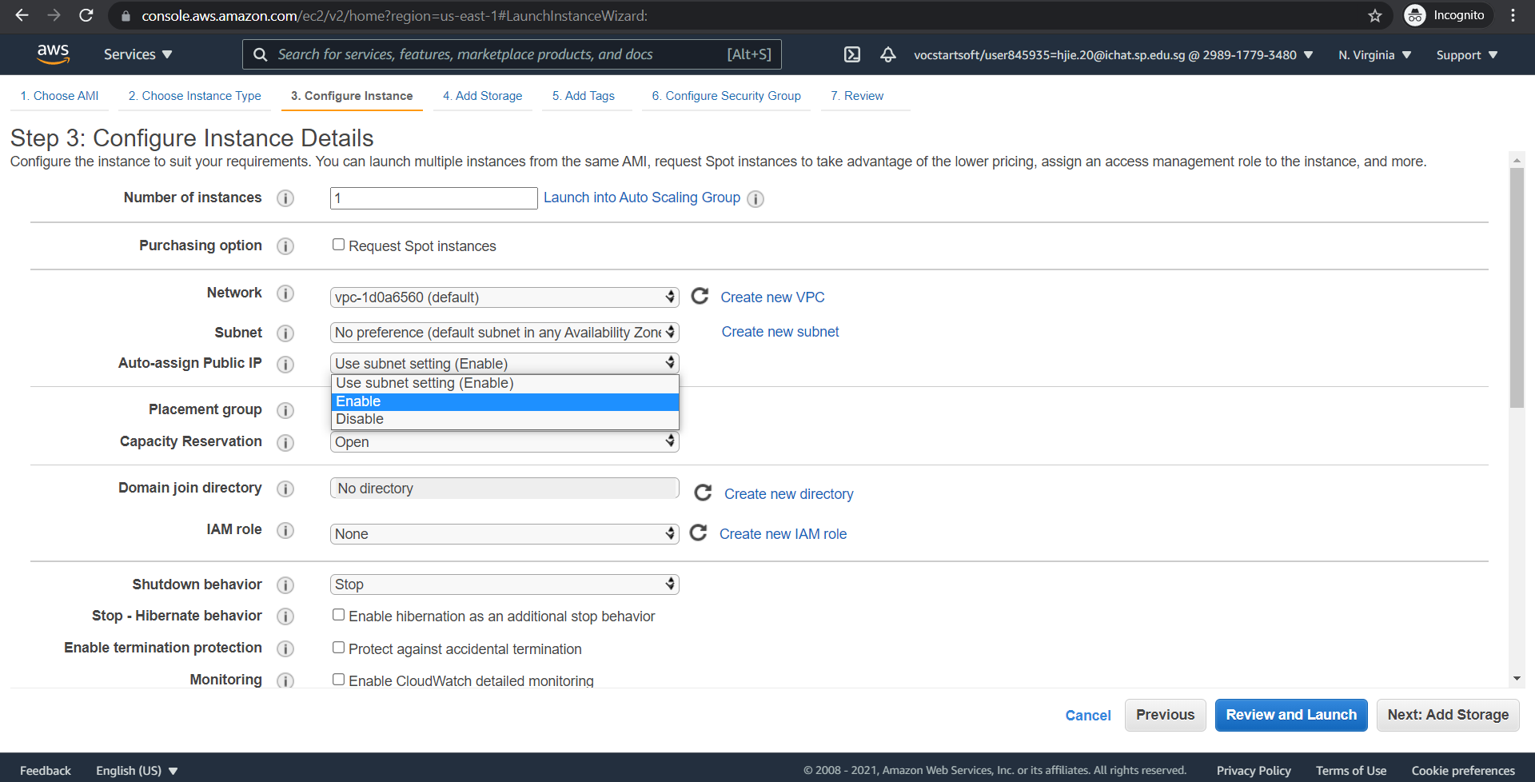

* Click Next

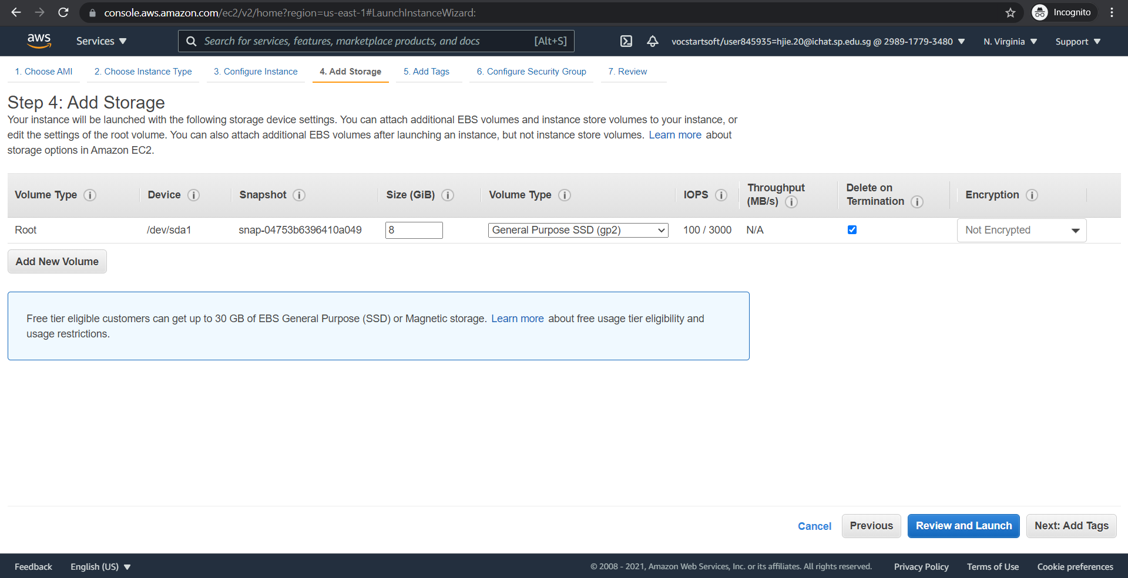

* At Key : input ‘Name’

At Value : input ‘ESDE Assignment Server’

and click Next

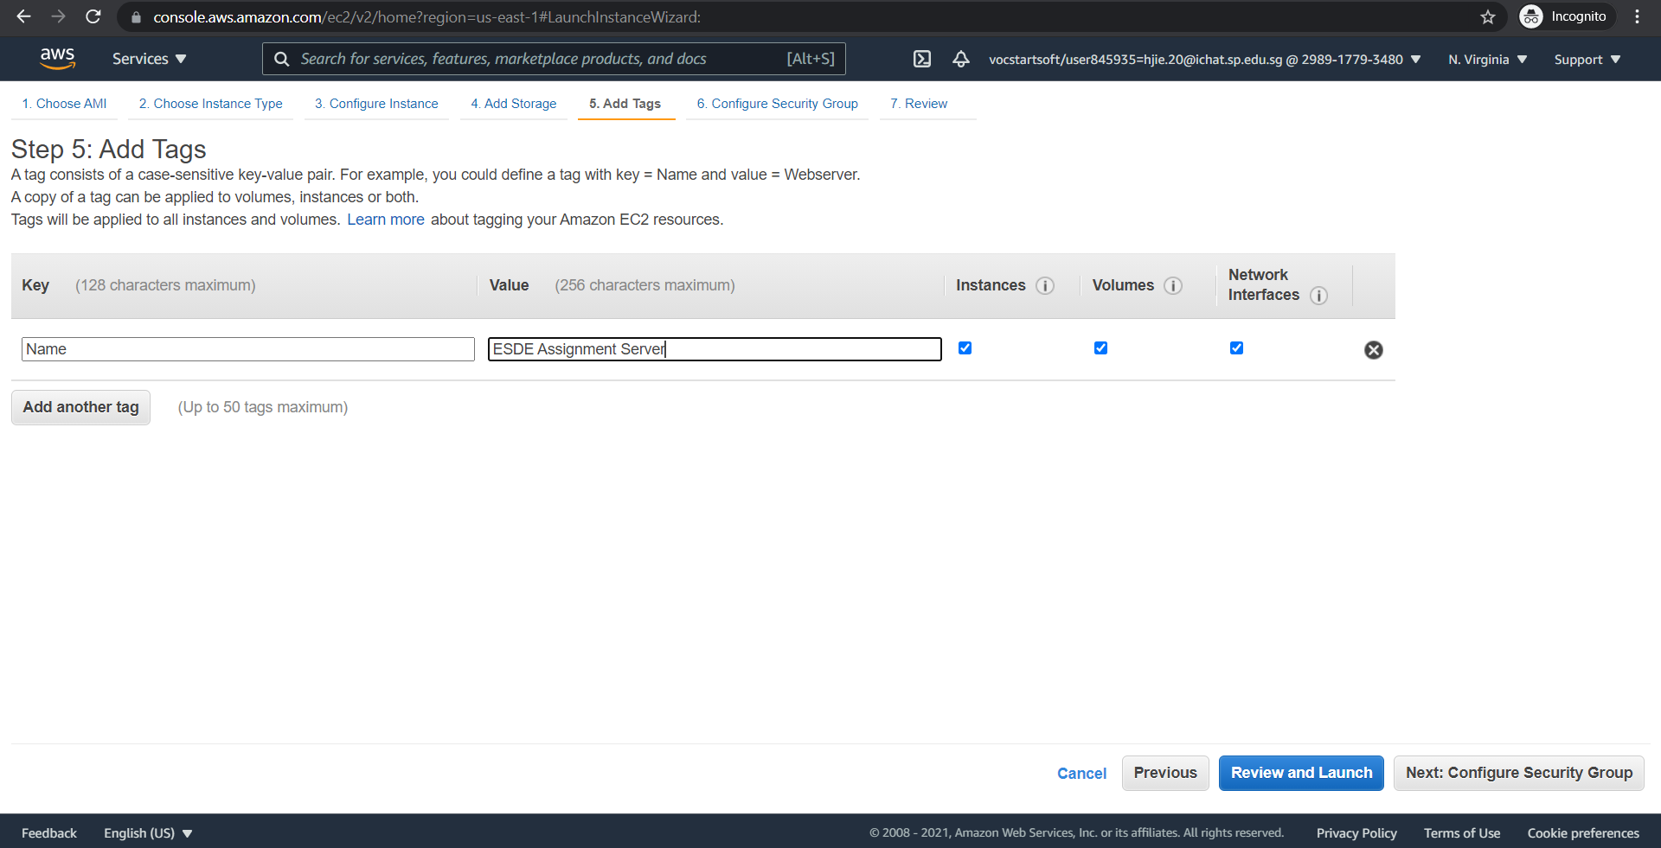

* create new security group as below, input the name and description as ‘ESDE-Assignment-Server-SecurityGroup’

and click Review and Launch *will pop warning error but its fine*

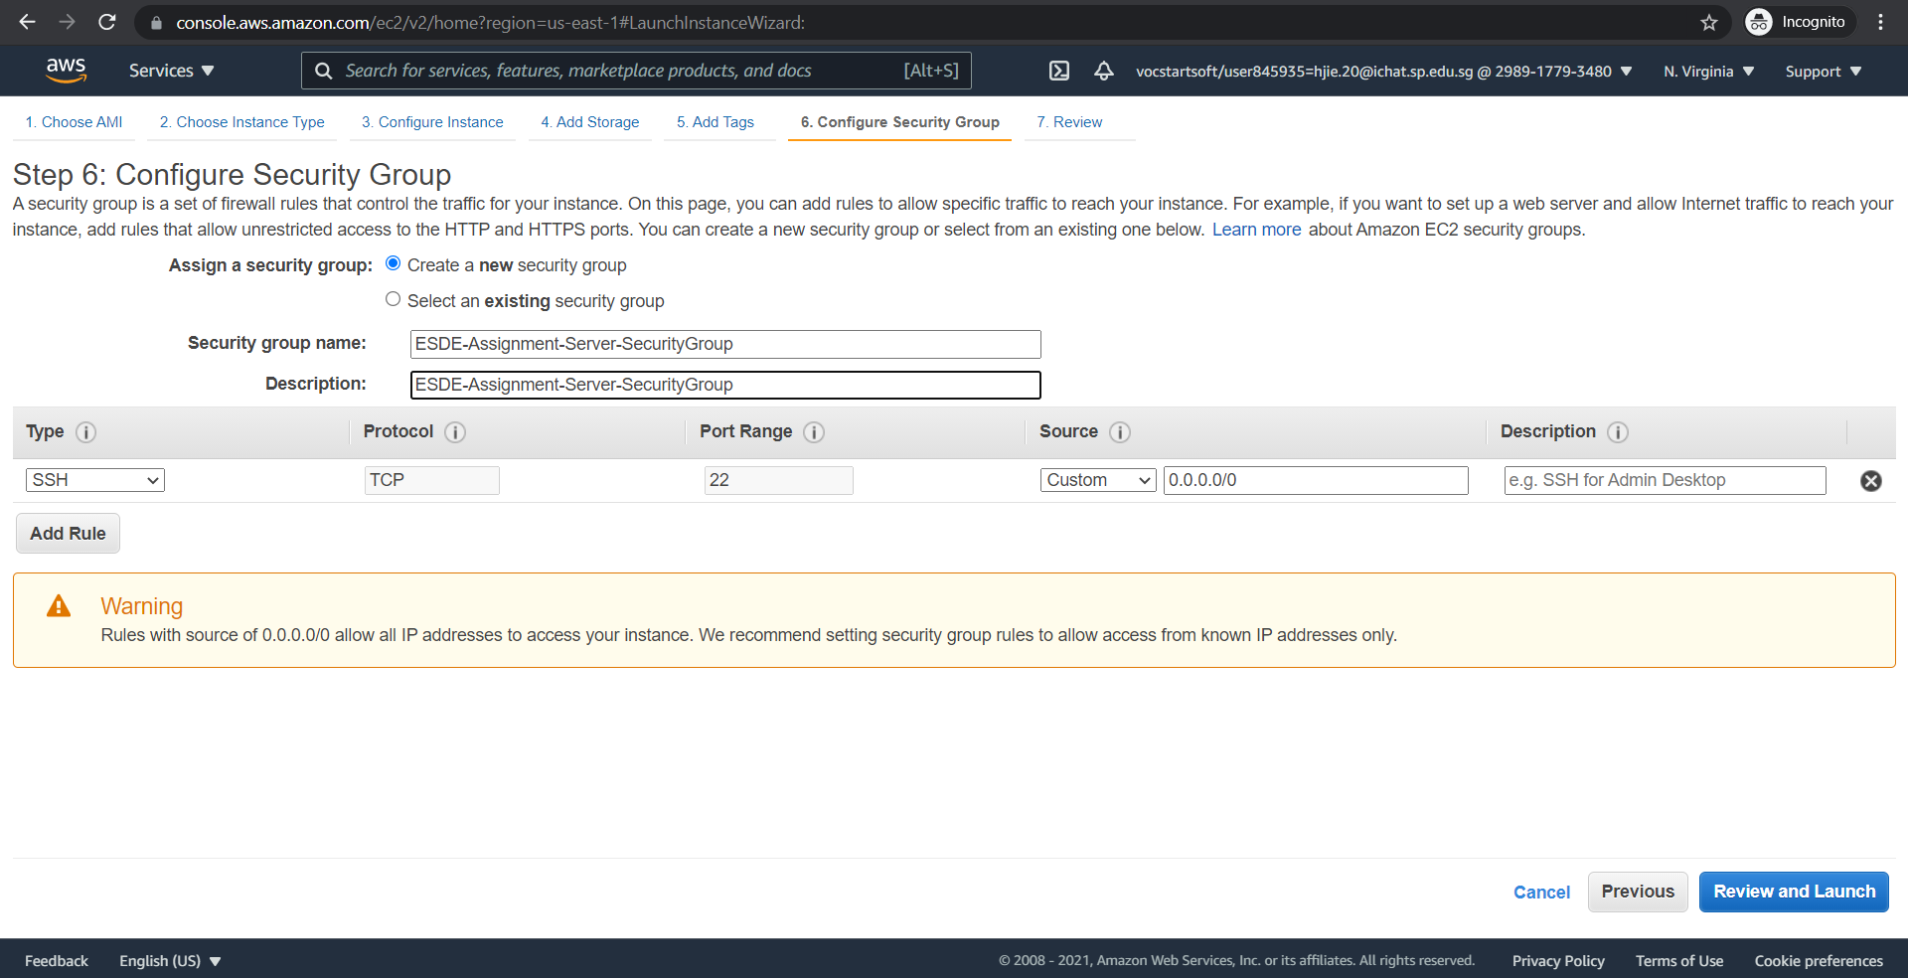

* Click Launch and add new key pair

Choose ‘Create a new key pair’, name the Key pair name as

‘2021-07-21 ESDEAssignmentServerKeyPair’

download the key pair and click on the ‘Launch instances’ button

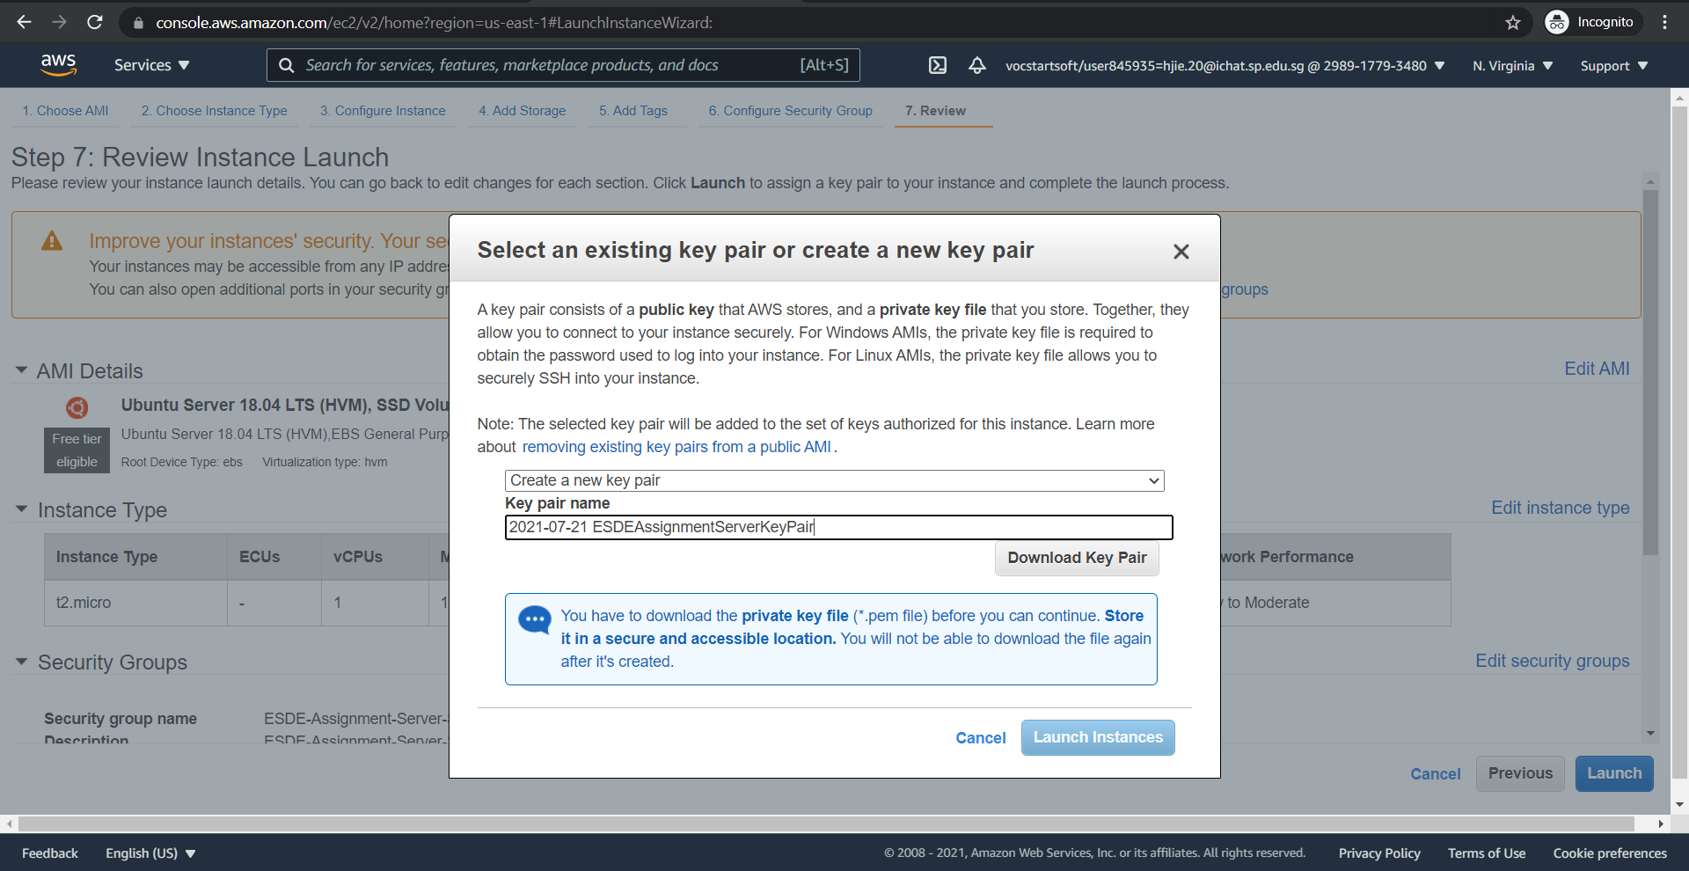

* Instance created and check the one running

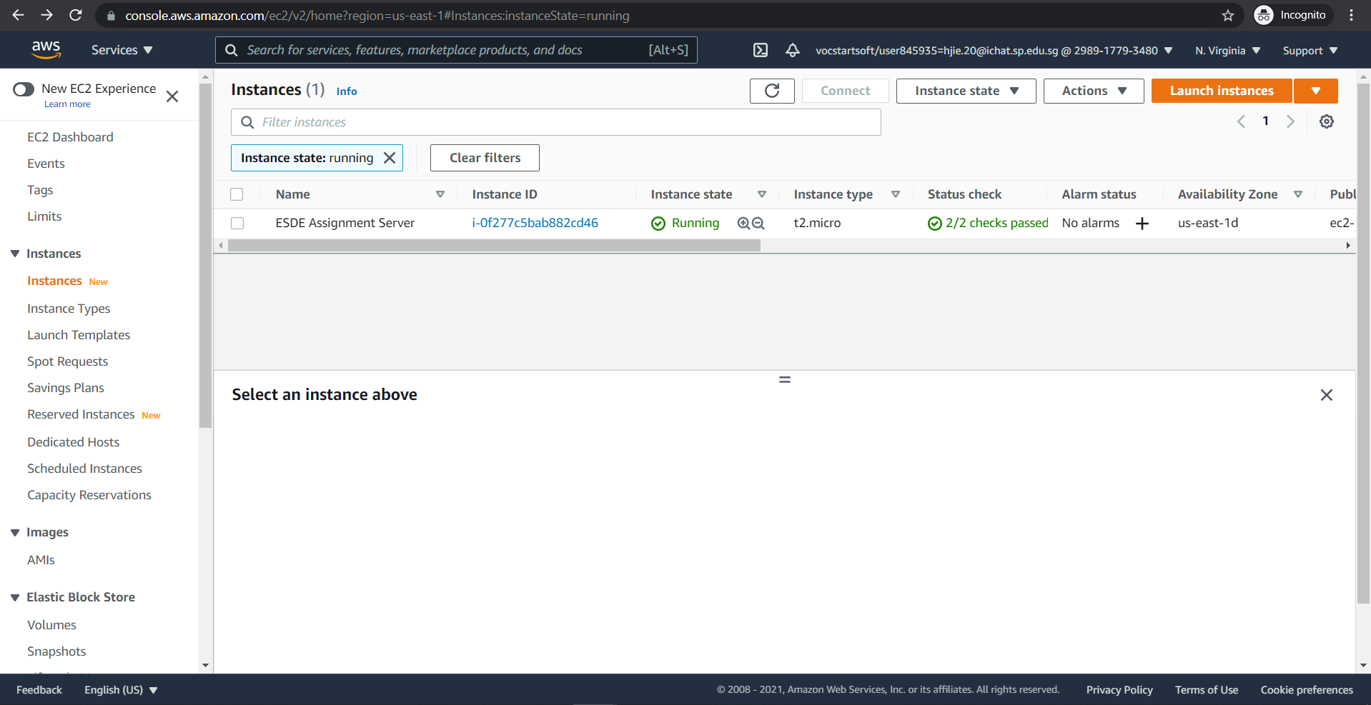

1. Setting up the elastic IP address

* Click on the ‘Elastic IPs’

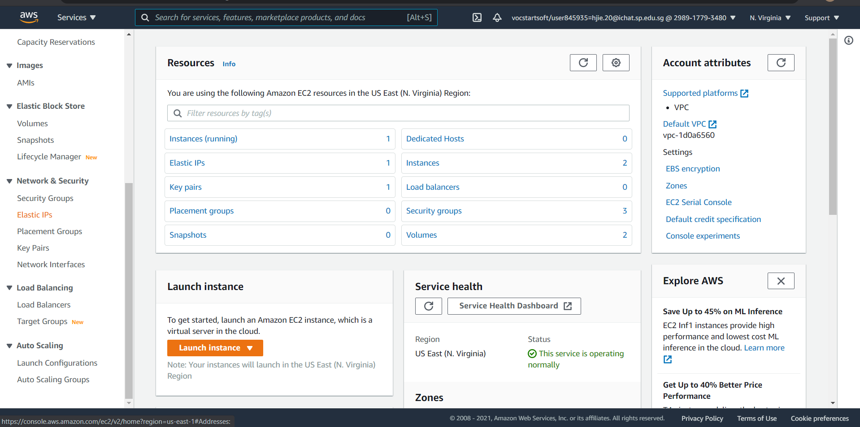

* Click on the ‘Allocate Elastic IP address’ button



* Settings as shown below

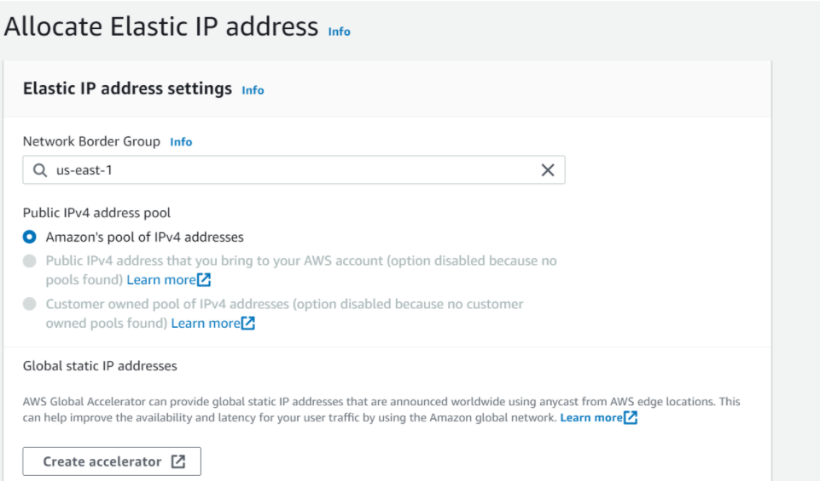

* Select created elastic IP address

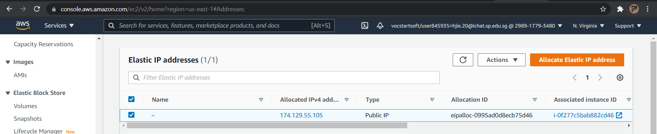

* Click on ‘Action’ button and click the ‘Associate Elastic IP address’

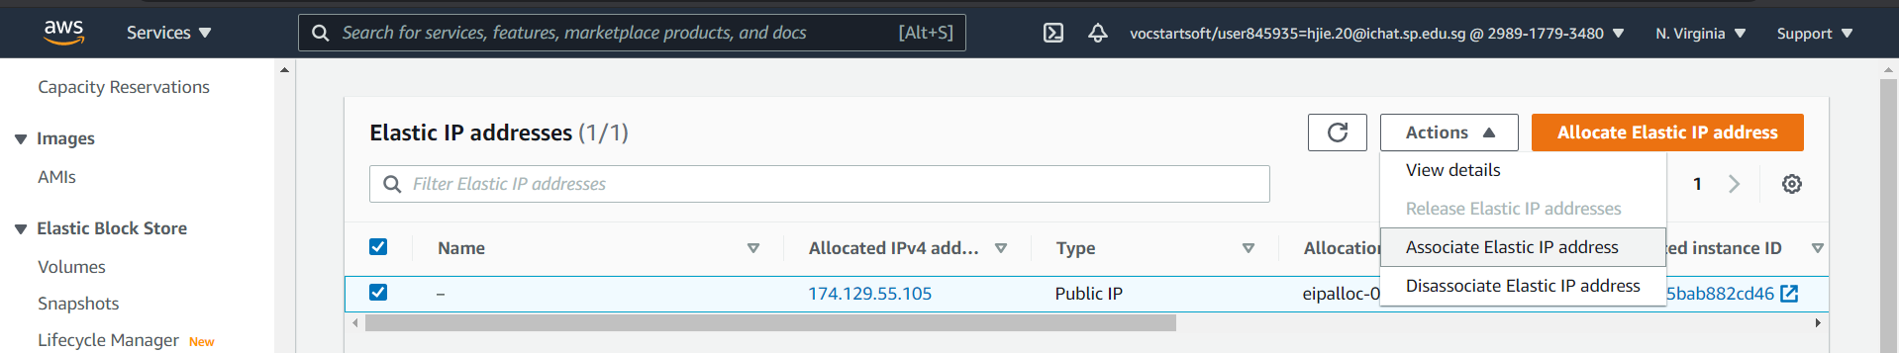

* Choose the instance that is running

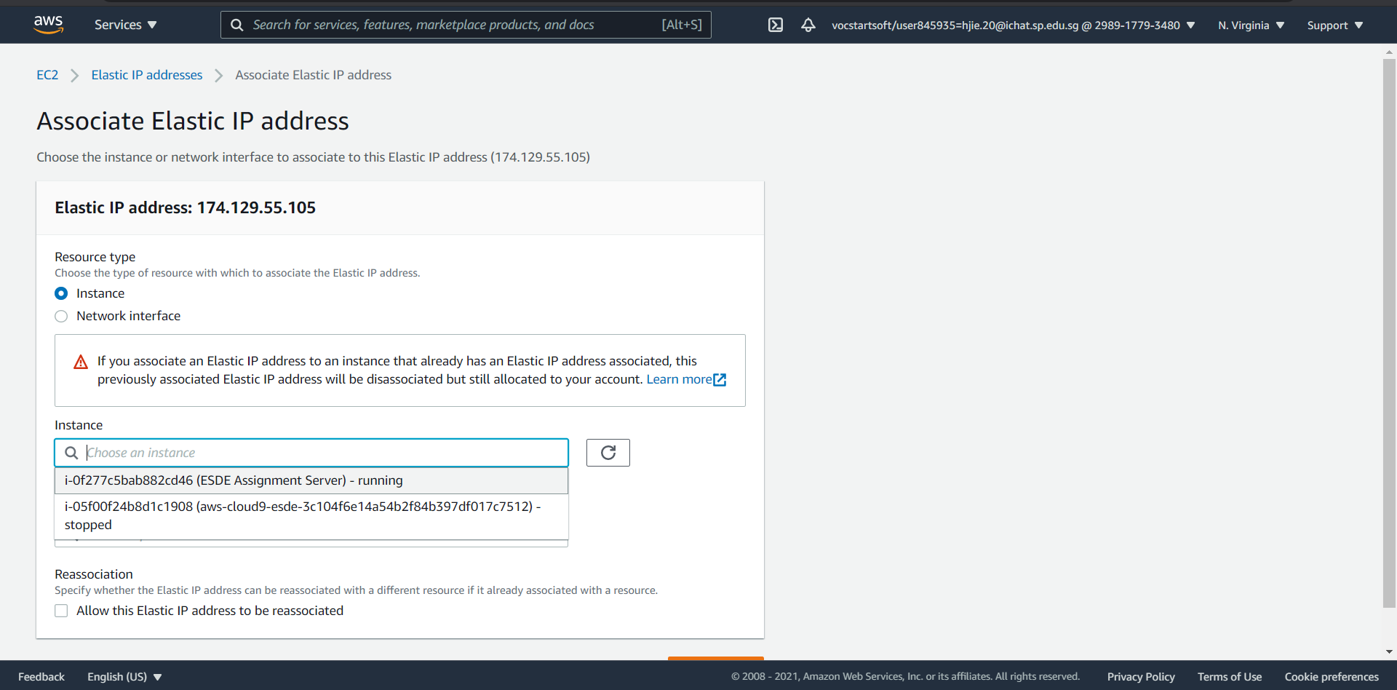

* Click on the ‘Associate’ button

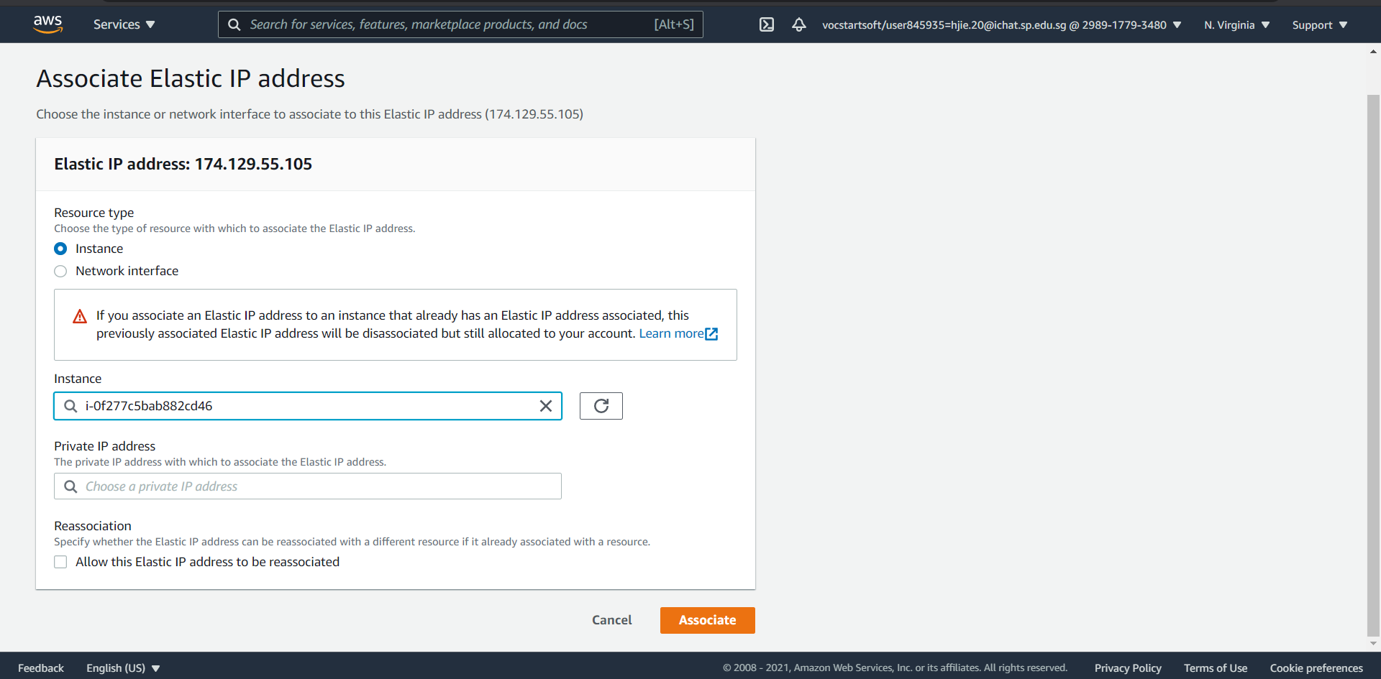

* Successfully associate with elastic IP address

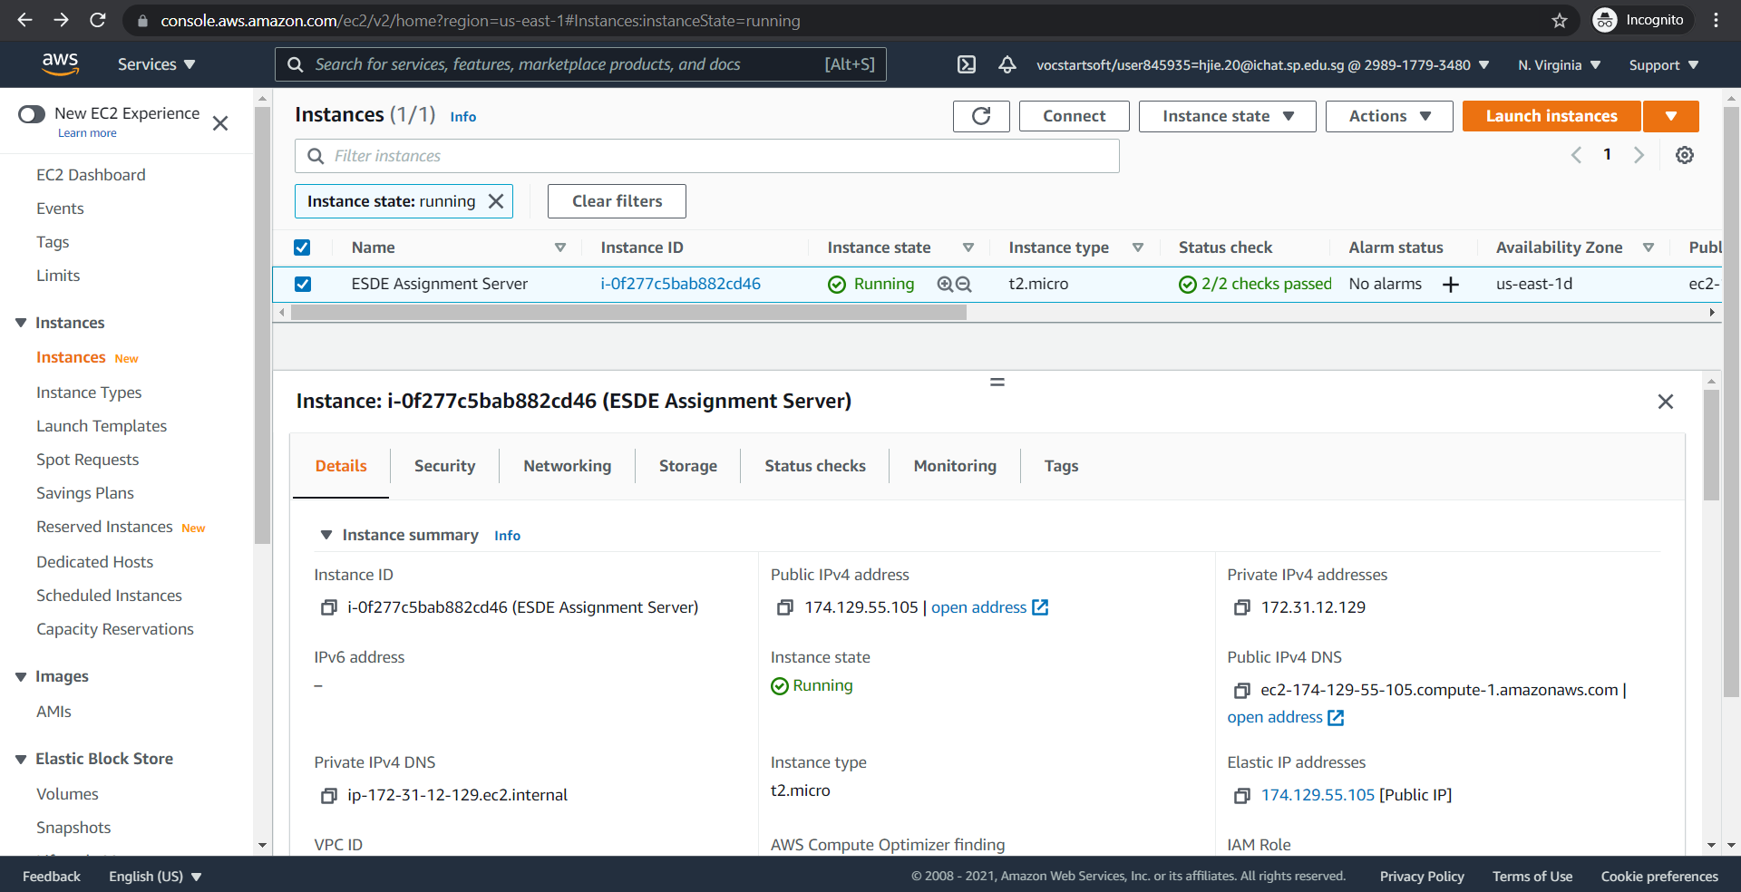

1. Setting up WinSPC

* Download WinSPC from online and open it

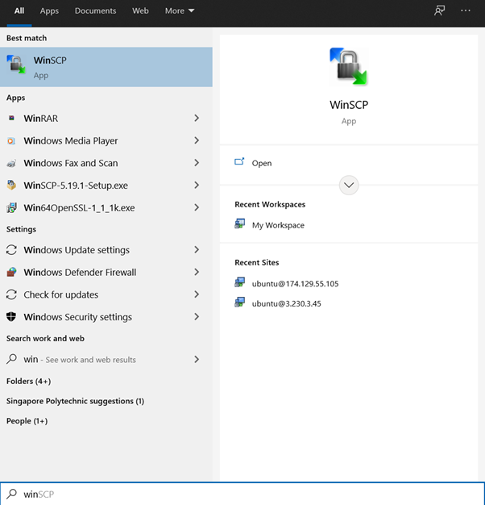

* Click on the ‘New Session’

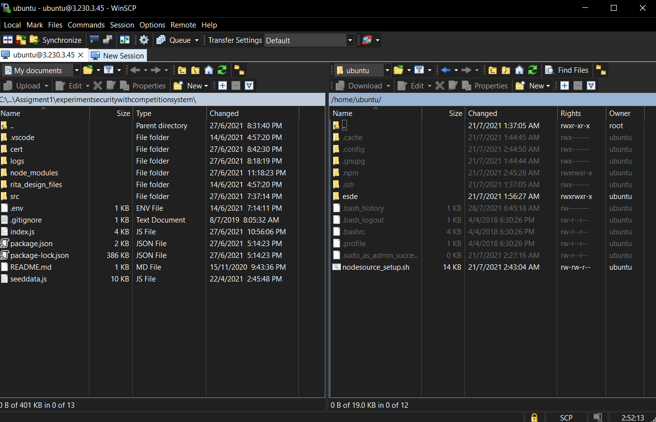

* At File protocol : choose SCP
* At Host name : input the elastic IP address which is ‘174.129.55.105’
* At Username : input “ubuntu”
* At password: input your password

and click on ‘Advanced’ button

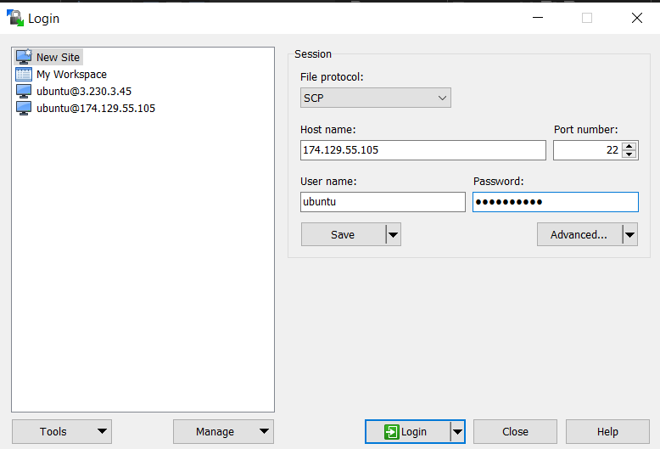

* Click on SSH > Authentication
* Select ‘…’ and choose the KeyPair file that downloaded

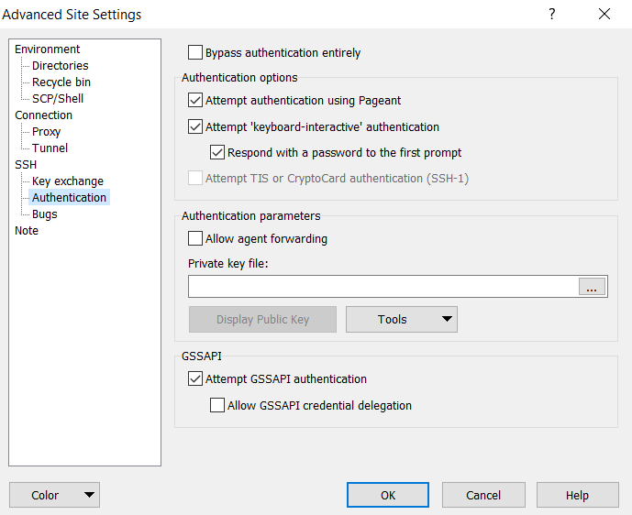

* Change the (*.ppk) to All Files (*.*) type

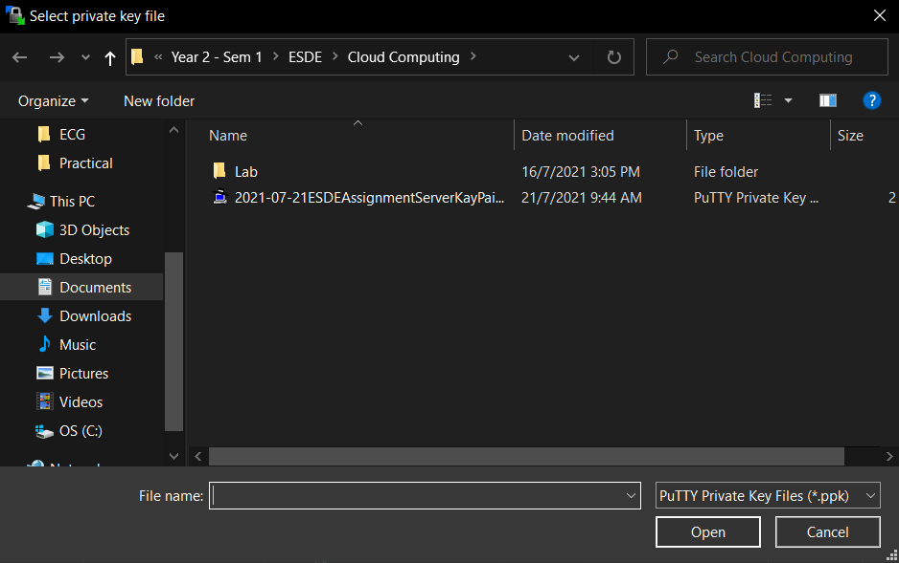

* Click on the ‘2021-07-21ESDEAssignmentServerKeyPair’

PEM File

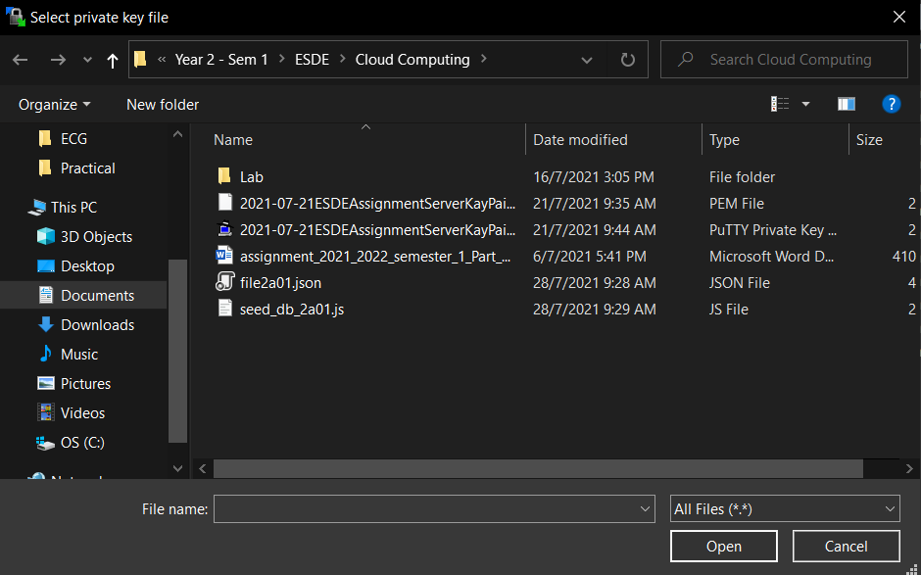

* Click OK to convert this pem file to PuTTY format

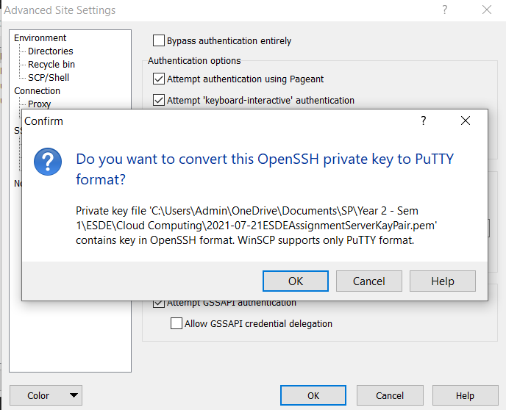

* Click save

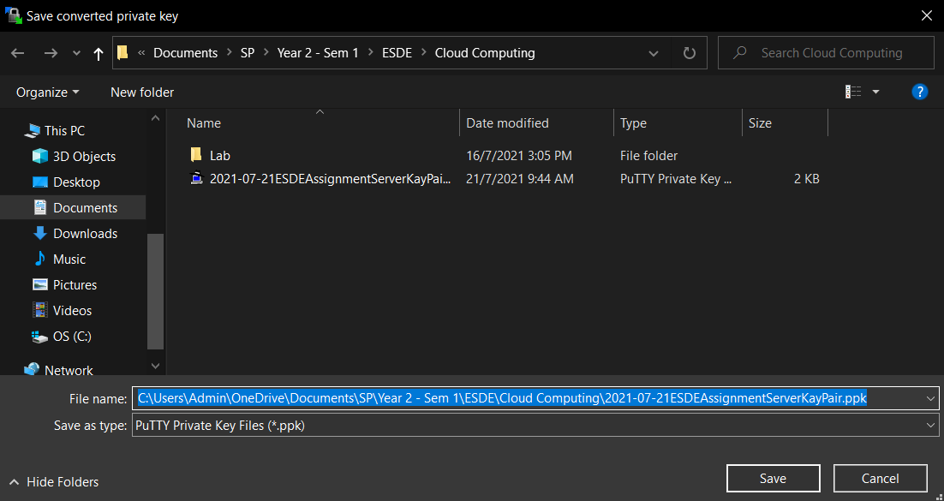

* Click OK

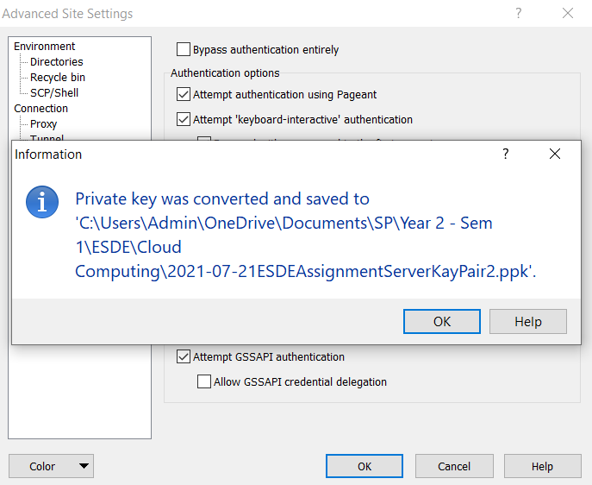

* Click OK

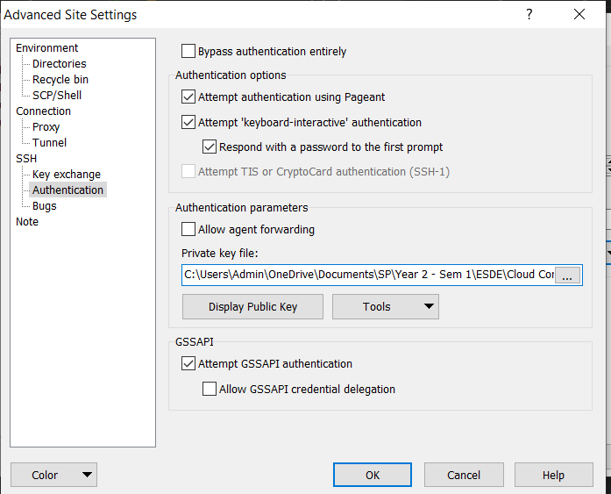

* Click Save and Login

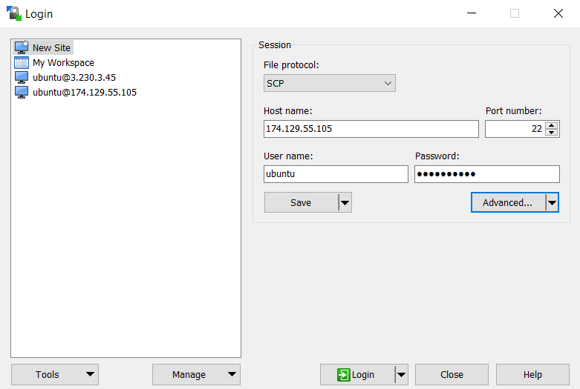

* At right side create a new folder and name it as ‘esde’

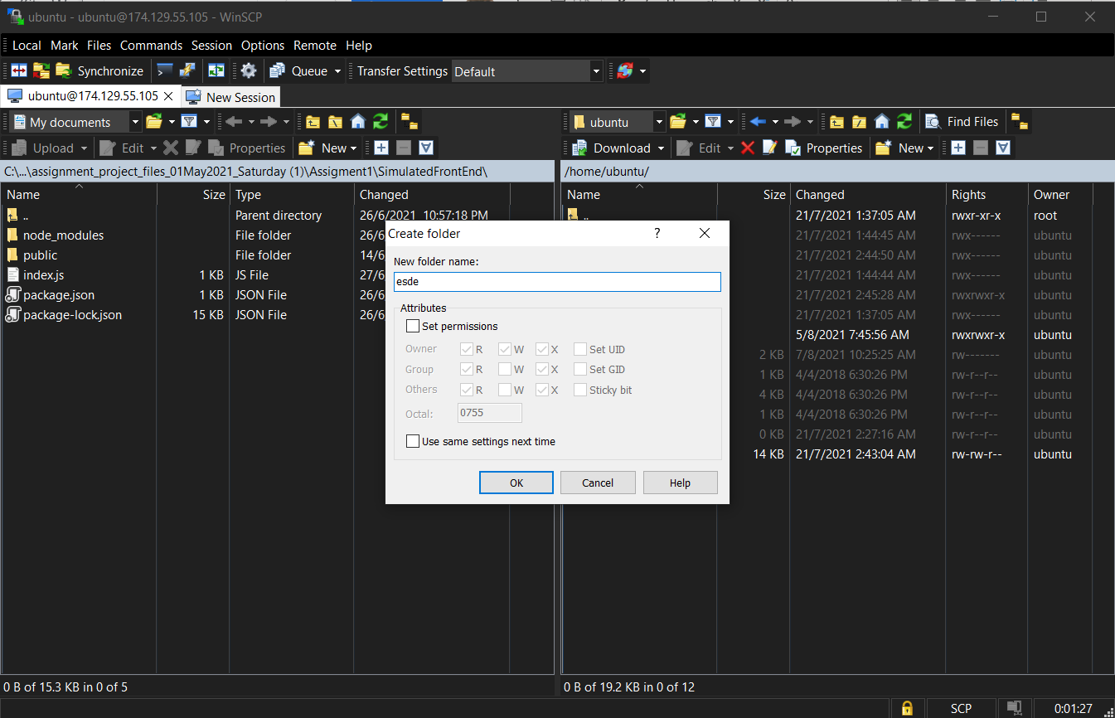

* In the esde folder create two more folders name it as

‘backEnd’ and ‘frontEnd’

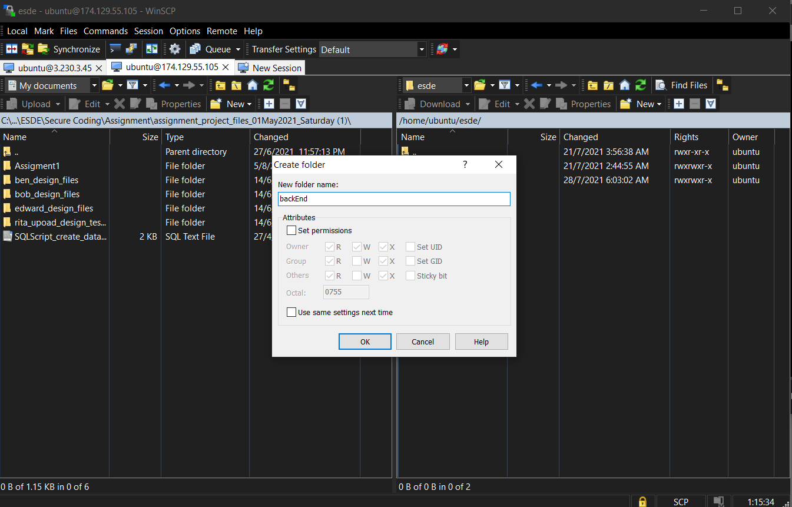

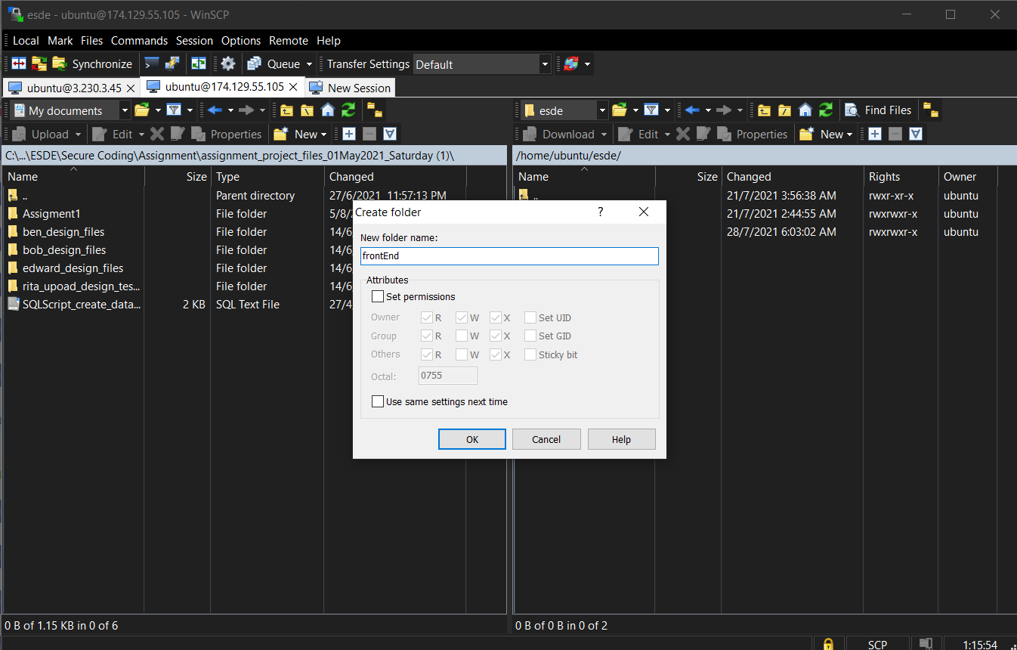

* Copy all files except node_modules into both folder respectively

backEnd folder should look like this:

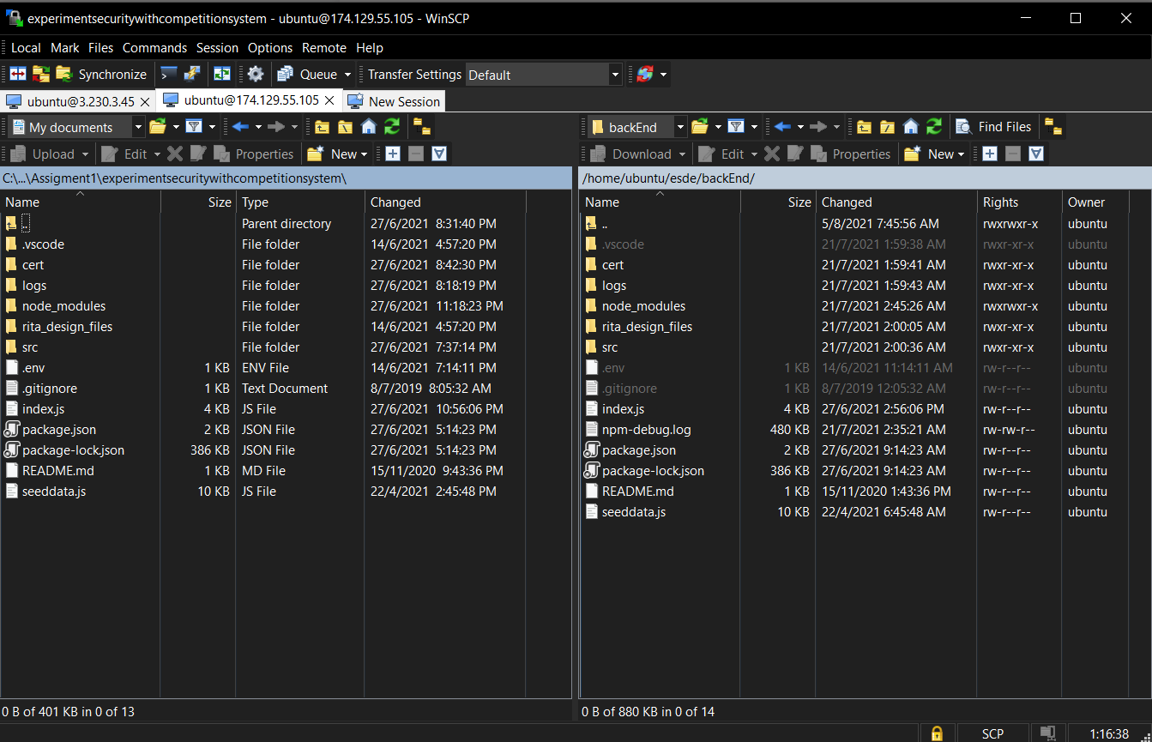

frontEnd folder should look like this:

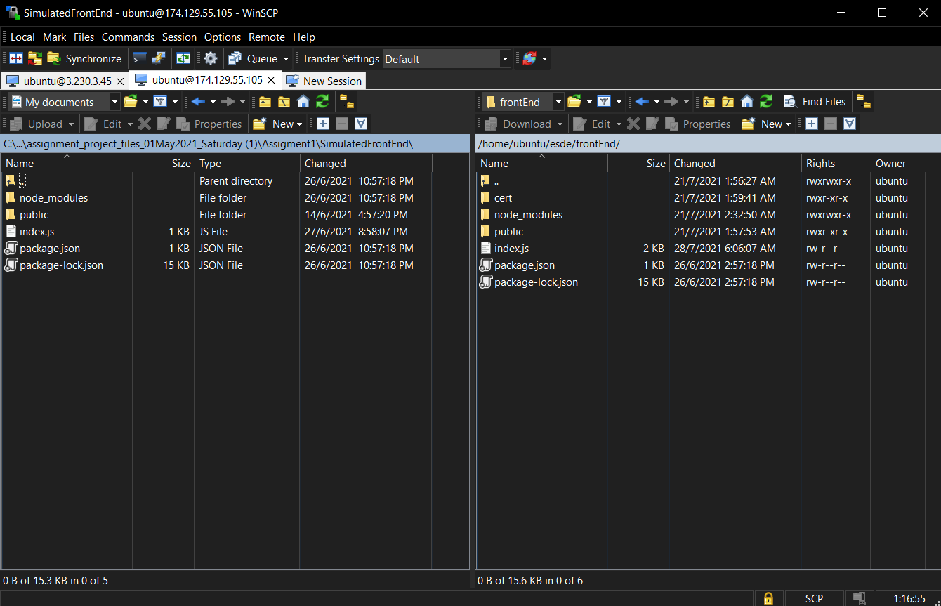

* Install NodeJS on ubuntu machine
* Open a putty window
* Do the following codes

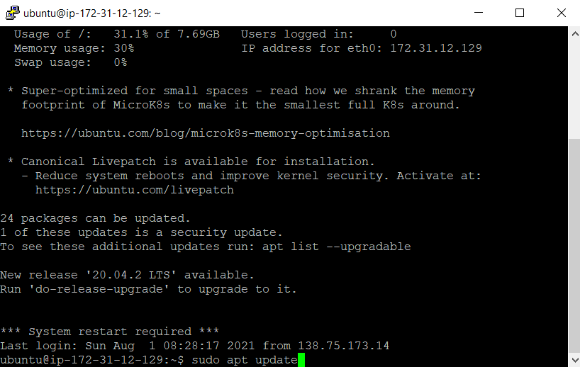

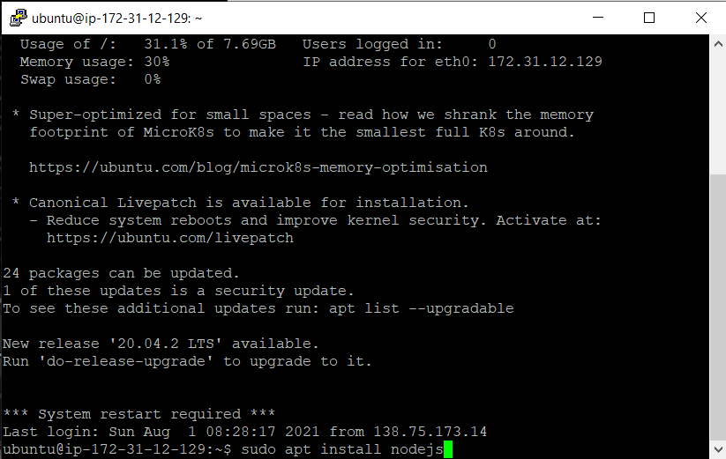

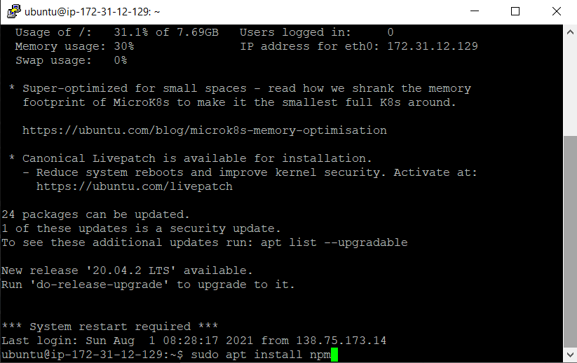

* nodejs -v : is to check version of nodejs

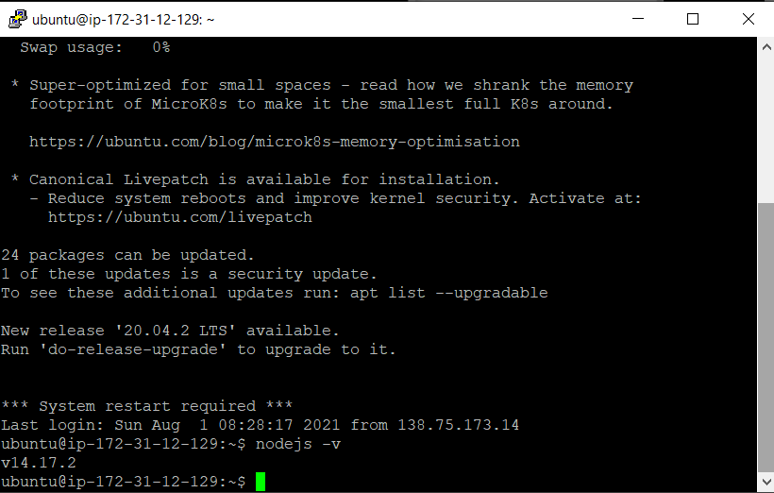

* Do npm install at frontEnd



* Then run the frontEnd

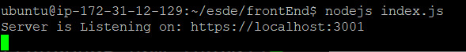

* To solve the npm install error at backEnd
* Do the following codes







* nodejs -v : is to check version of nodejs

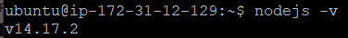



* Do npm install at backEnd



* Then run the backEnd

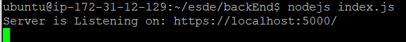

1. Configure the instance security group

* Click on ‘Security’

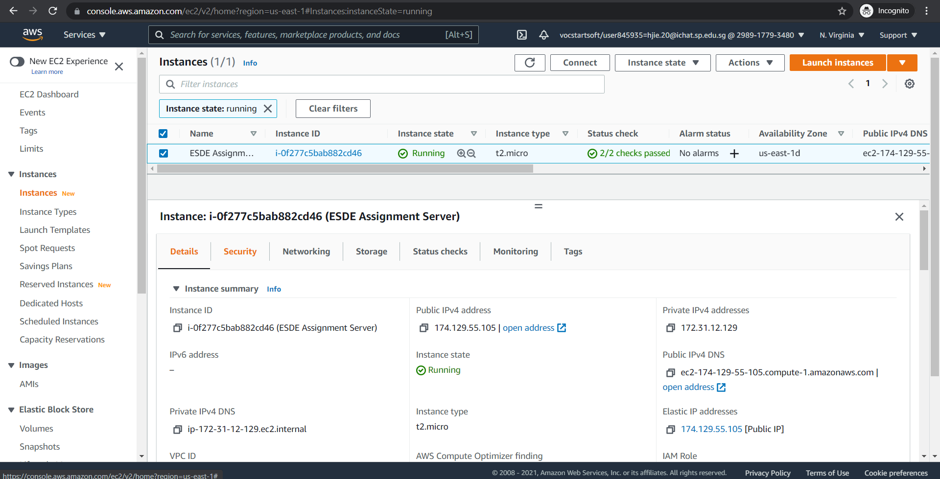

* Click on the link below the Security groups

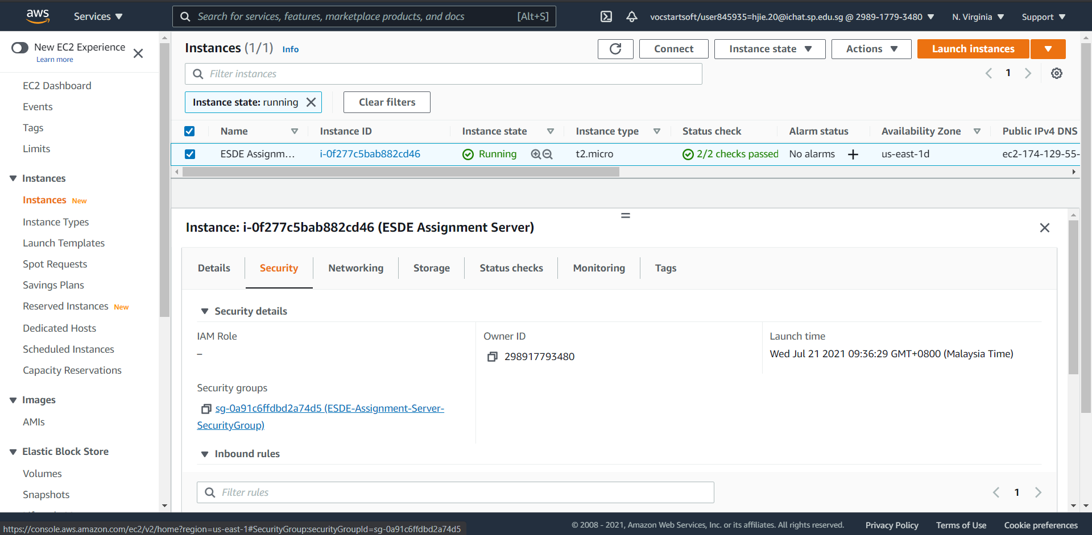

* Click on the ‘Edit inbound rules’ button

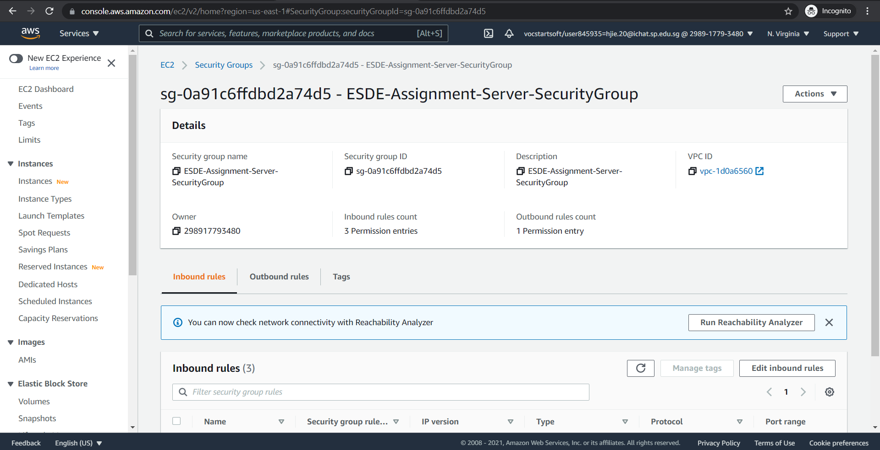

* Add two rules as shown below and click Save rules

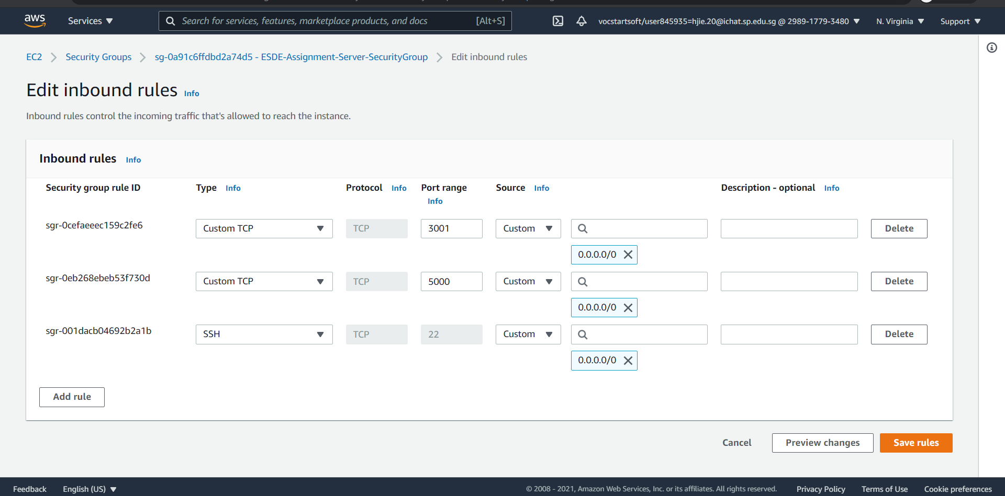

1. Try accessing your web page through

<https://174.129.55.105:3001>

* Click on ‘Advanced’ button

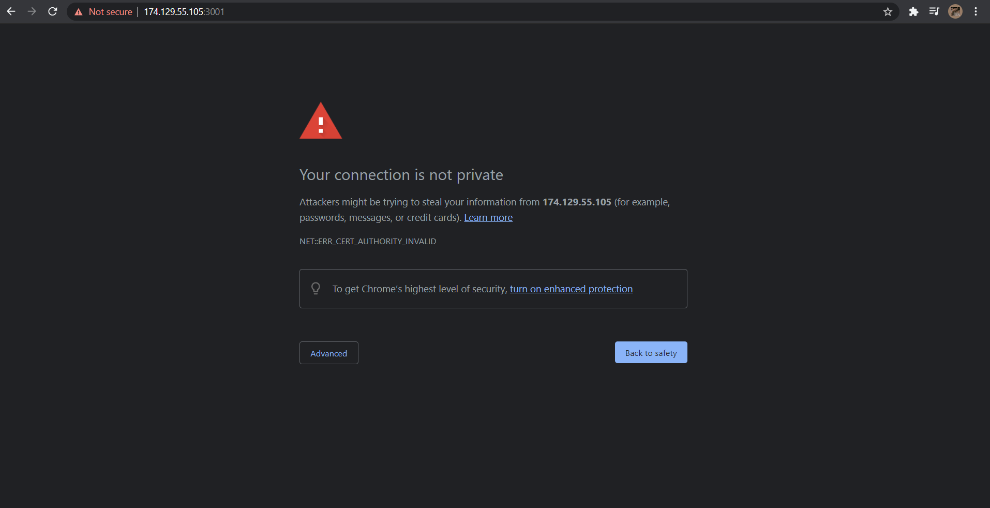

* Click the ‘Proceed to 174.129.55.105 (unsafe)’ link

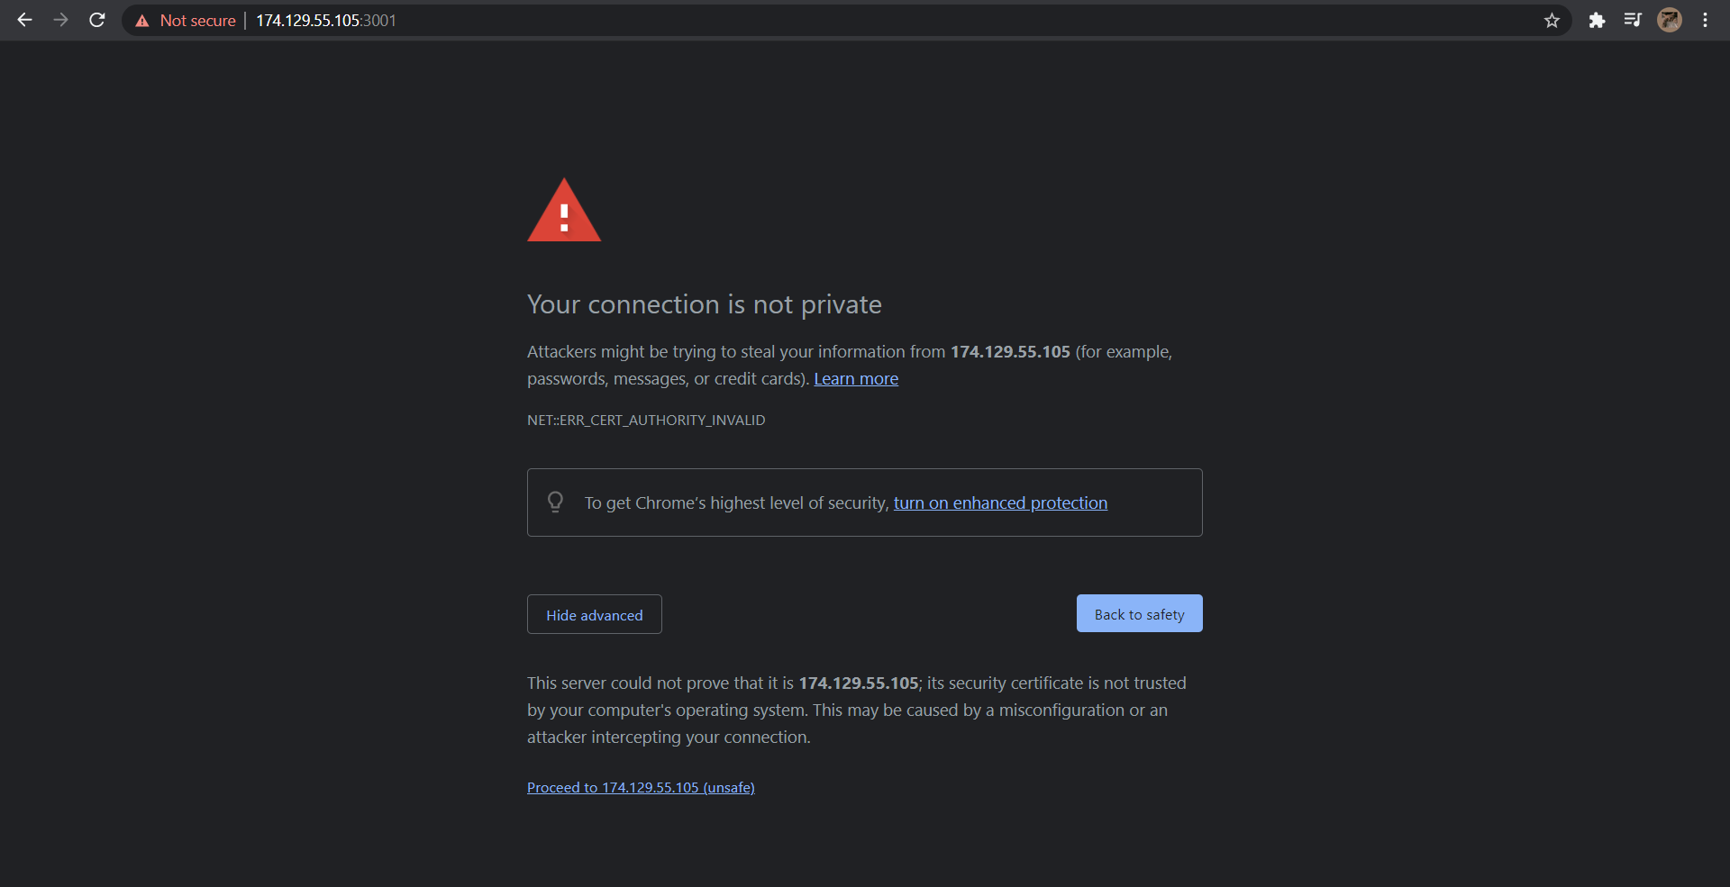

* Successfully access the web page

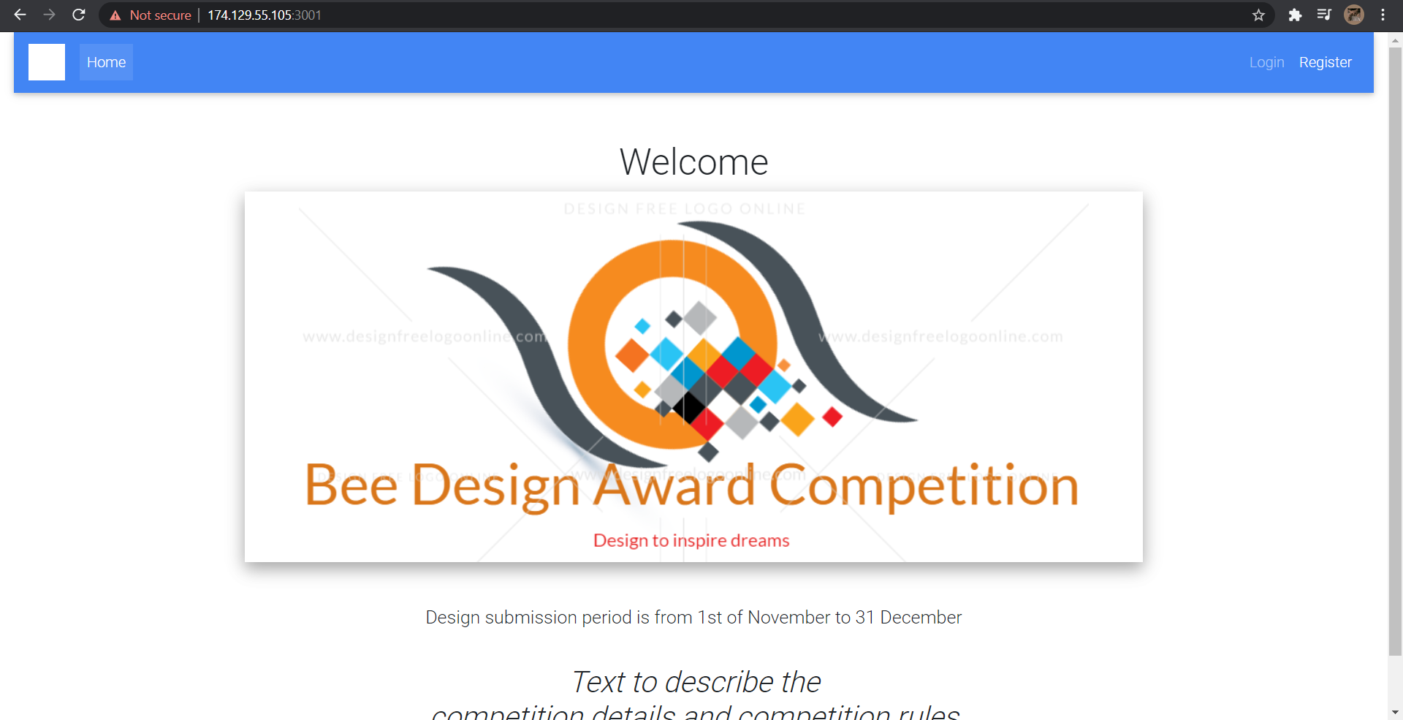

**Create RDS**

1. Create database

* Search for rds in search bar

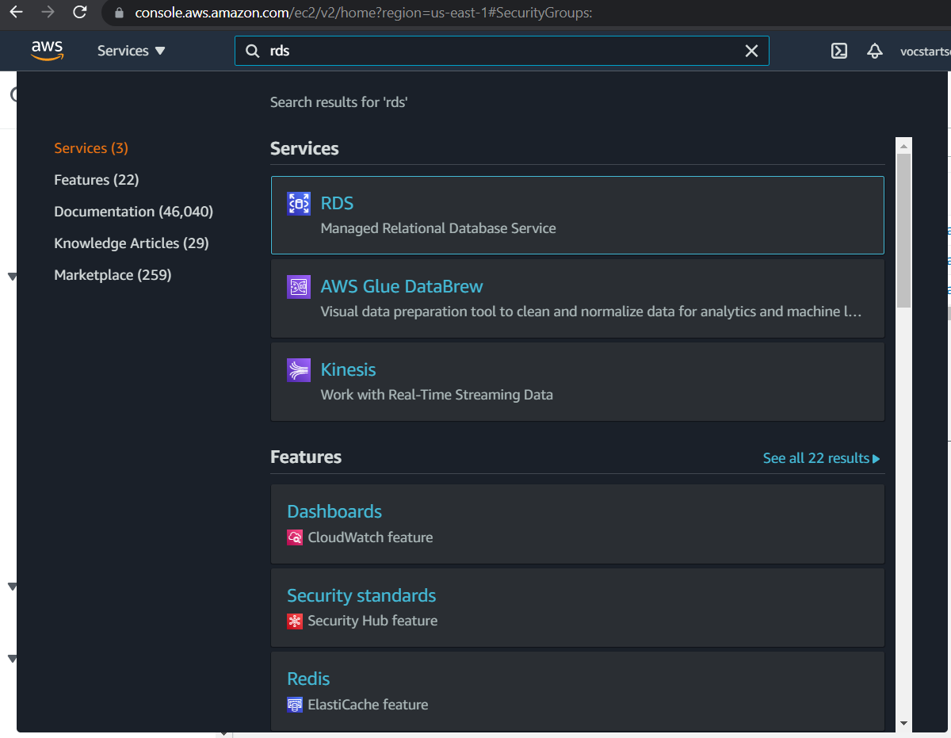

* Click on the Create database

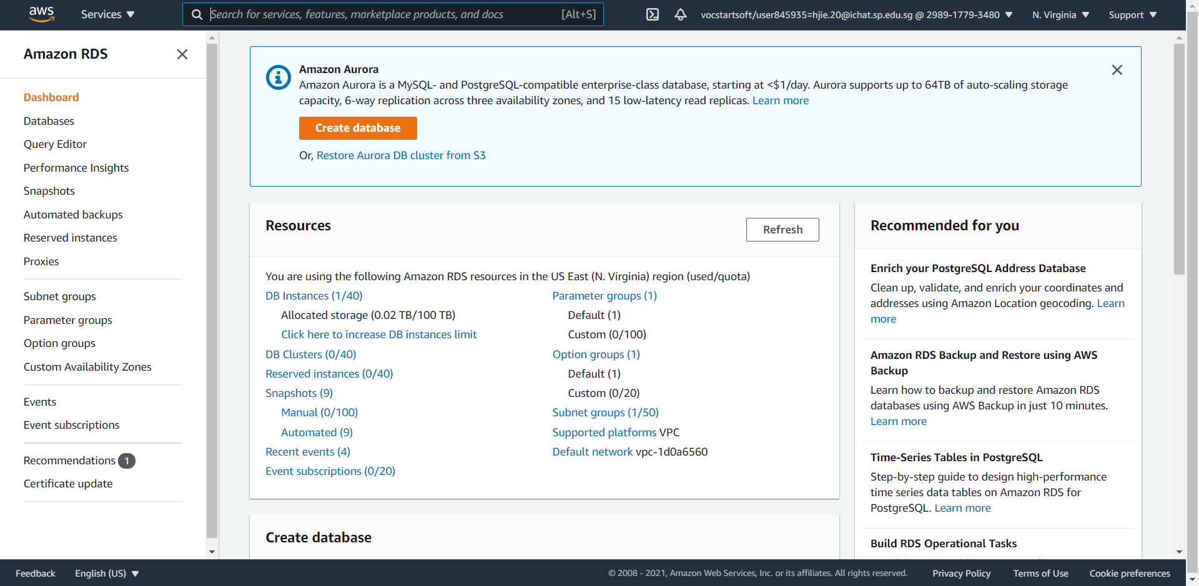

* Choose the Standard create and MySQL

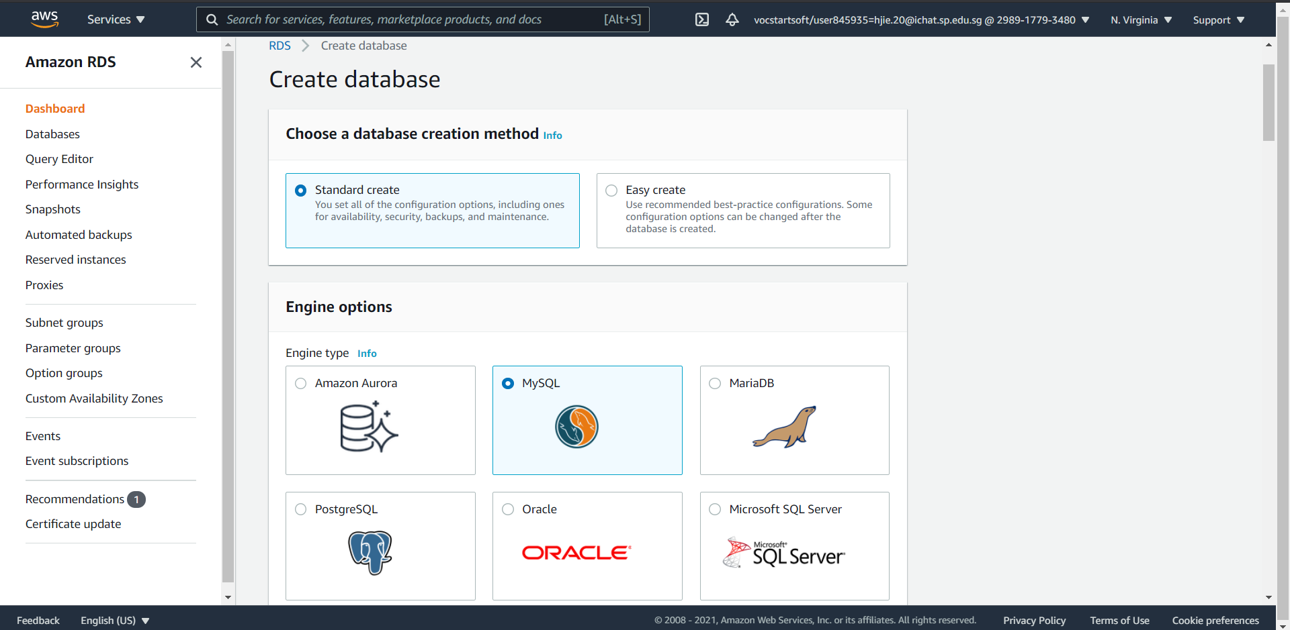

* Choose the MySQL 8.0.23 version and Free tier

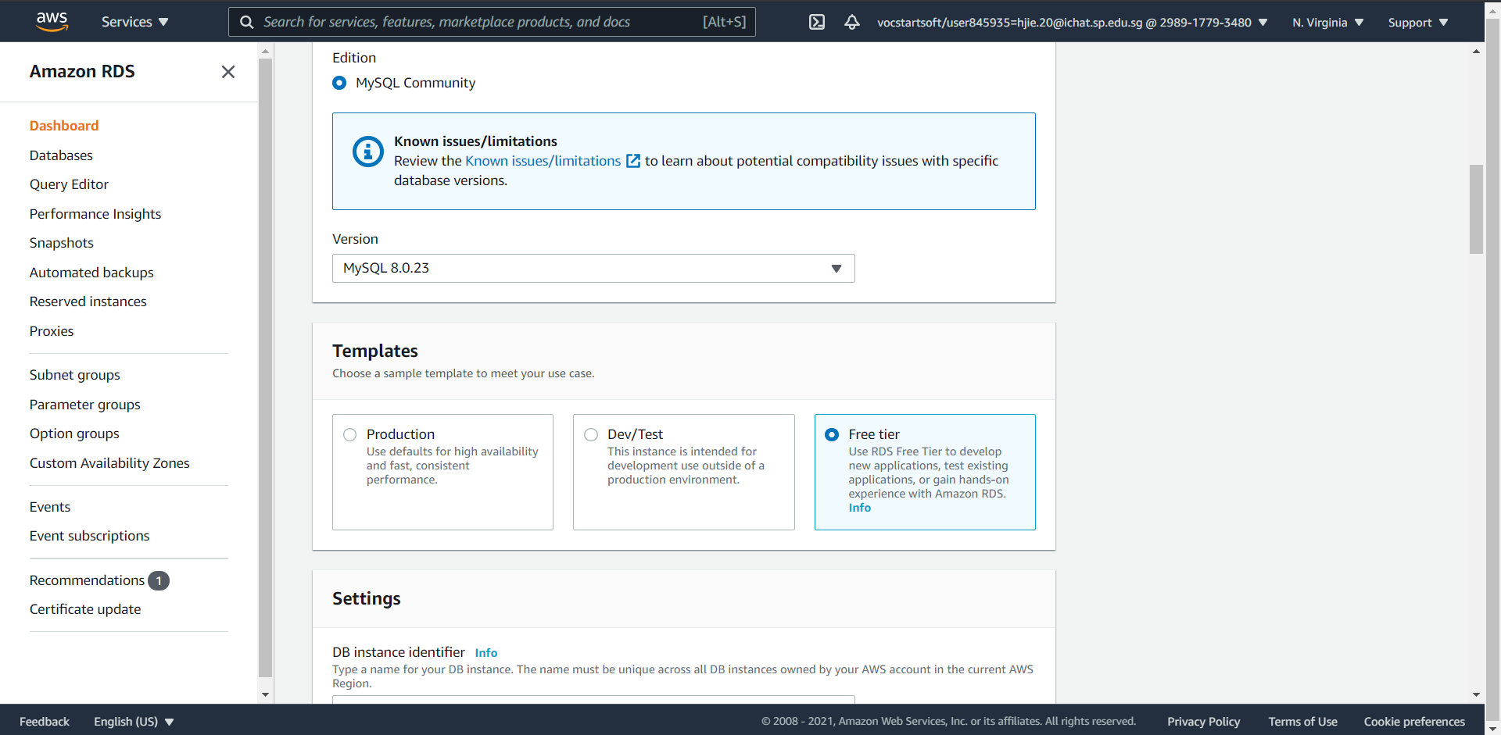

* At Master username: input admin
* At Master password and Confirm password: input password

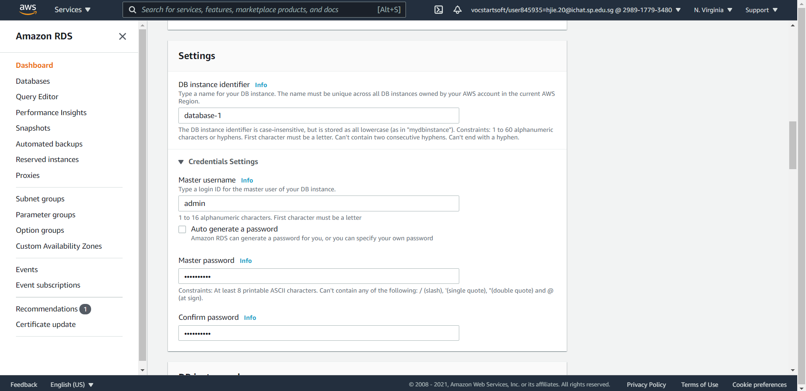

* At the public access: choose yes

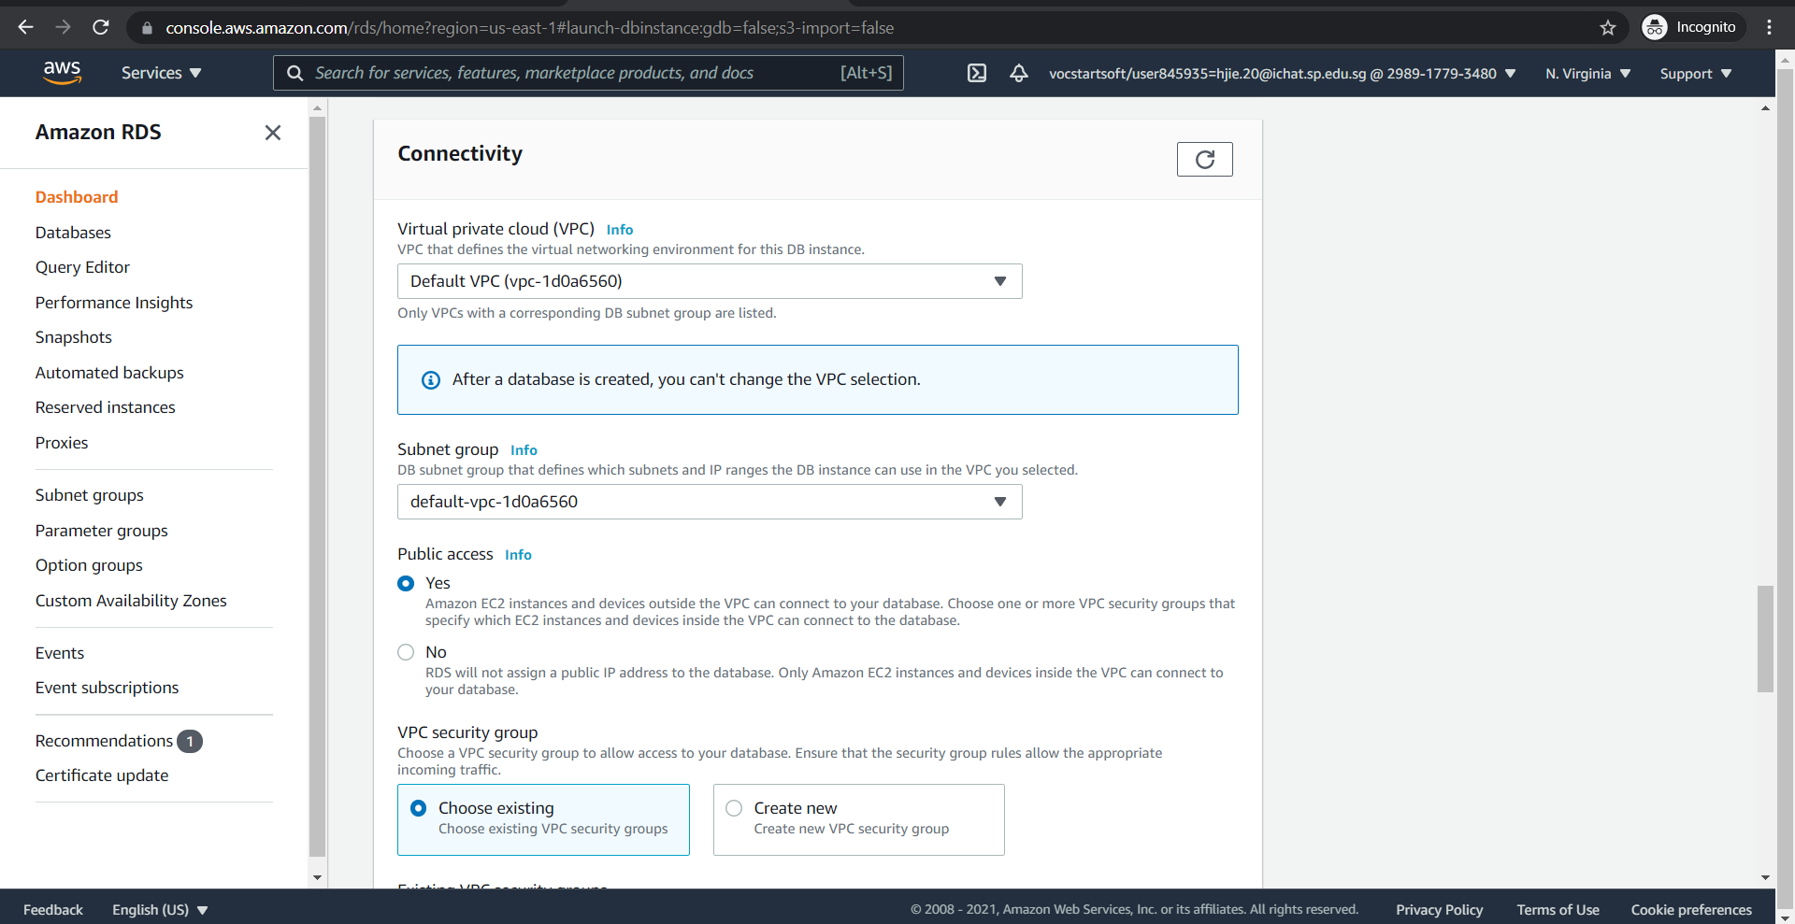

* Click on the Create database

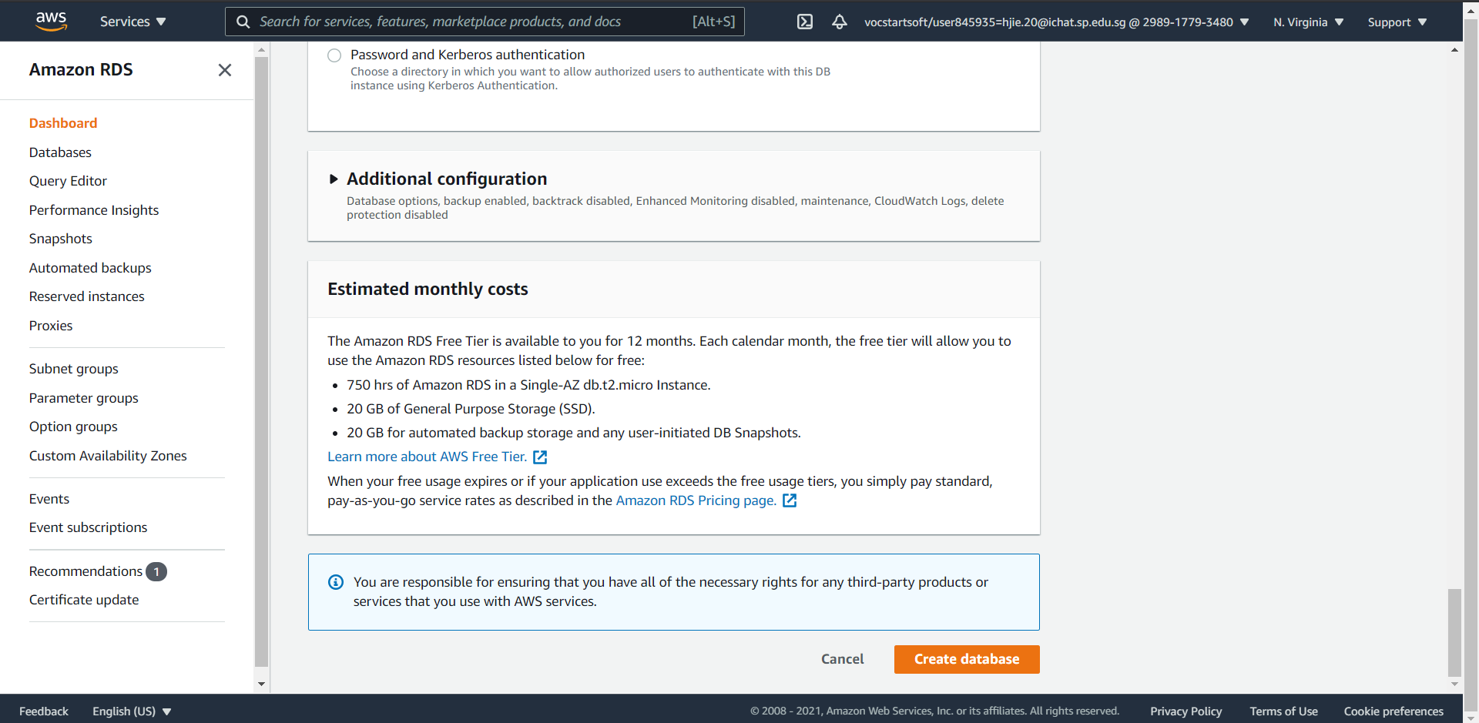

* Click the ‘database-1’

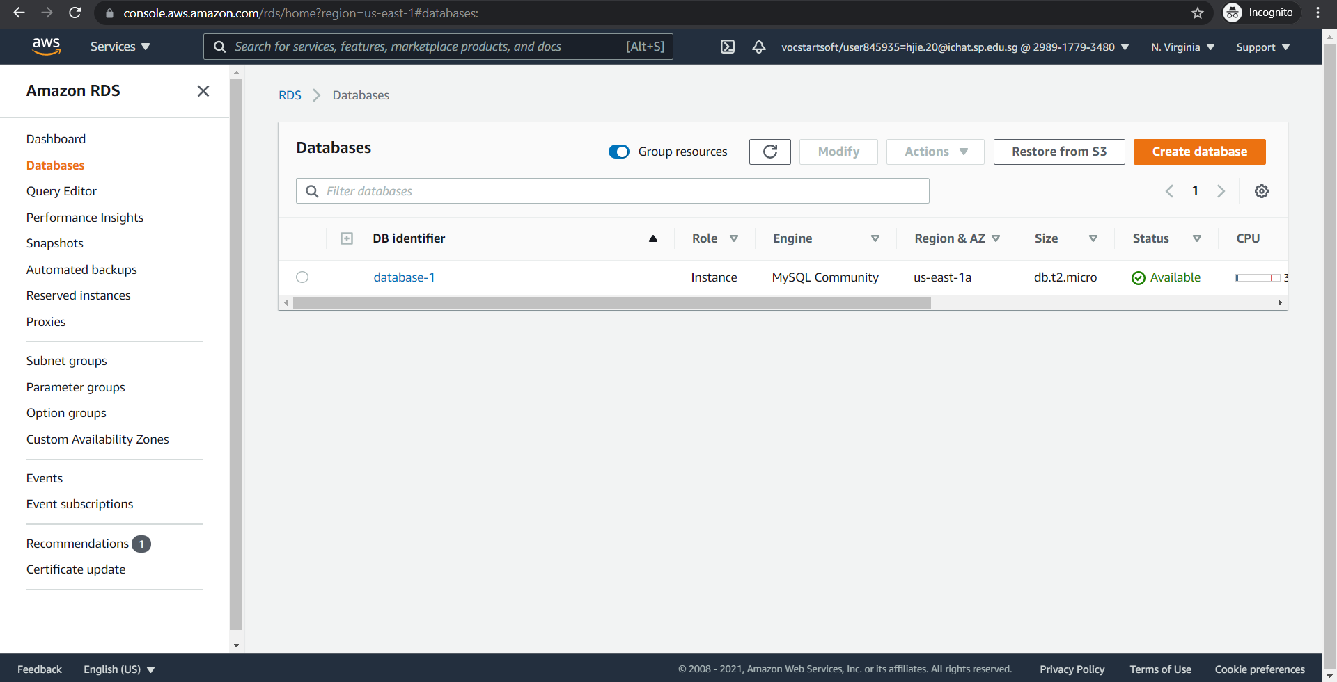

* Copy the Endpoint

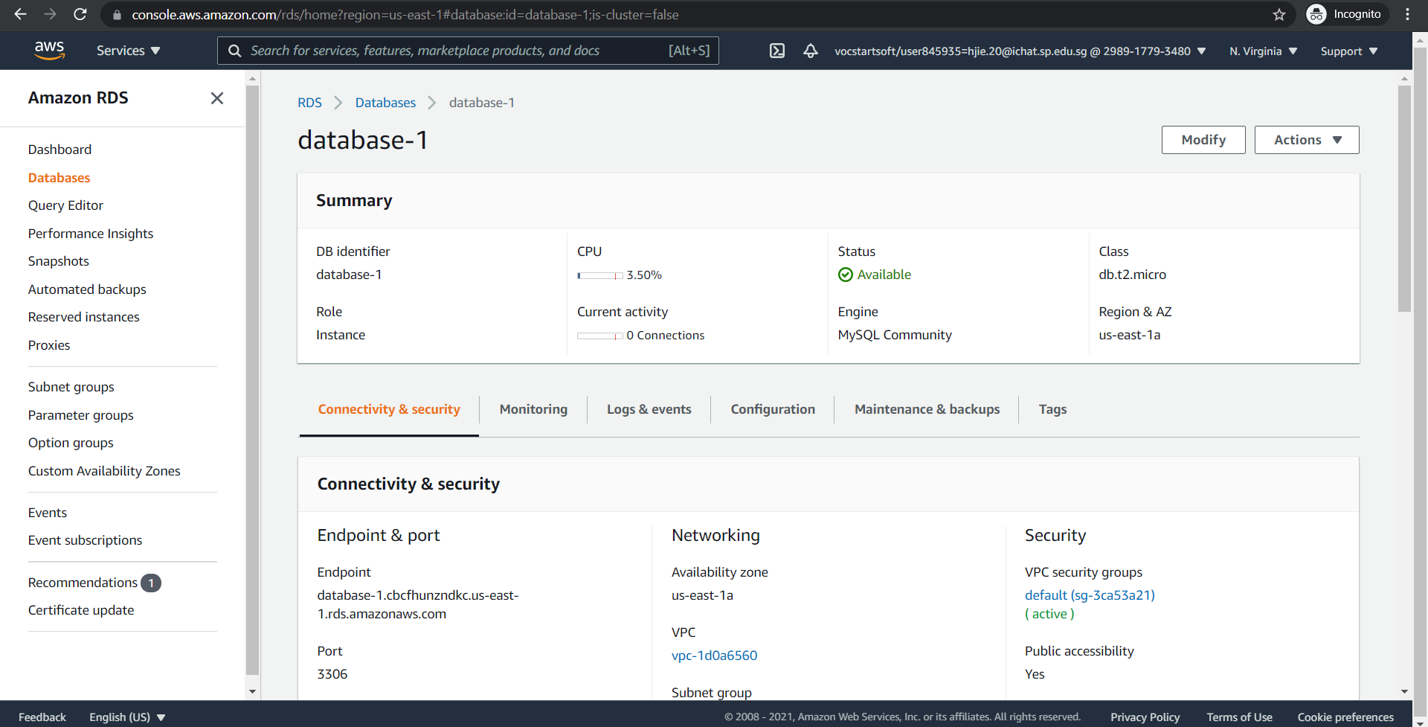

* At backEnd folder, src > config > database.js
* Change the host to the endpoint that copied just now

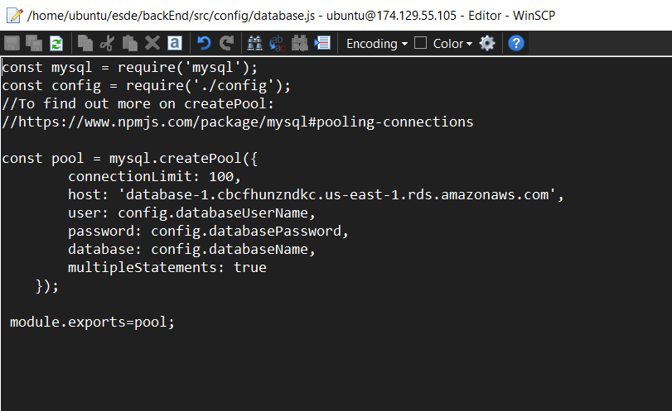

1. Setting up the MySQL Workbench

* Open up mysql workbench

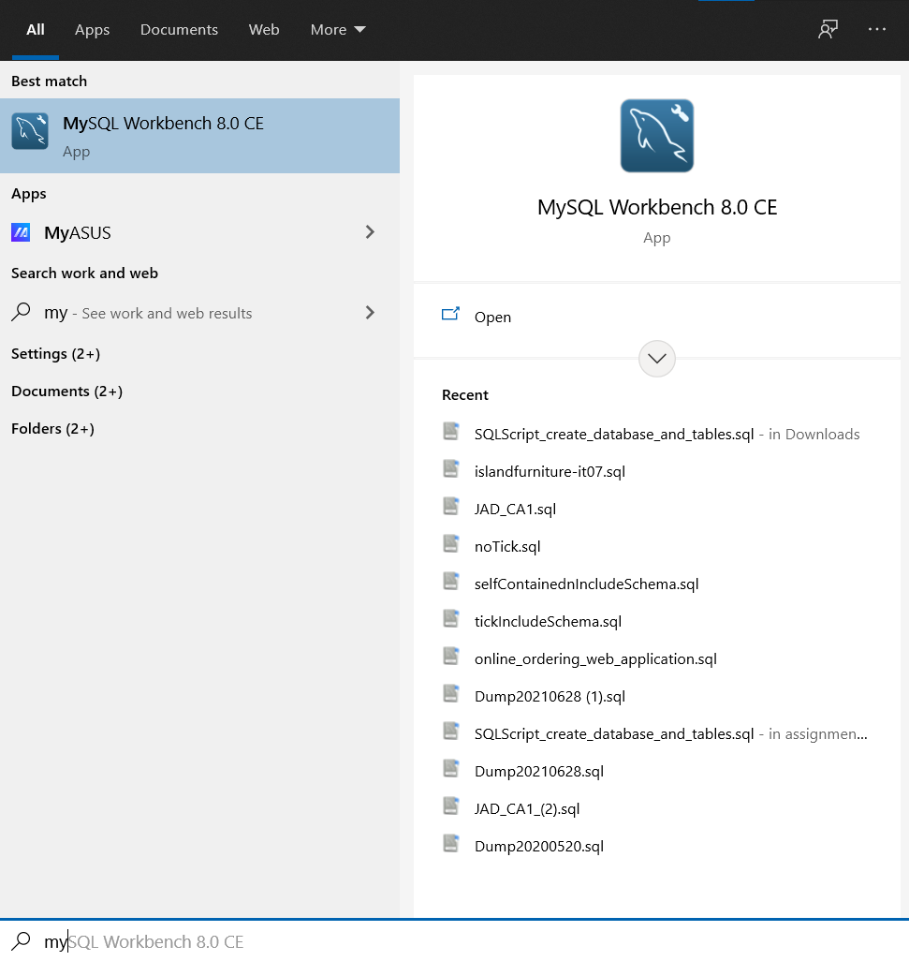

* Click on the ‘+’ icon

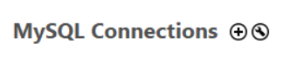

* At Connection Name: input ‘AWS Ec2 serve for ESDE’
* At Hostname: input endpoint that copied just now
* At Username: input ‘admin’

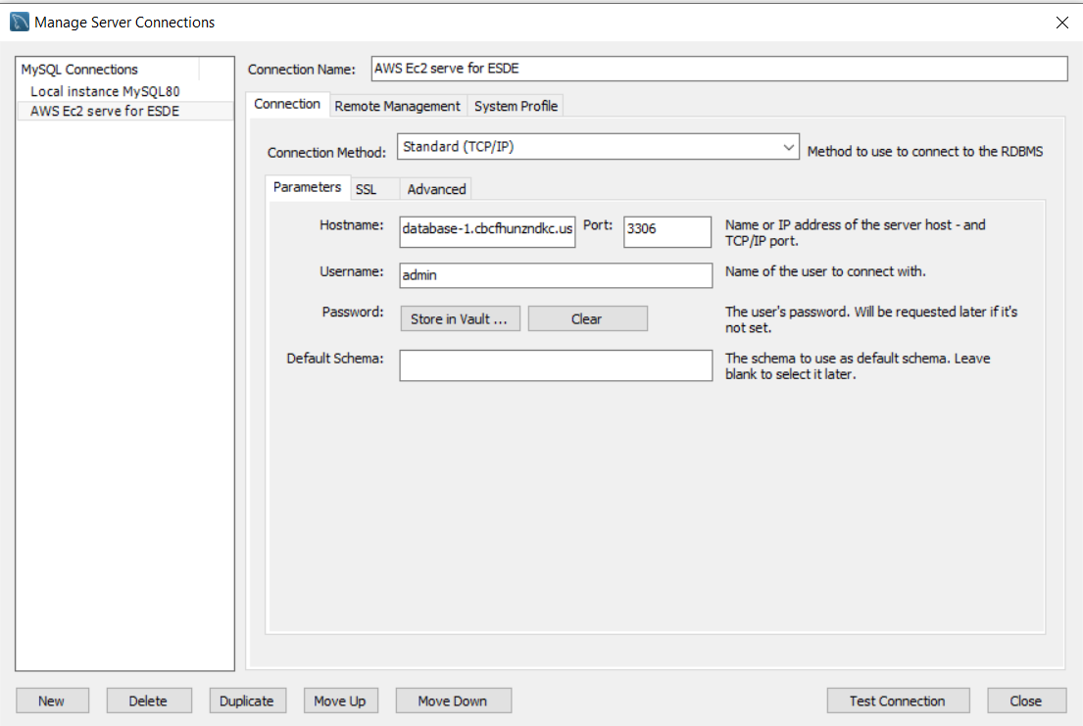

* New connection created shown as below

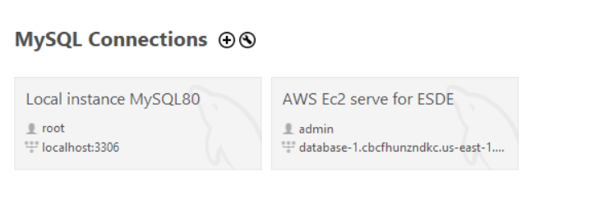

* Import the sql script that used in CA1
* Change the line 33 from ‘*.*’ to ‘competition_system_security_concept_v2_db.*’

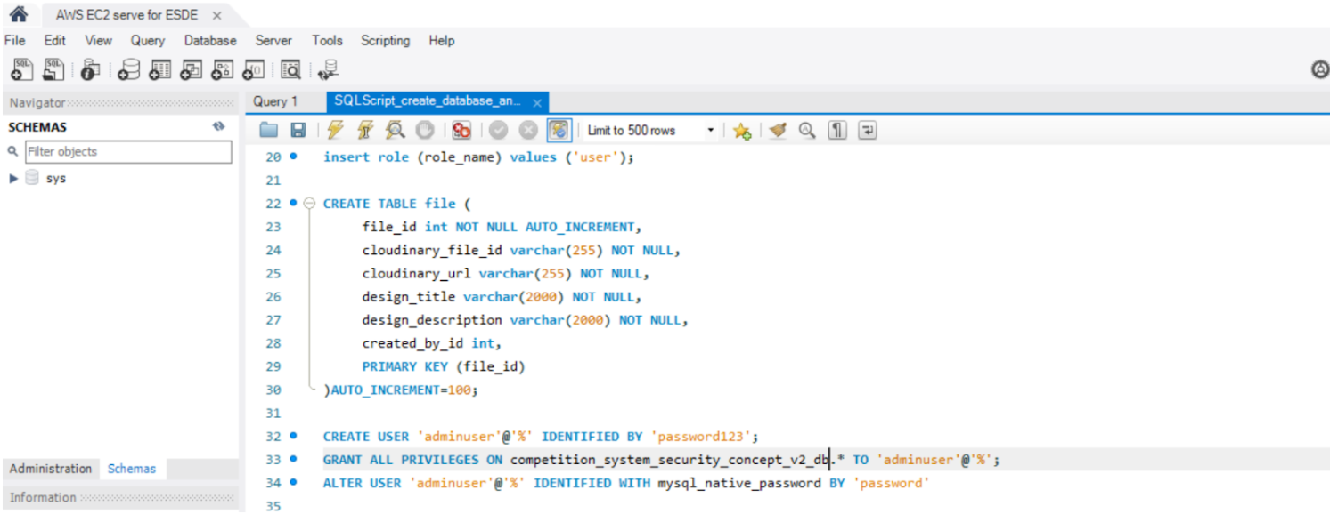

* Click on the lightning button to run the script

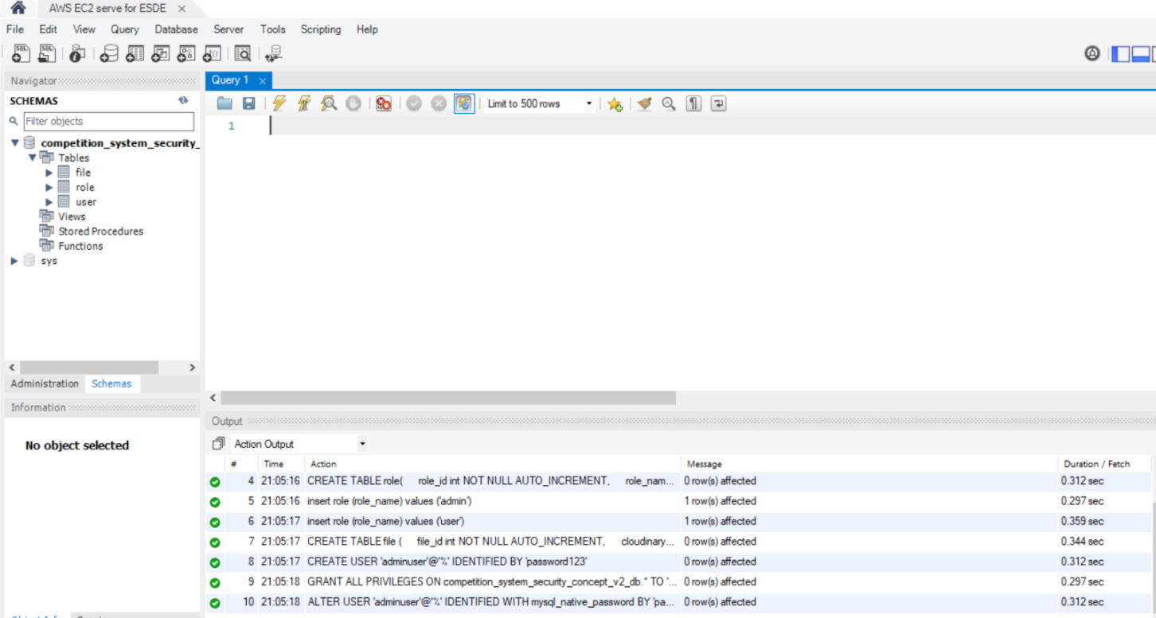

* In WinSPC open up a putty window
* cd to esde/backEnd
* Run the seeddata.js file



* Data will be inserted shown as below

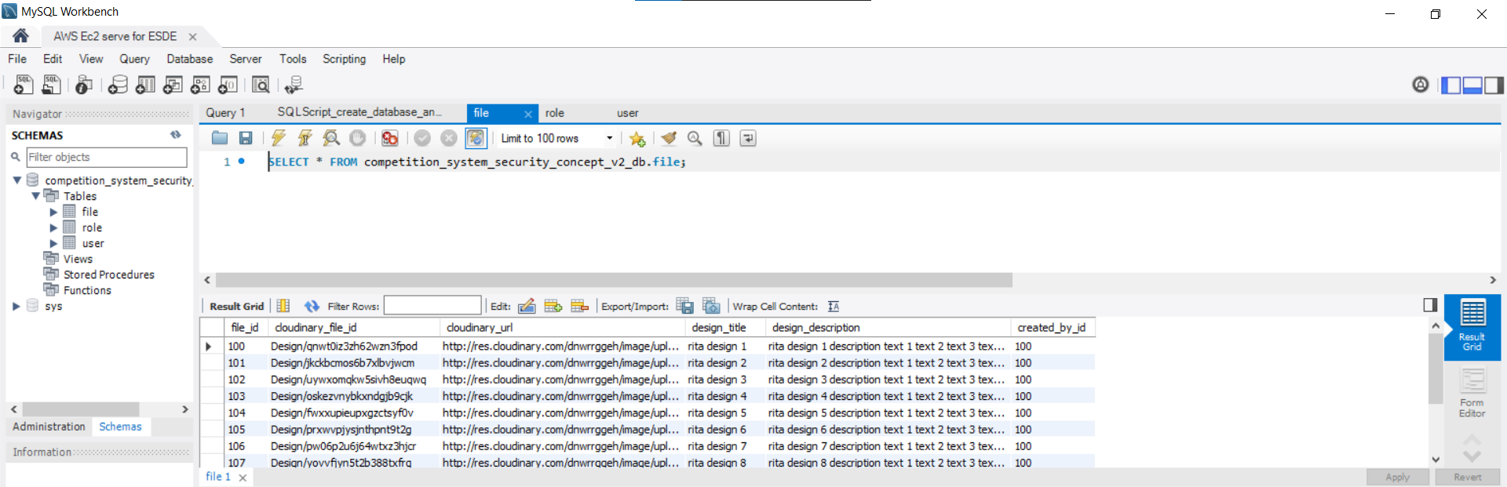

* In WinSPC navigate to frontEnd folder

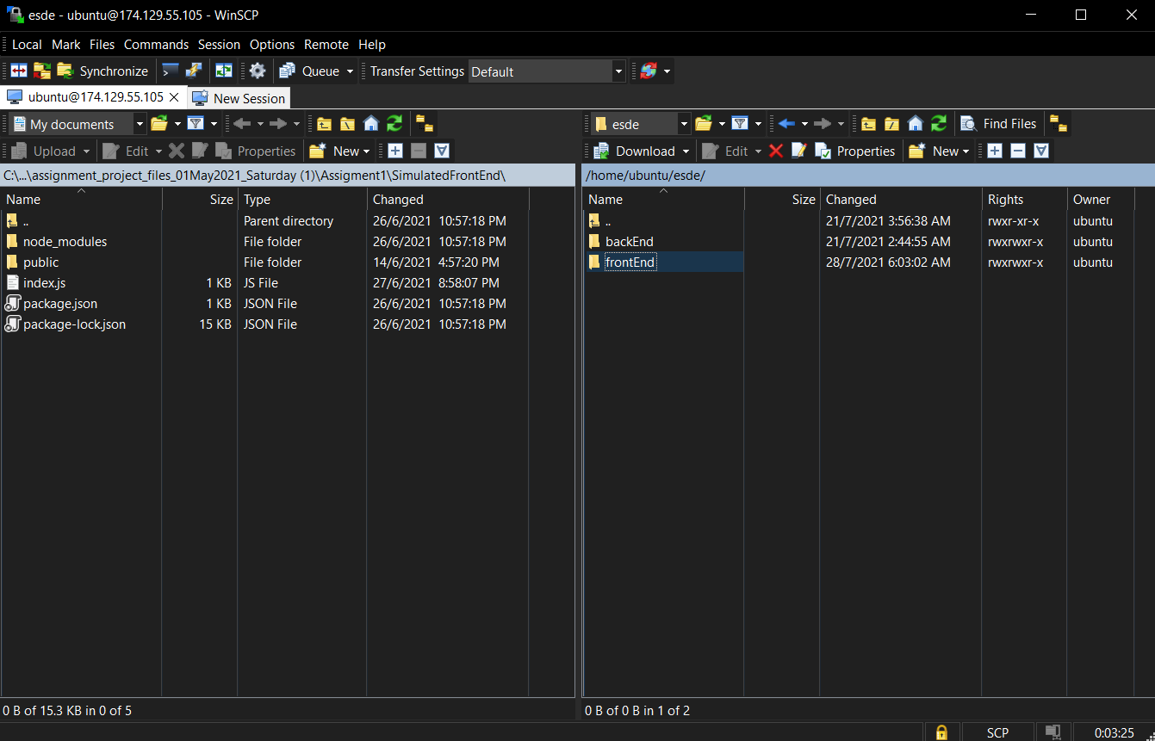

* In frontEnd folder navigate to public folder

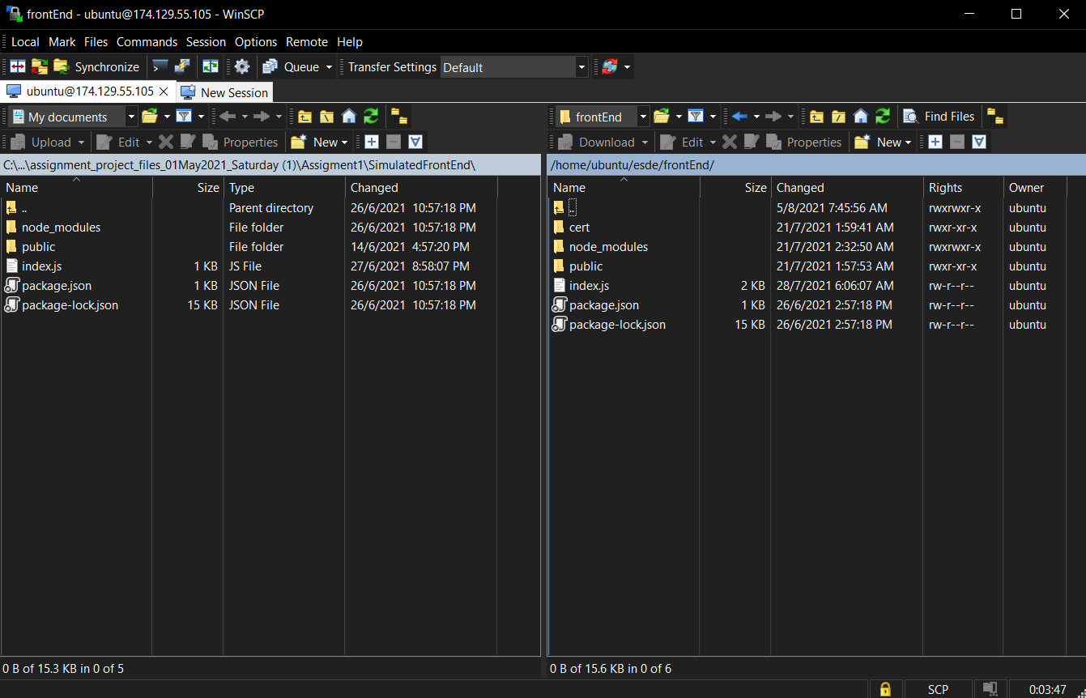

* In public folder navigate to js folder

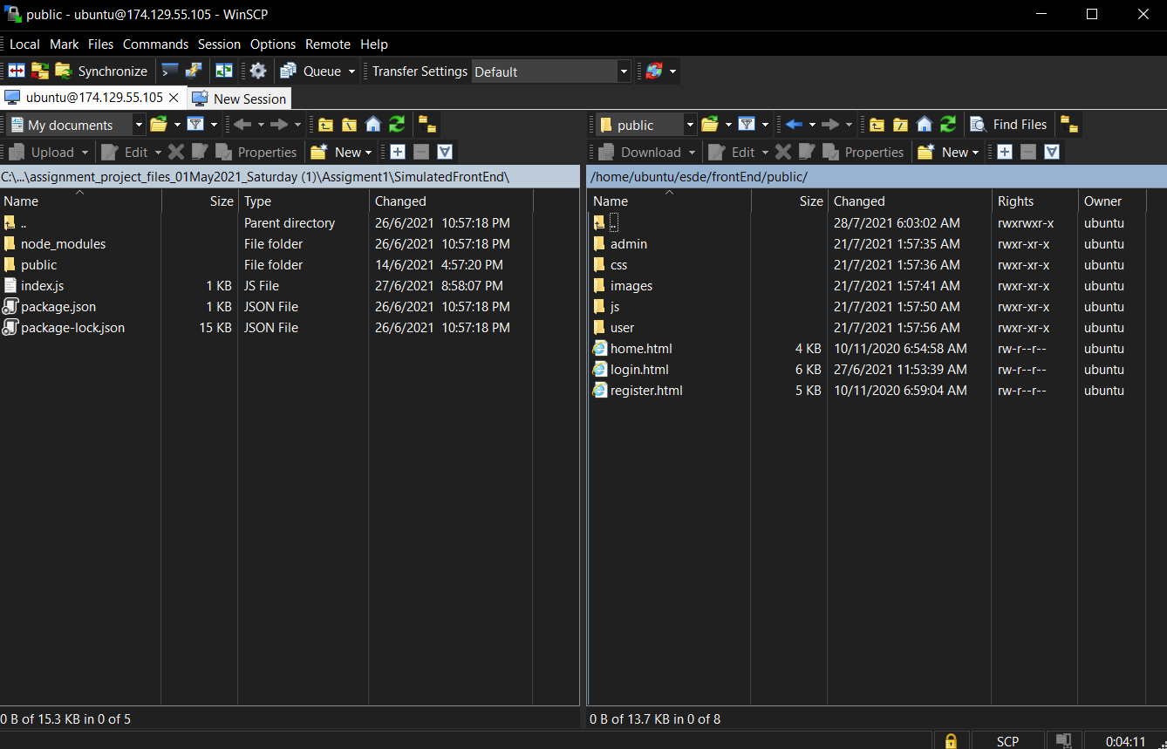

* In js folder navigate to login.js file

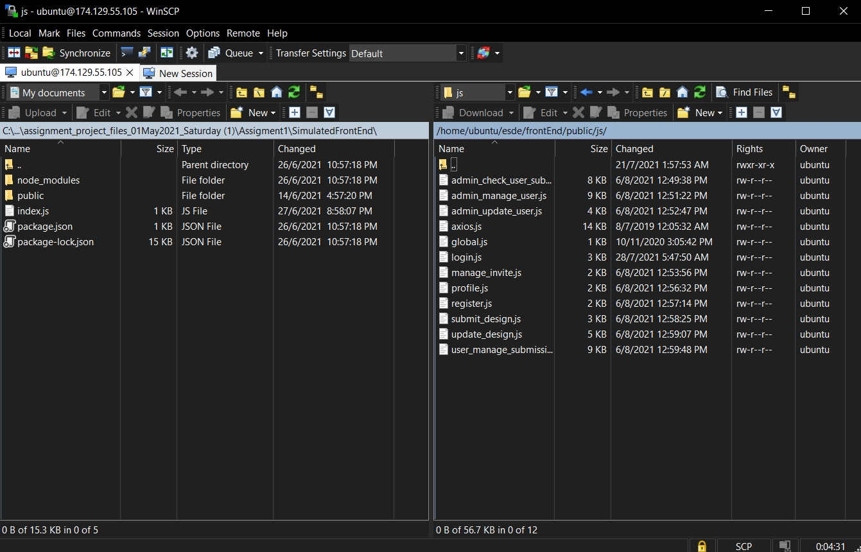

* Change the const baseUrl in all js file at frontEnd from ‘https://localhost:5000’ to ‘https://174.129.55.105:5000’

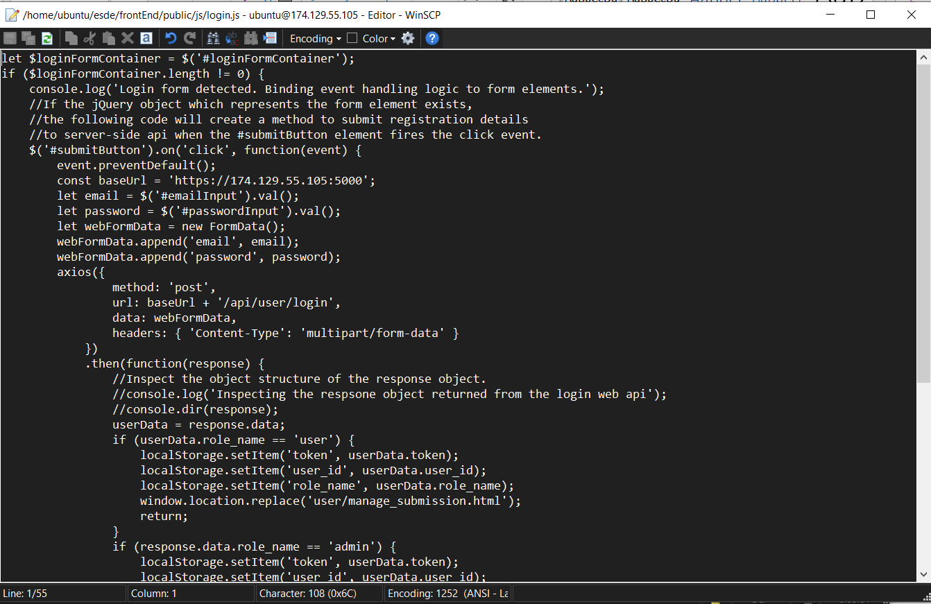

1. Try to login and search through the web page

* Input the email and password

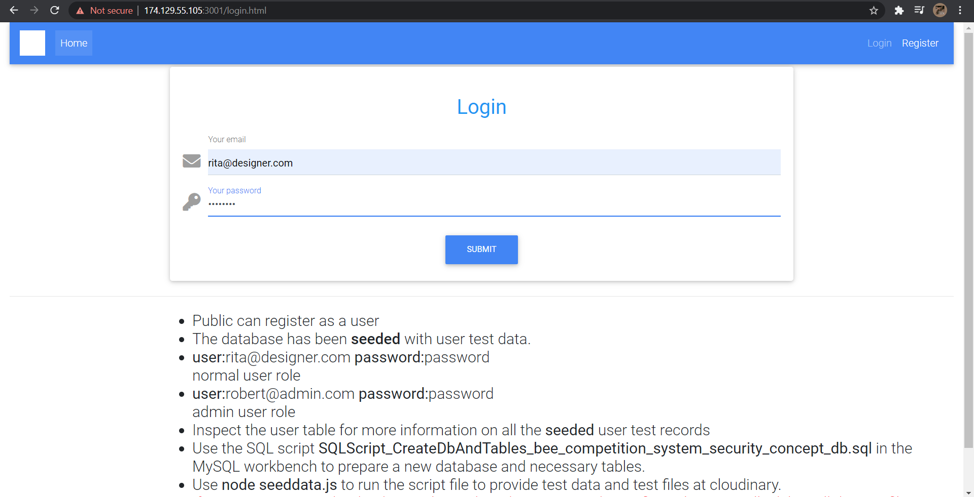

* Input ‘rita’ to search

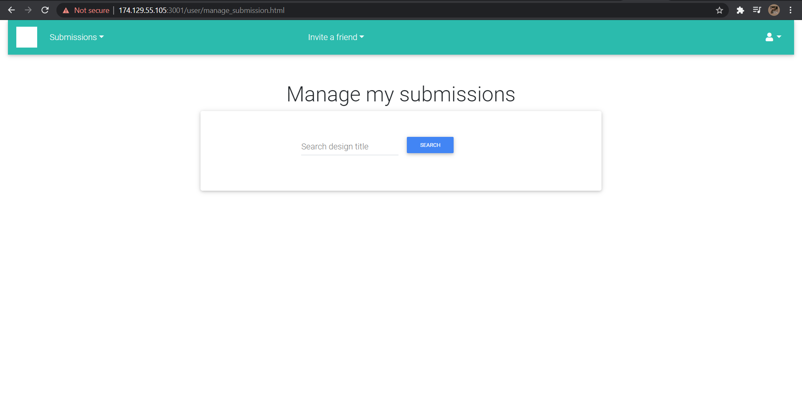

* Successfully retrieve the data of rita

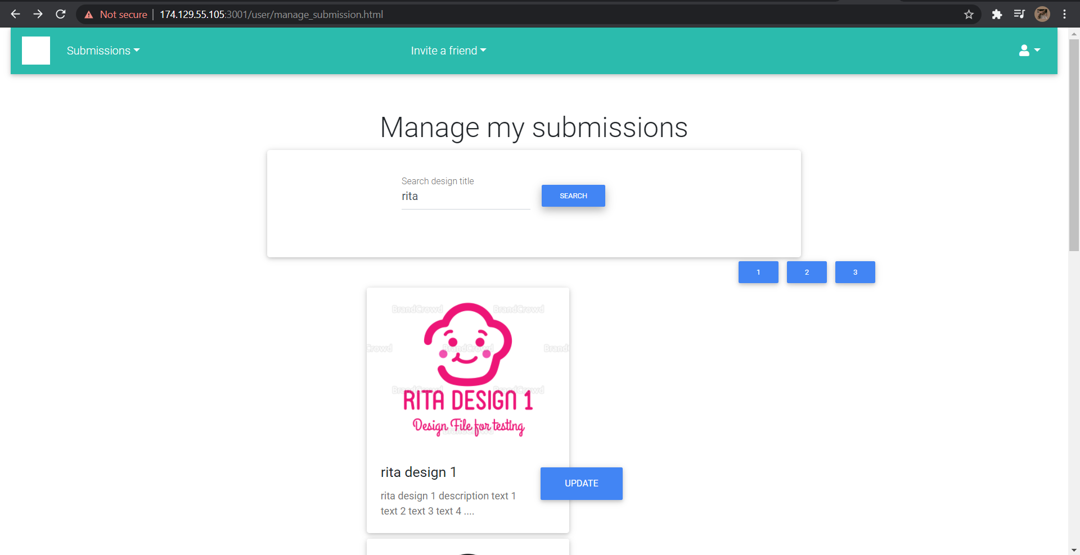

**Create Cloud9**

* Search cloud9 at the search bar

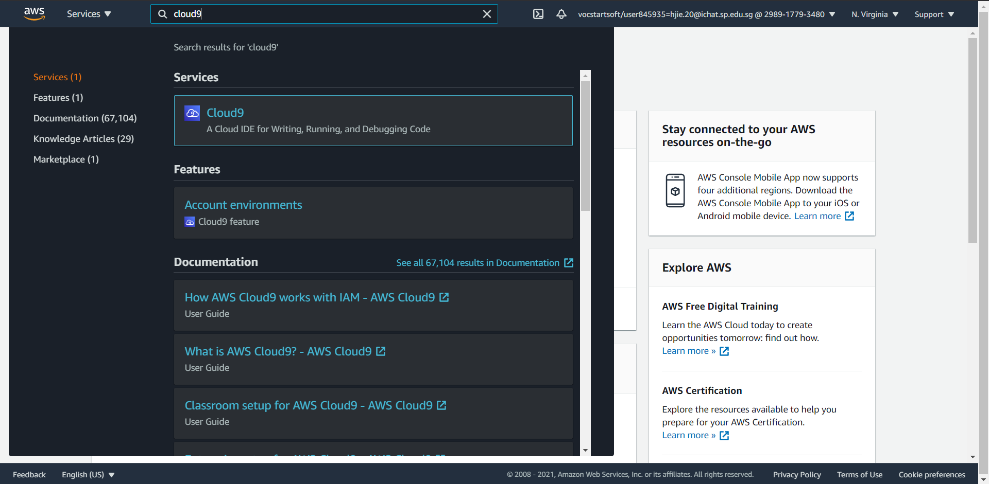

* Click on the Create environment

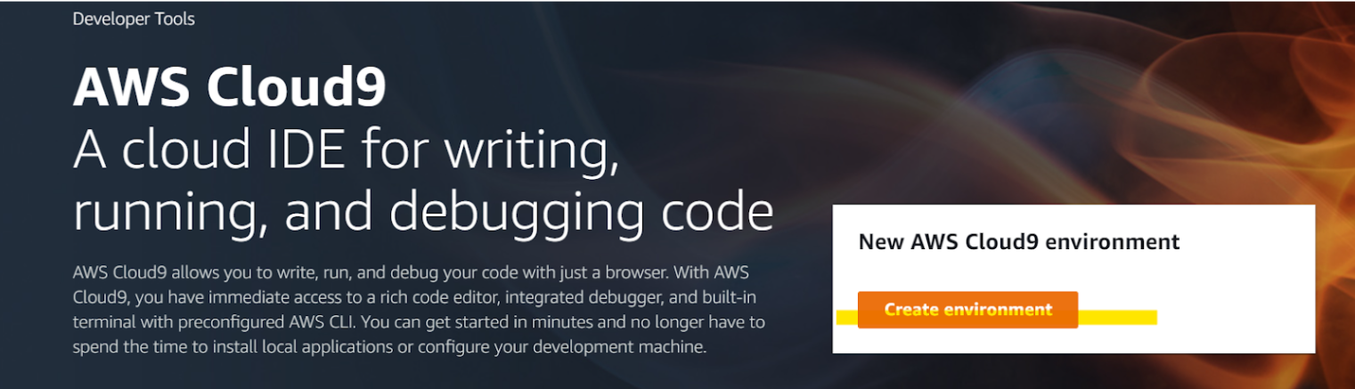

* Name the environment as ‘esde’ and click Next step

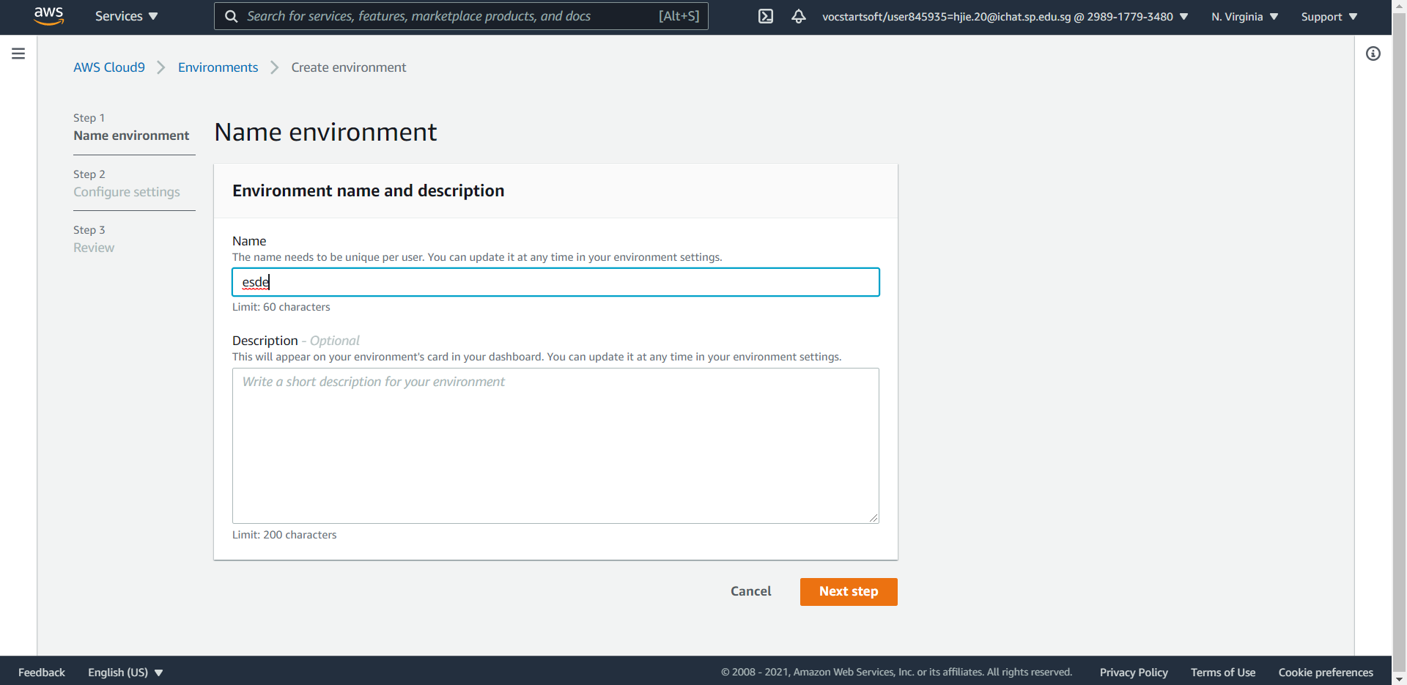

* Follow the configure settings shown as below

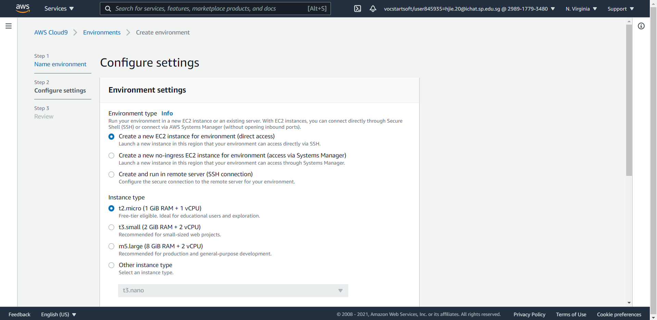

* Click on Next step

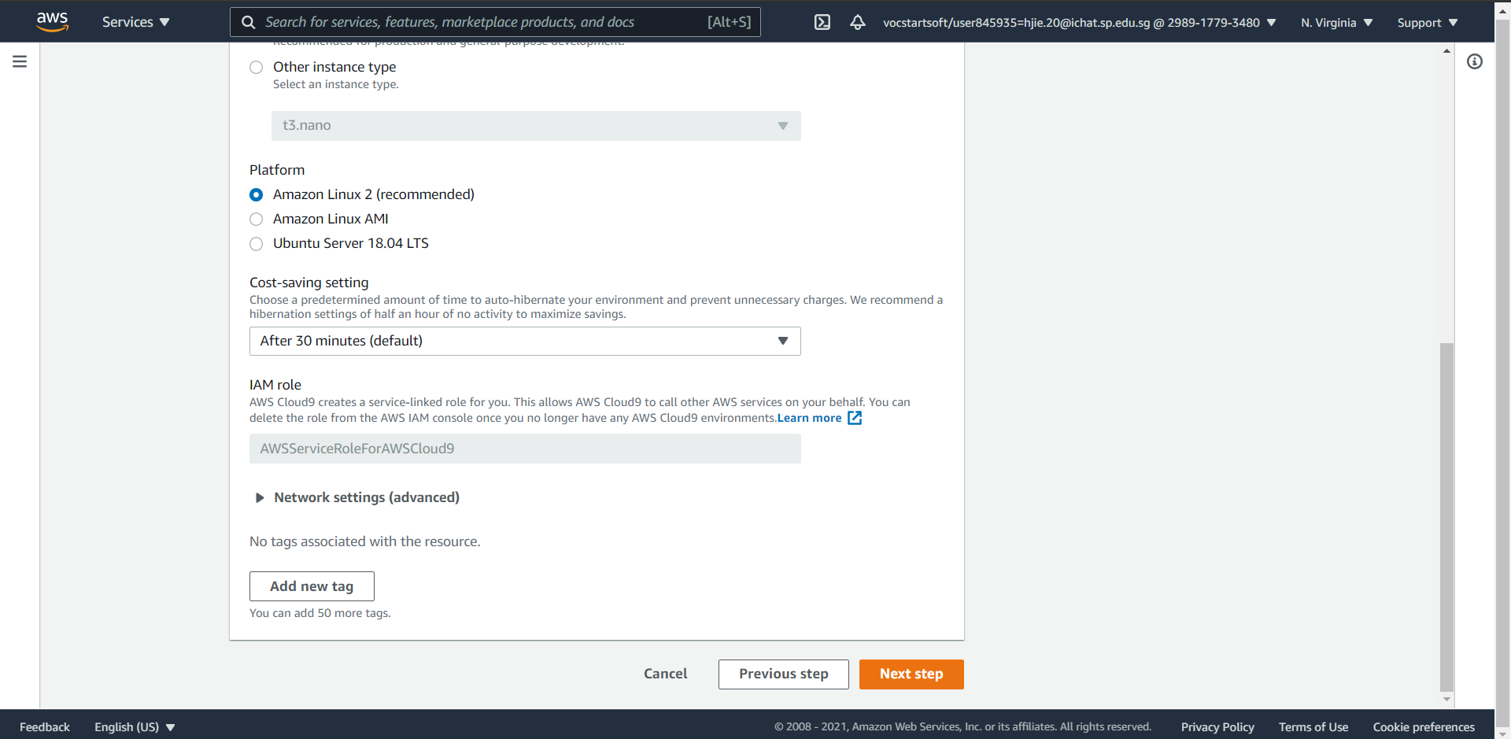

* Click on the Create environment

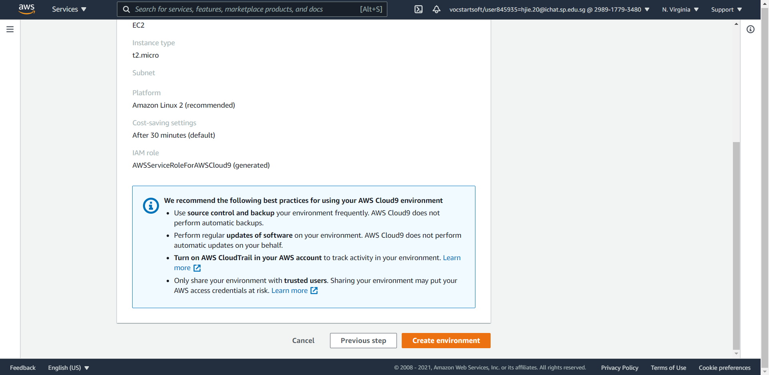

* After the cloud9 environment created do the

npm install aws-sdk



**Create DynamoDB**

* Click on the create table

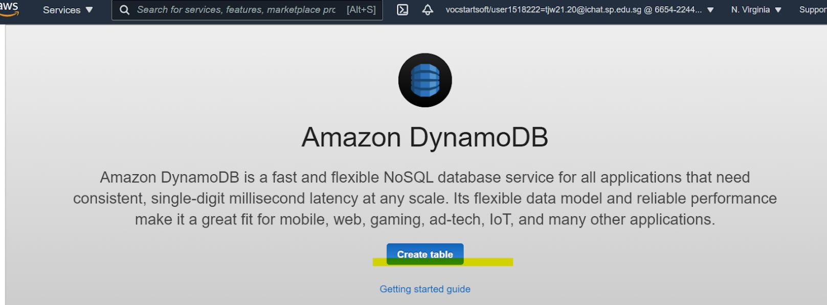

* At the Table name: input files
* At the Primary key: input file_id
* At the dropdown list choose String

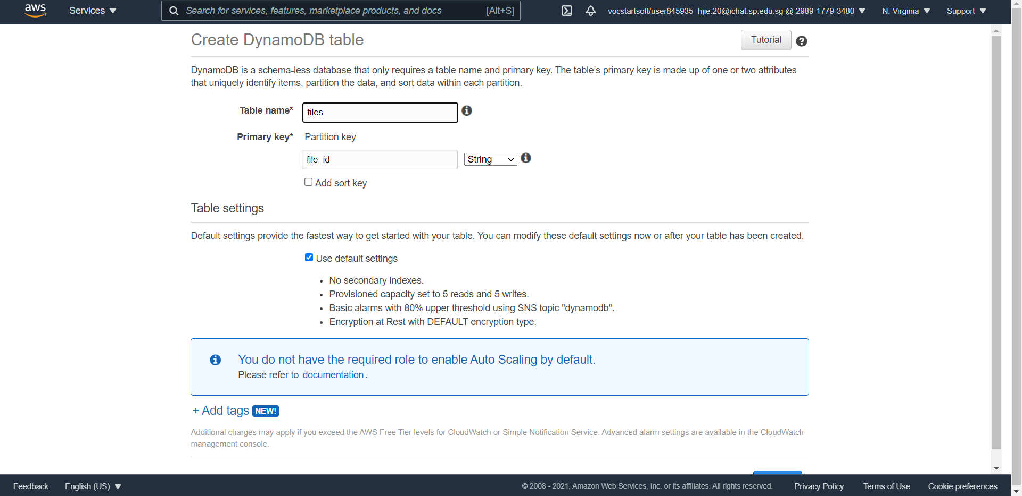

* Click on Create

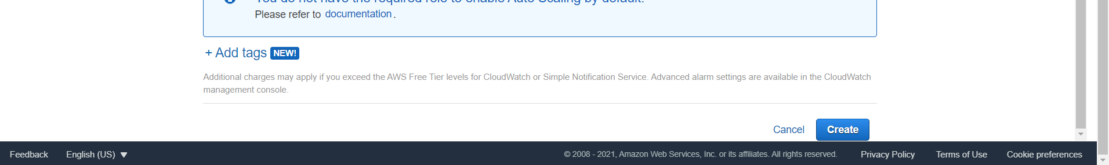

* Then it will show the overview of the table that created just now

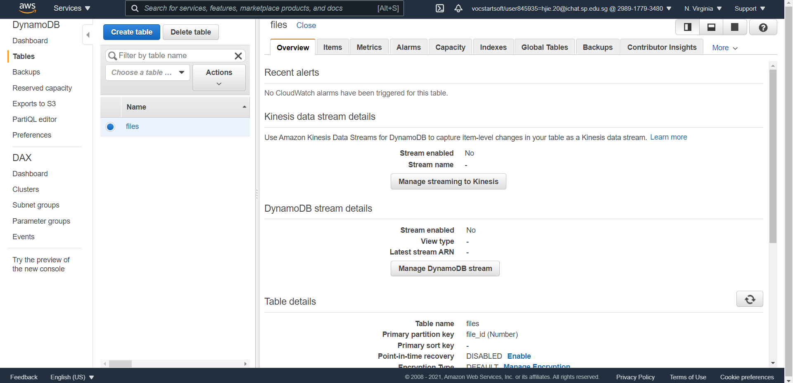

* In mysql workbench, right click on the file table and click on the table data export wizard

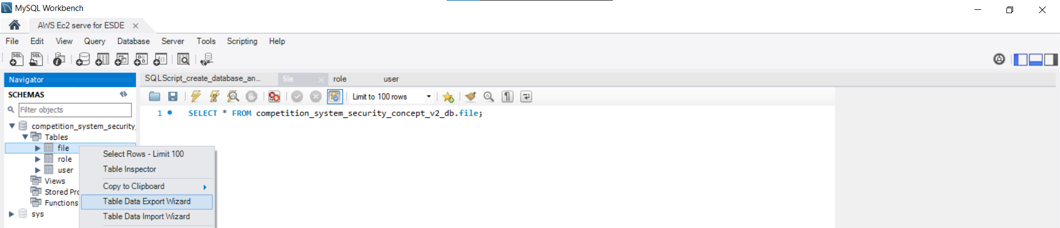

* Click on Next

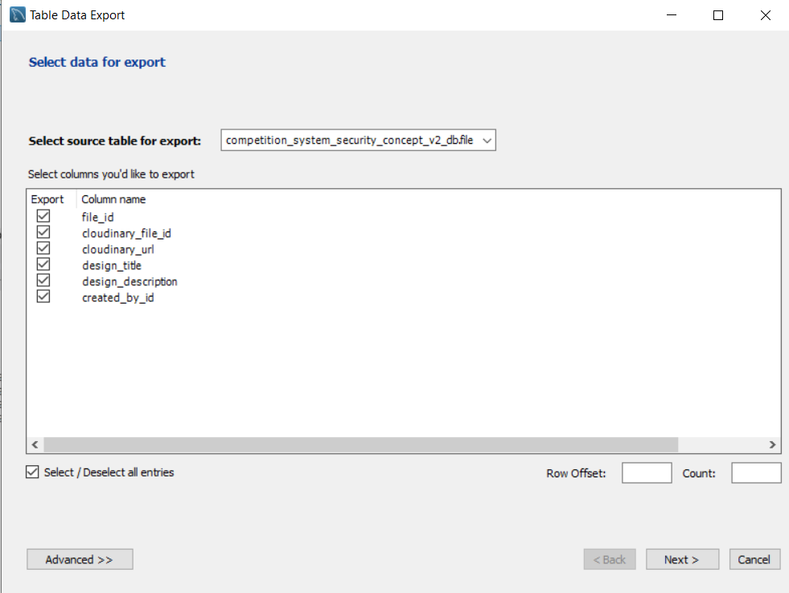

* Change the csv to json
* Click on ‘Browse…’

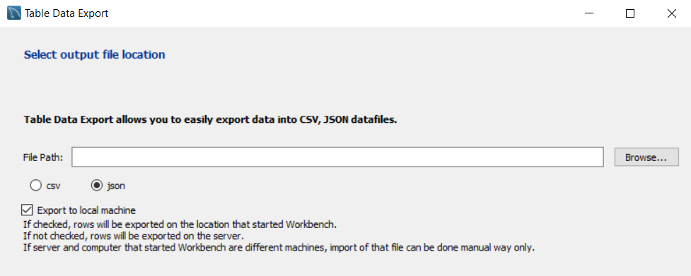

* Name it as file-2a01 and change to .json type
* Click on Save

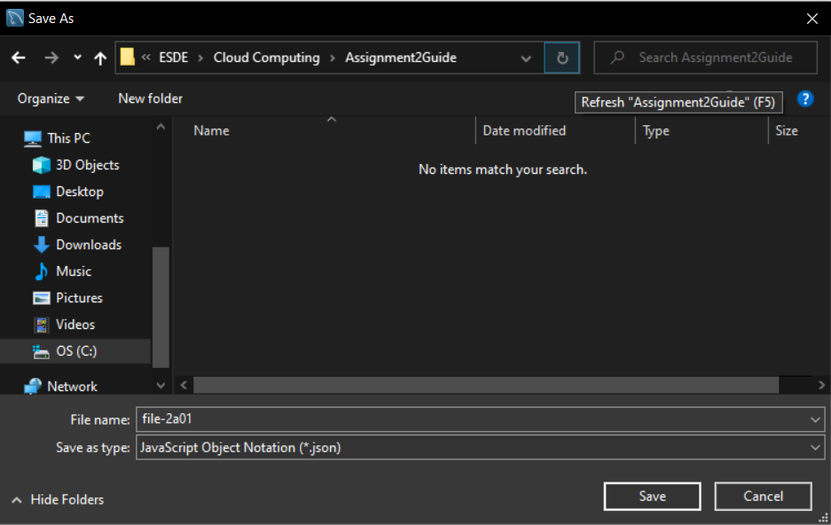

* Change the csv to json
* Click on Next

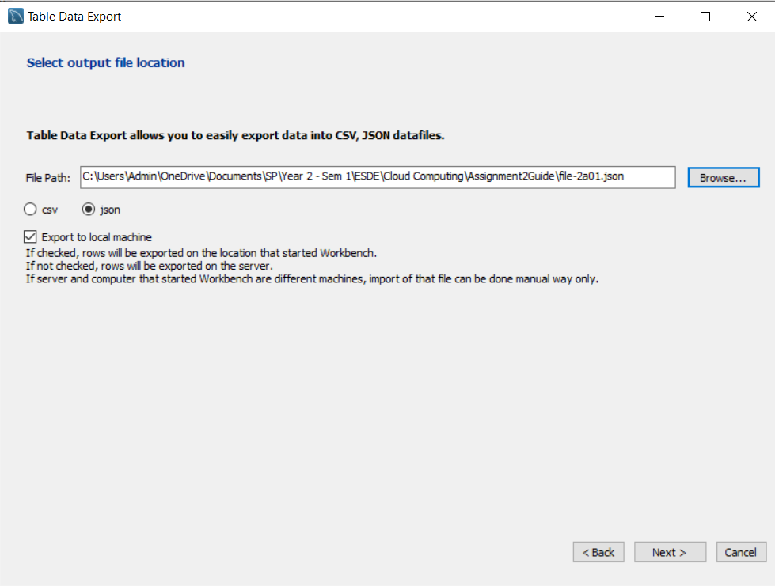

* Click on Next

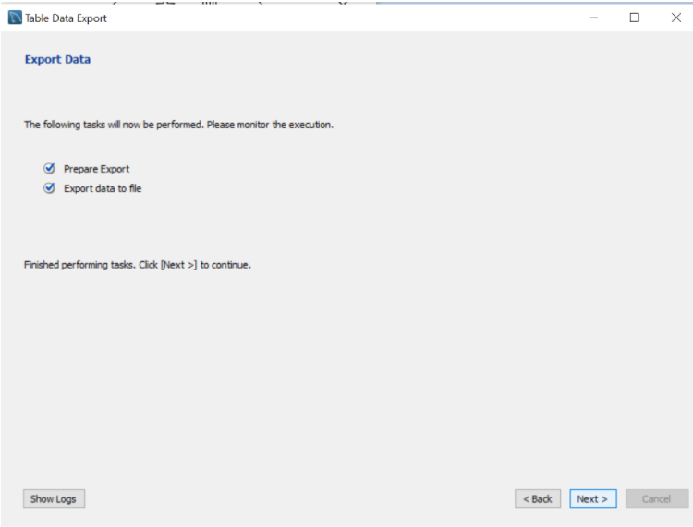

* In cloud9, click on File and click on Upload Local Files…

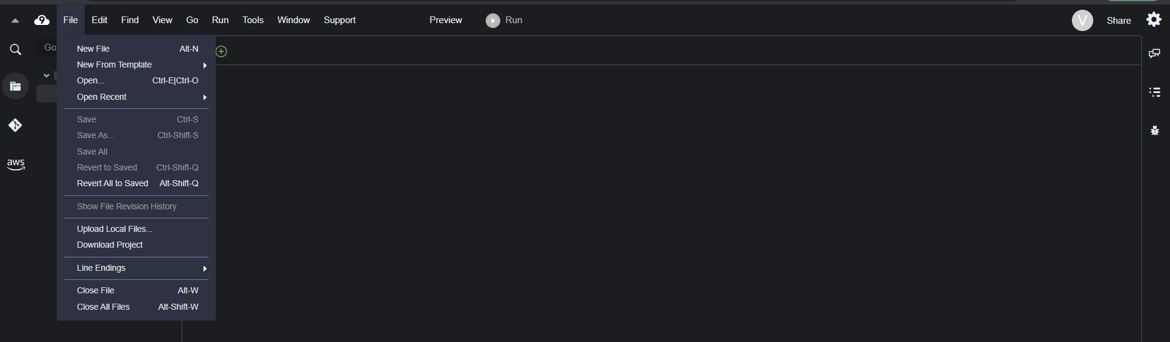

* Drag&drop the file2a01.json and seed_db_2a01.js from left to right

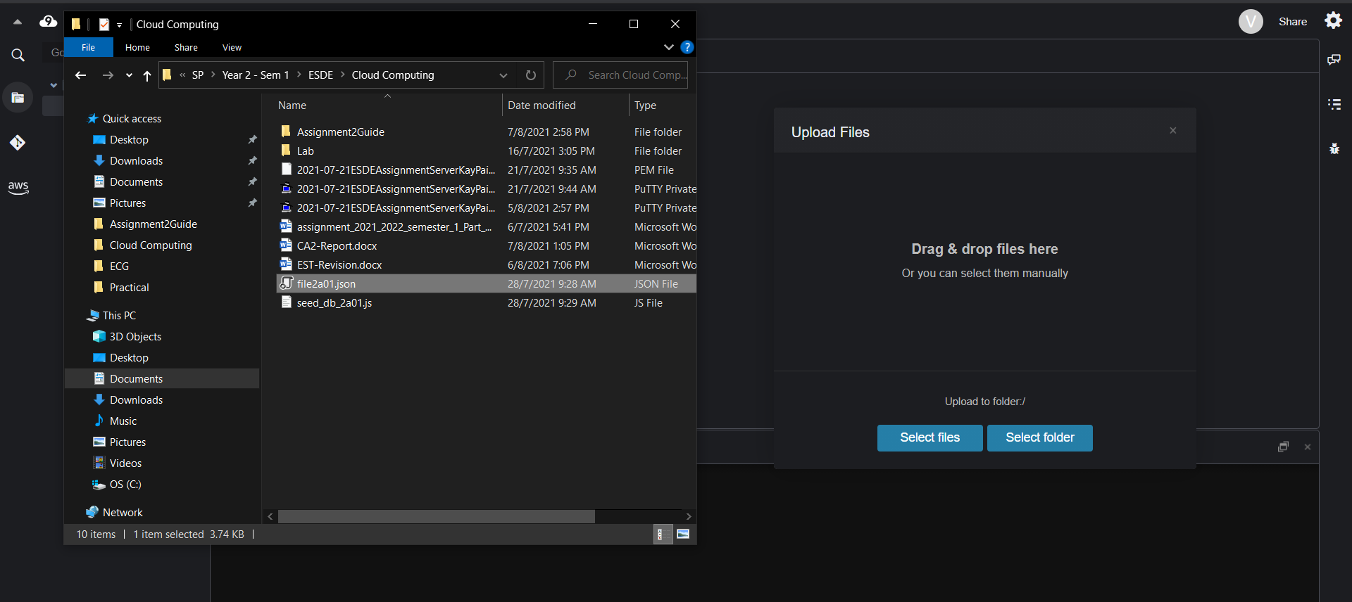

* After drag&drop it will show as the screenshots below

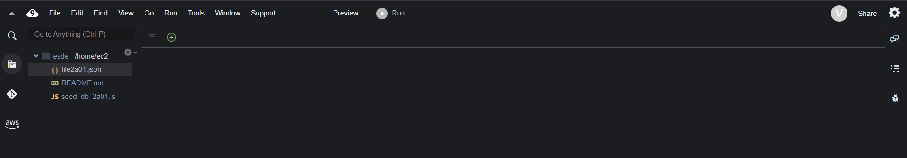

* Open up the seed_db_2a01.js file and click on Run

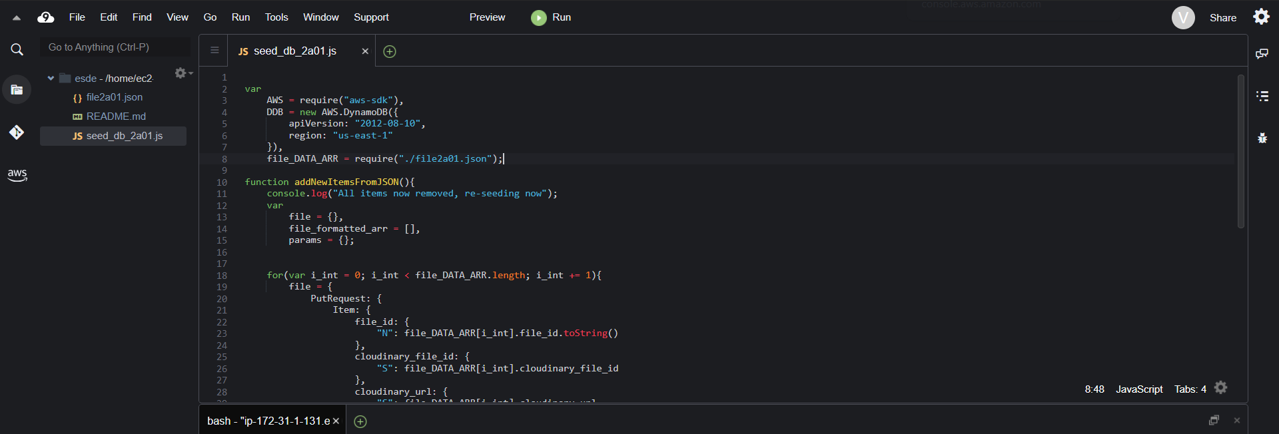

* After run successfully the data will be inserted in dynamodb

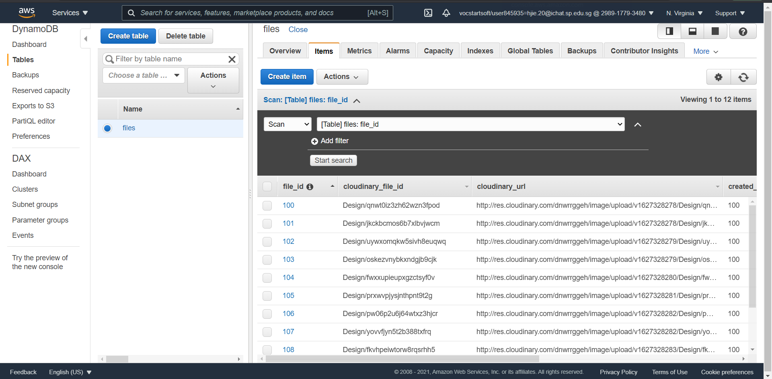

**Create Lambda function**

* Search for lambda at the search bar

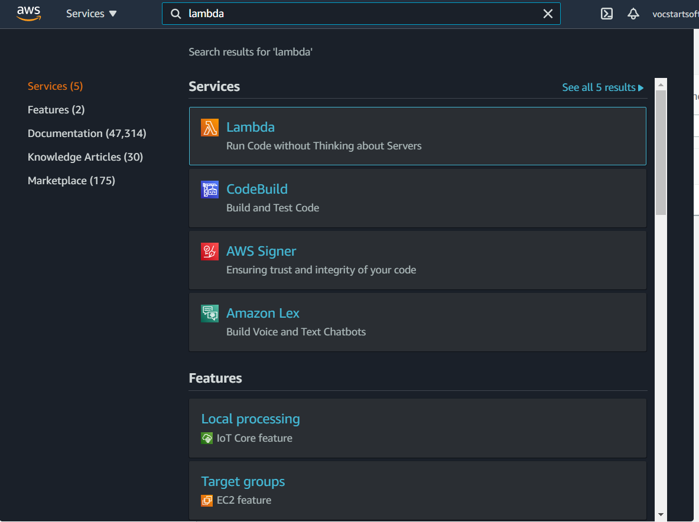

* Click on Create function

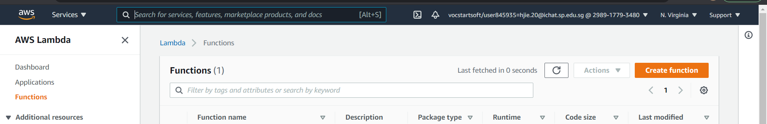

* At Function name: input ‘esde_beedesign_getDesignById’
* At Runtime: choose Nodejs 14.x

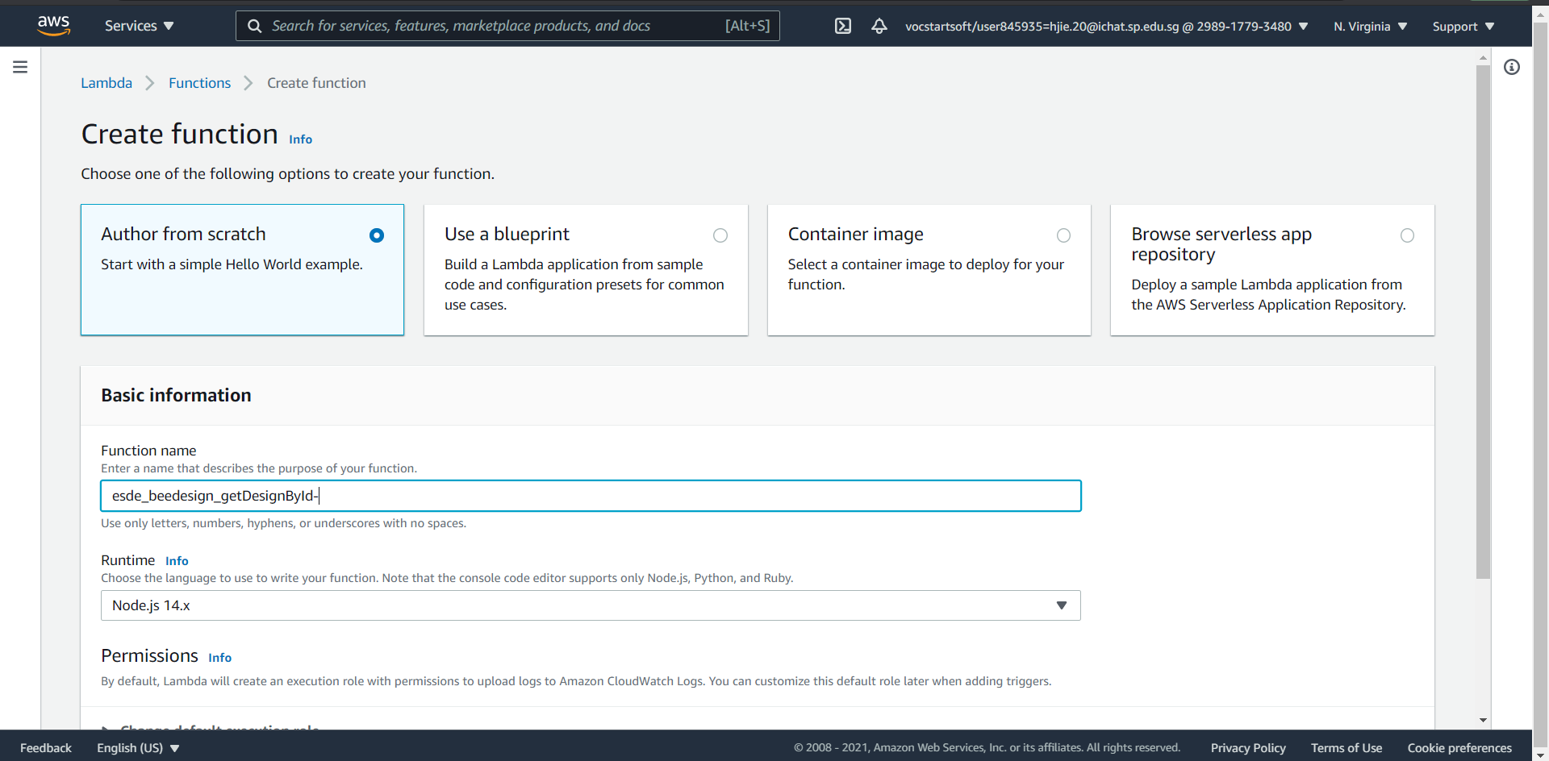

* Click on Create function

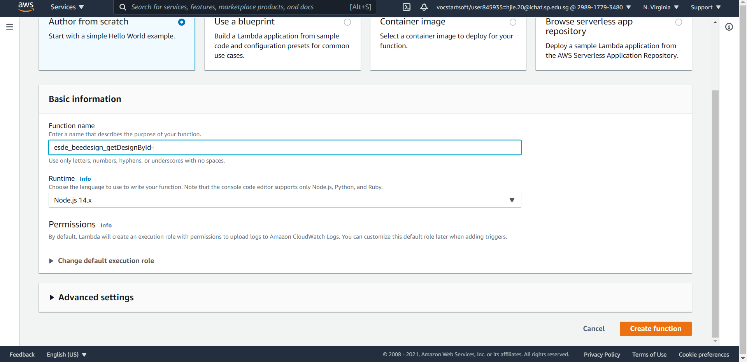

* Lambda successfully created will show as below

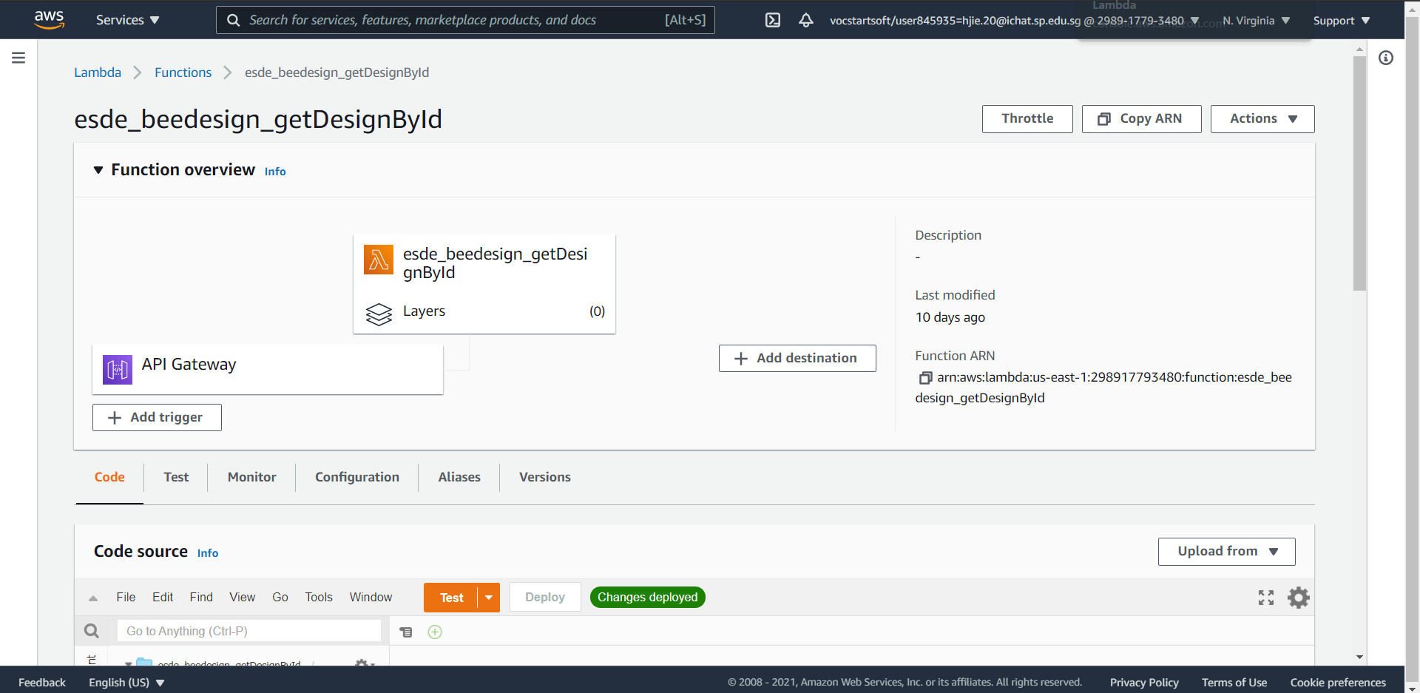

* Create a folder name as dynamodb
* Create a js file name as query_dynamodb.js

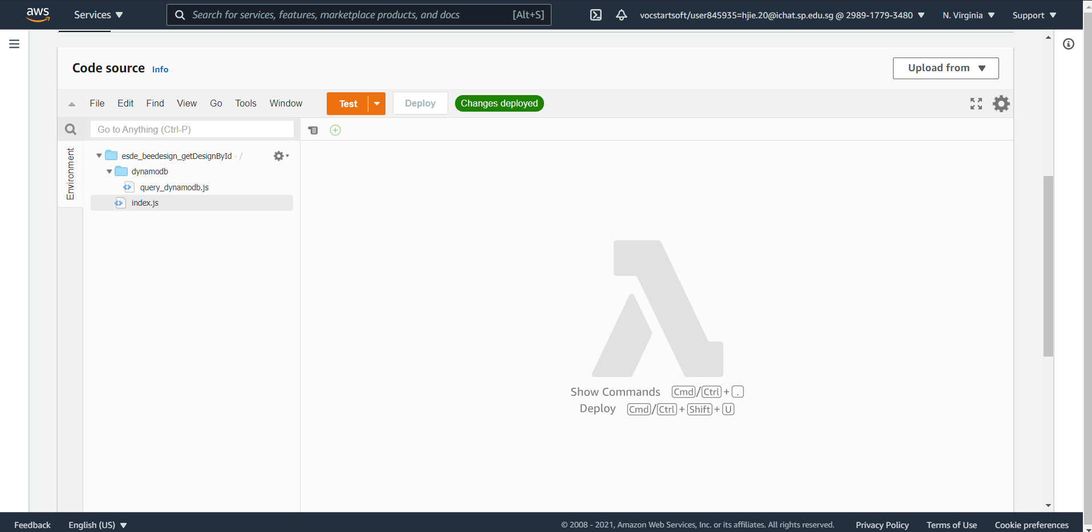

* Replace the codes in index.js and click on Deploy

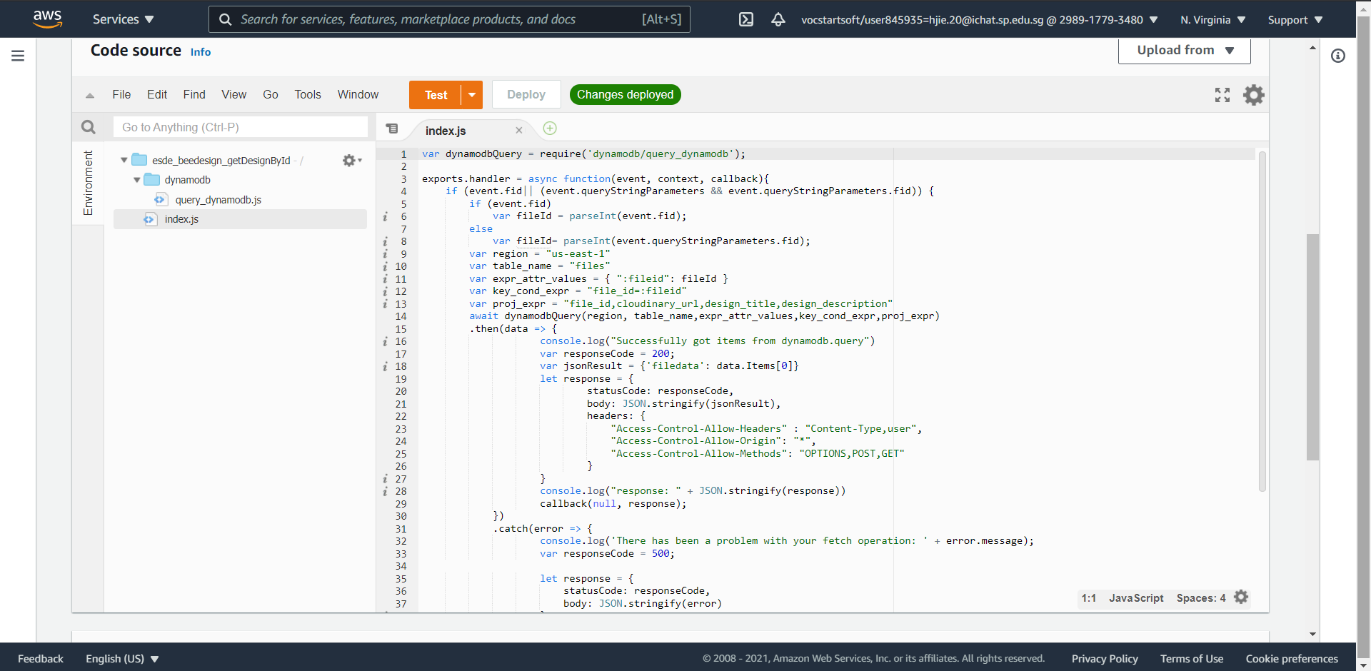

* Click on Configuration

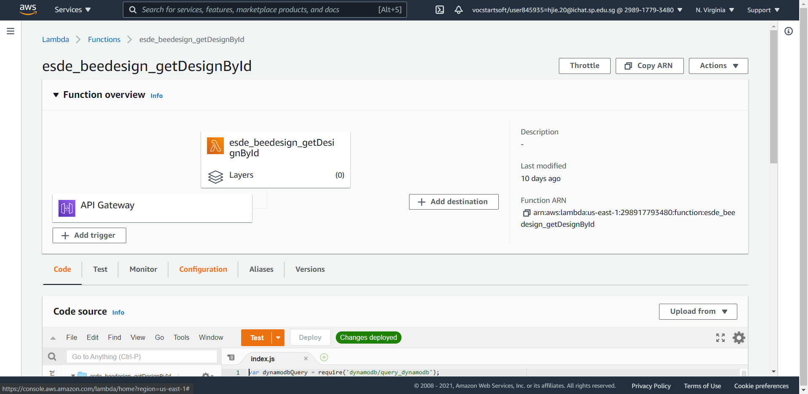

* Click on the link below the Role name

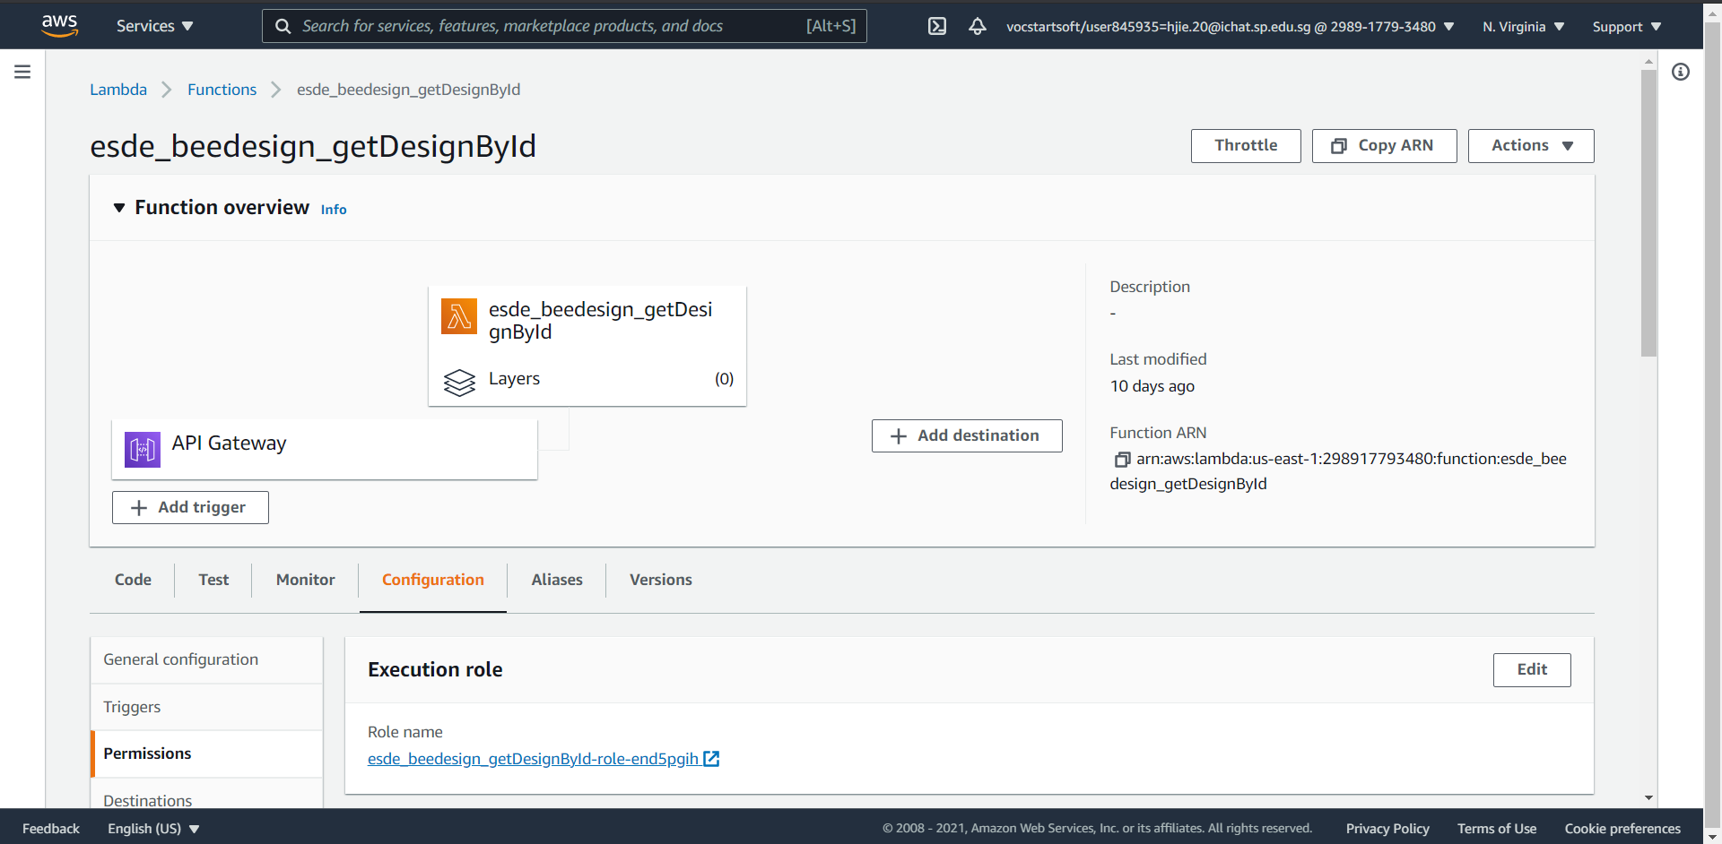

* Copy the Role ARN

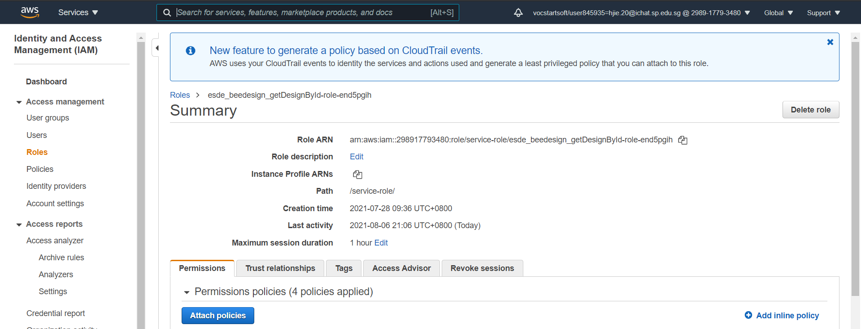

* Click on Attach policies
* Give permission by choosing the policies shown as below

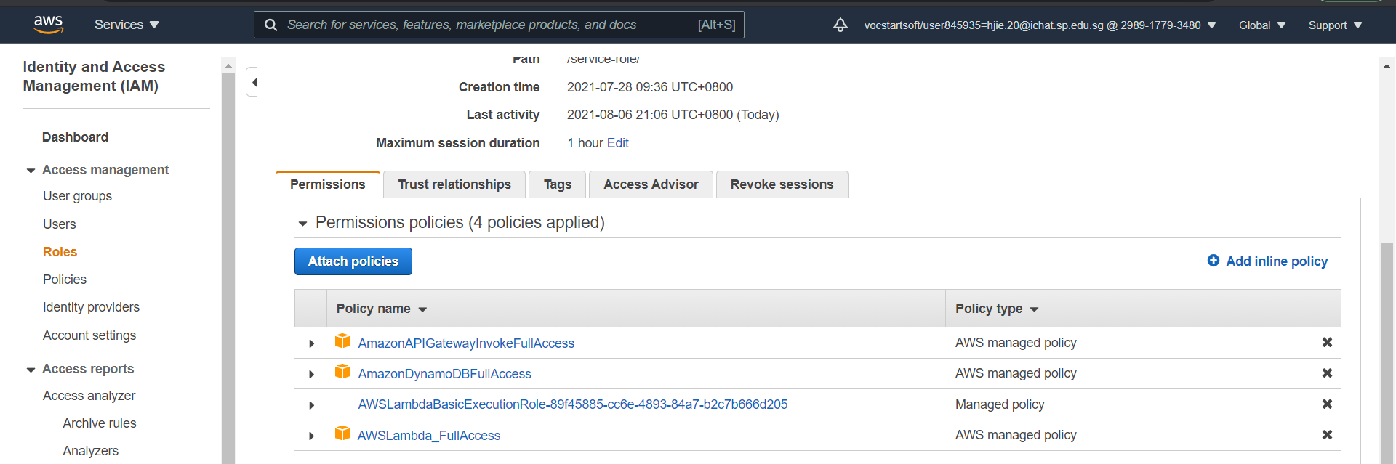

* Click on Trust relationships

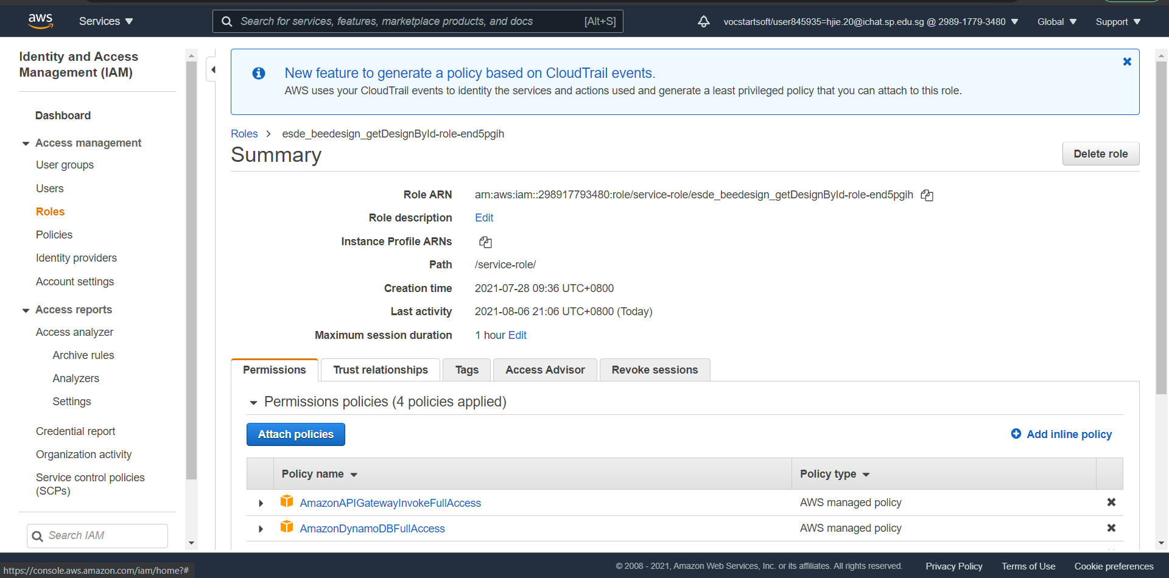

* Add the three services shown as below and click on Update Trust Policy

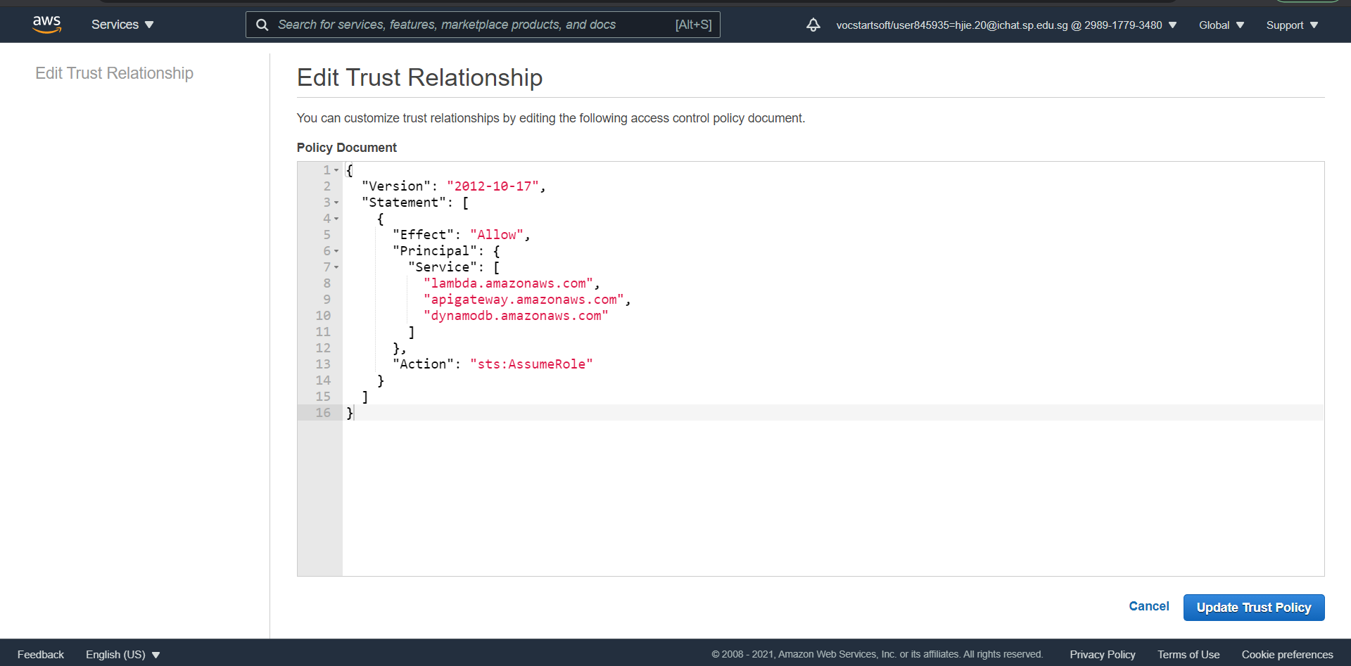

* Add the code in query_dynamodb.js and click on Deploy

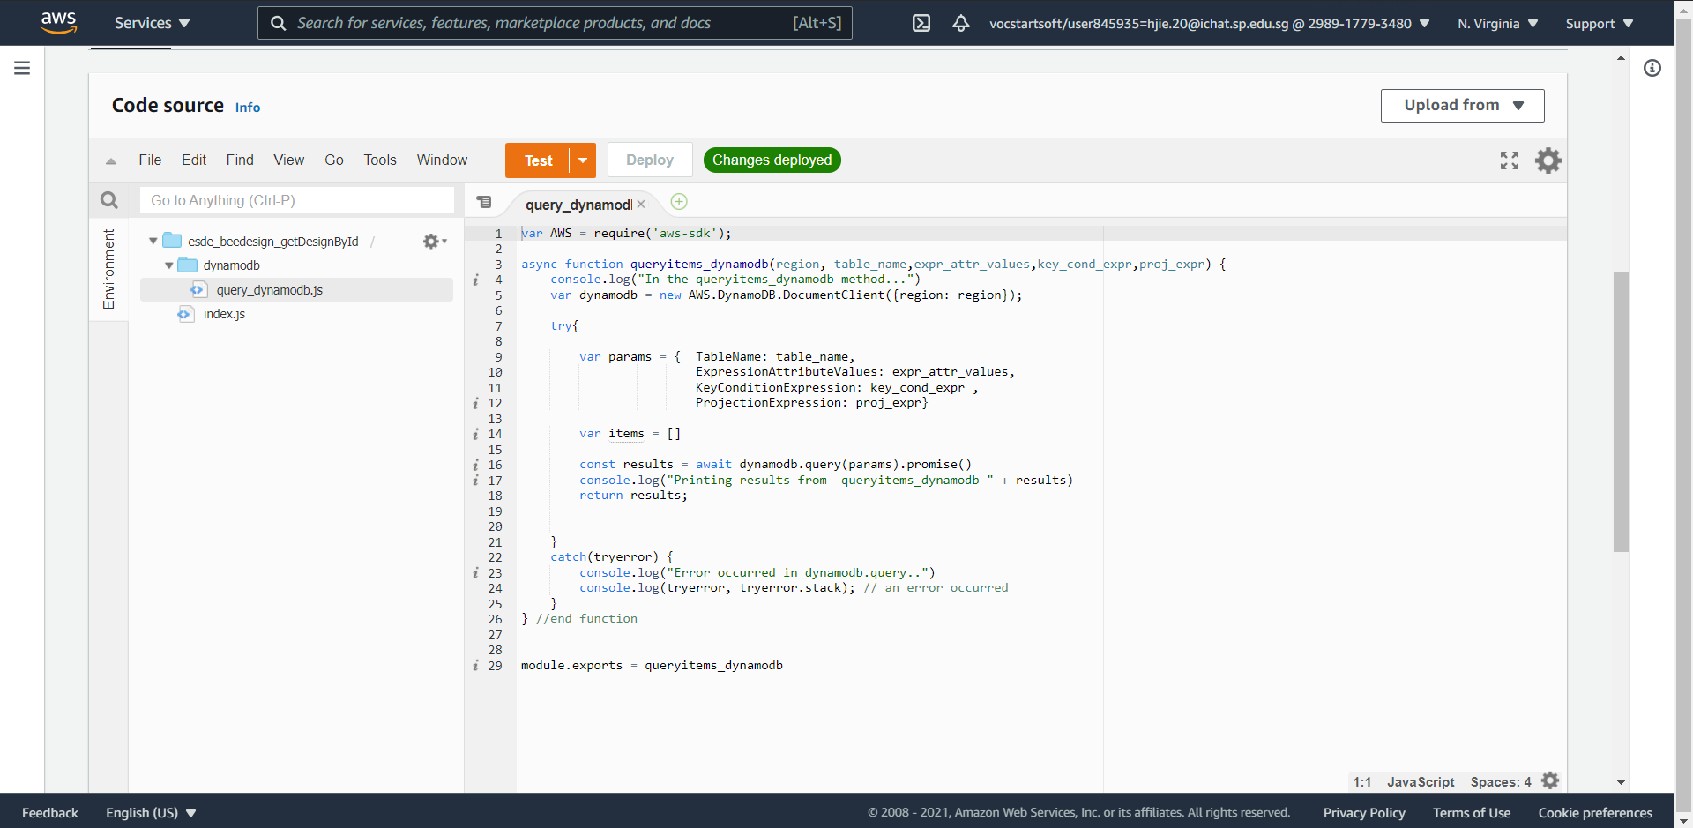

* Click on test and click on Configure test event

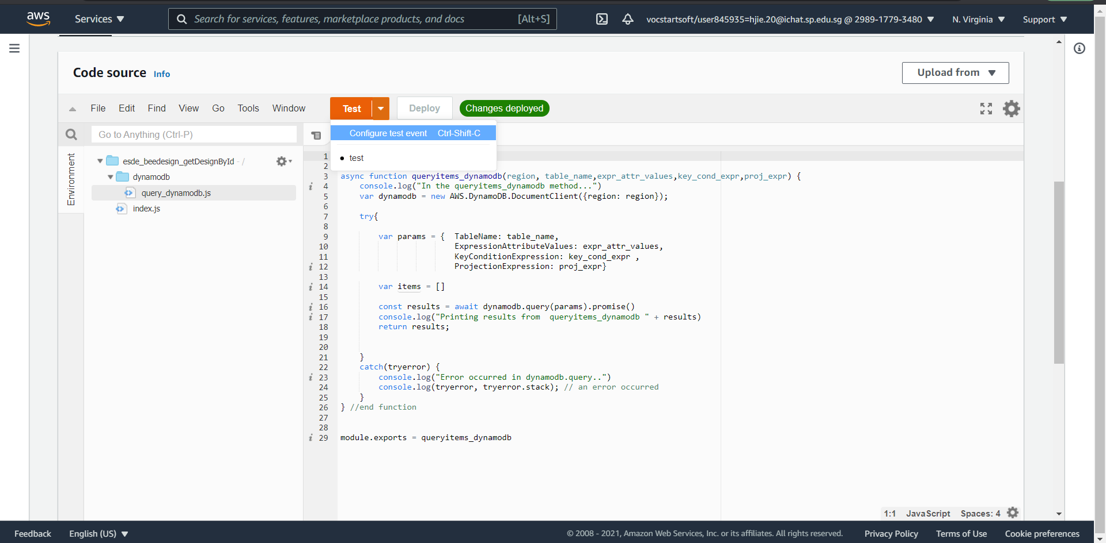

* Select Create new test event
* At the Event name: input ‘test’
* Insert the code { “fid”: “100” }

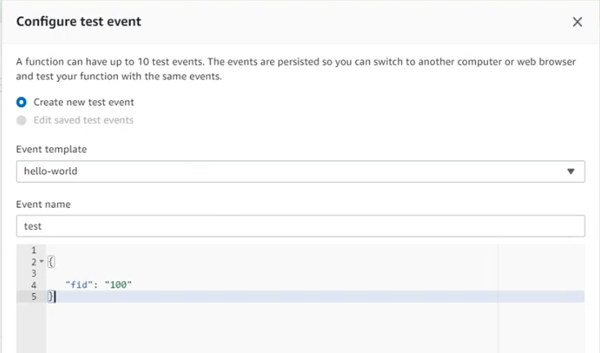

* Click on Create button

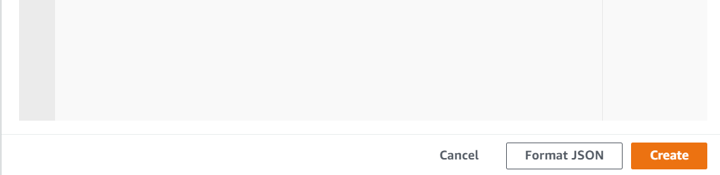

* Click on the Test button

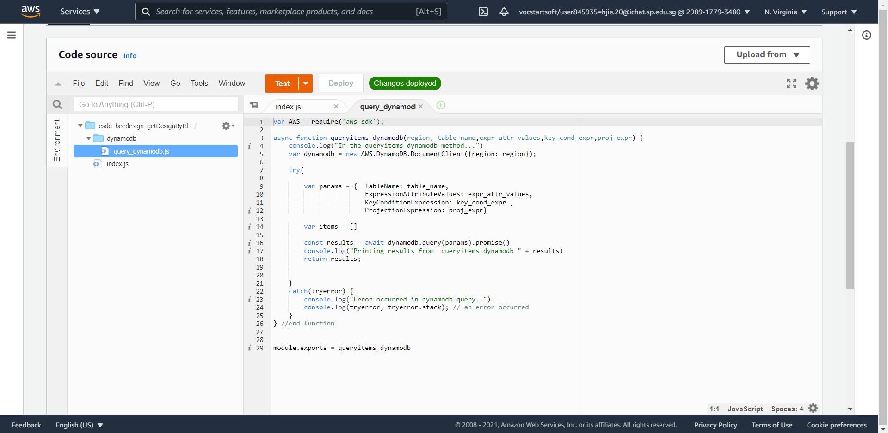

* The result will show as below

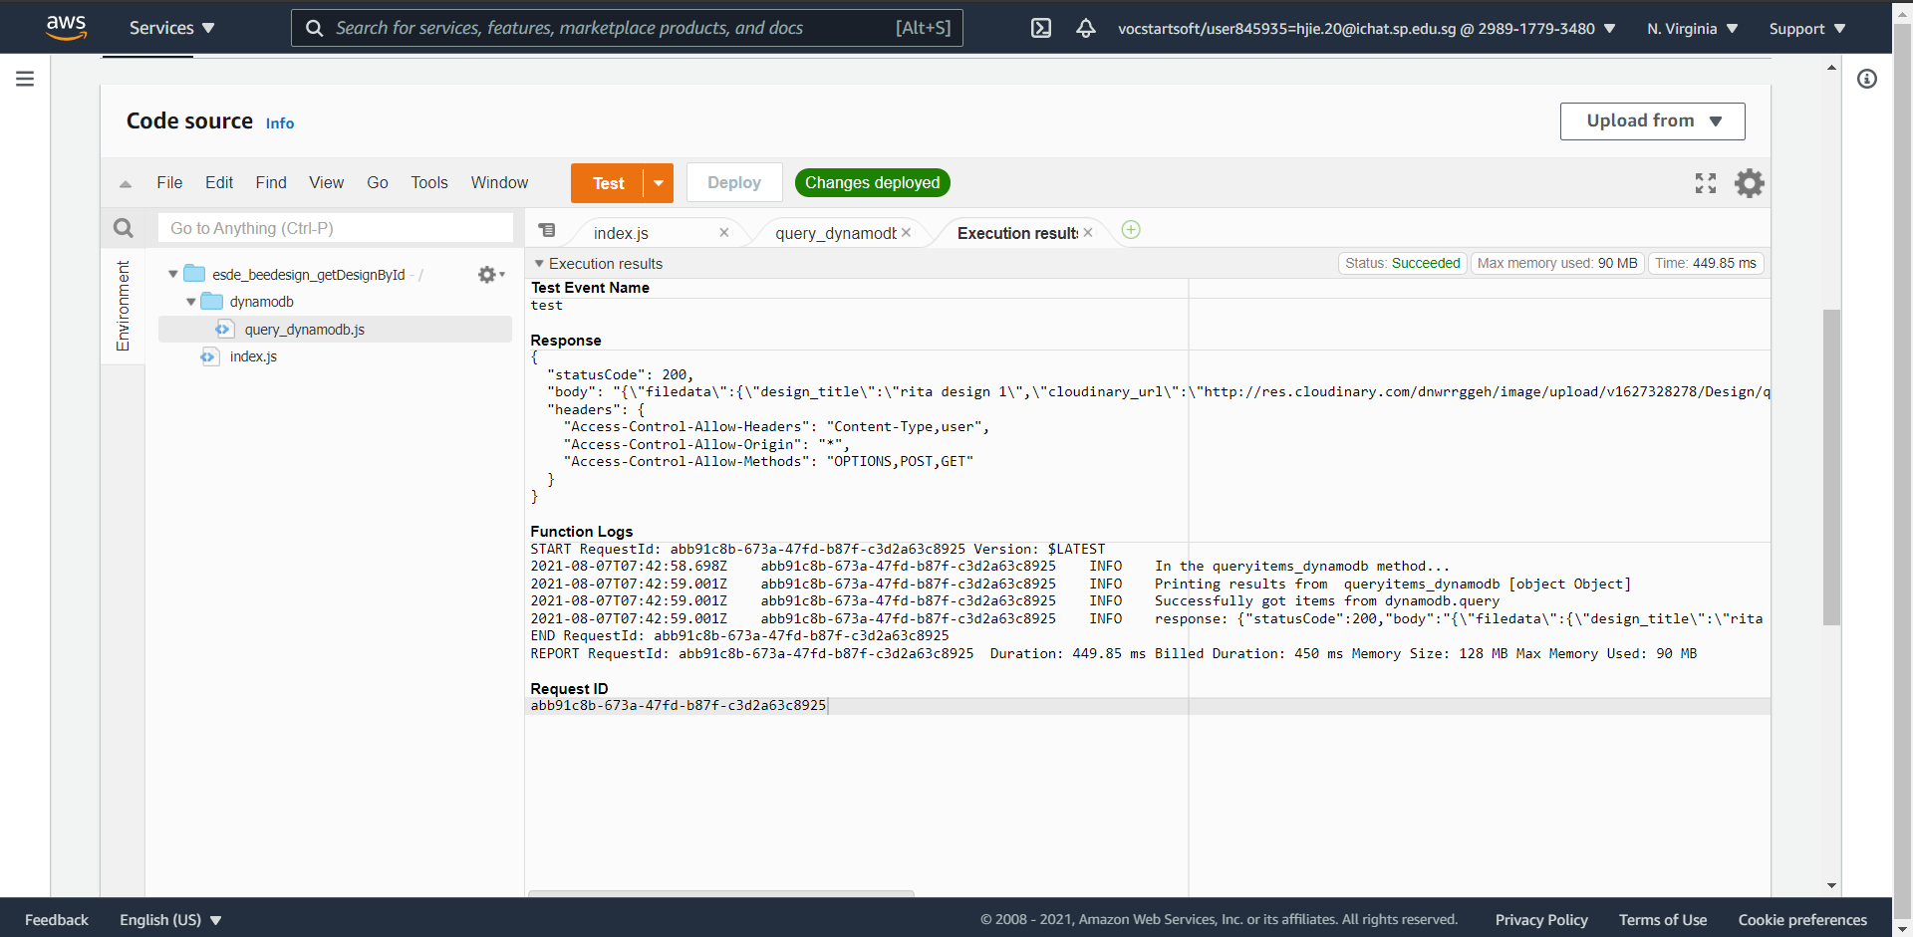

**Create API Gateway**

* Search for API Gateway at the search bar

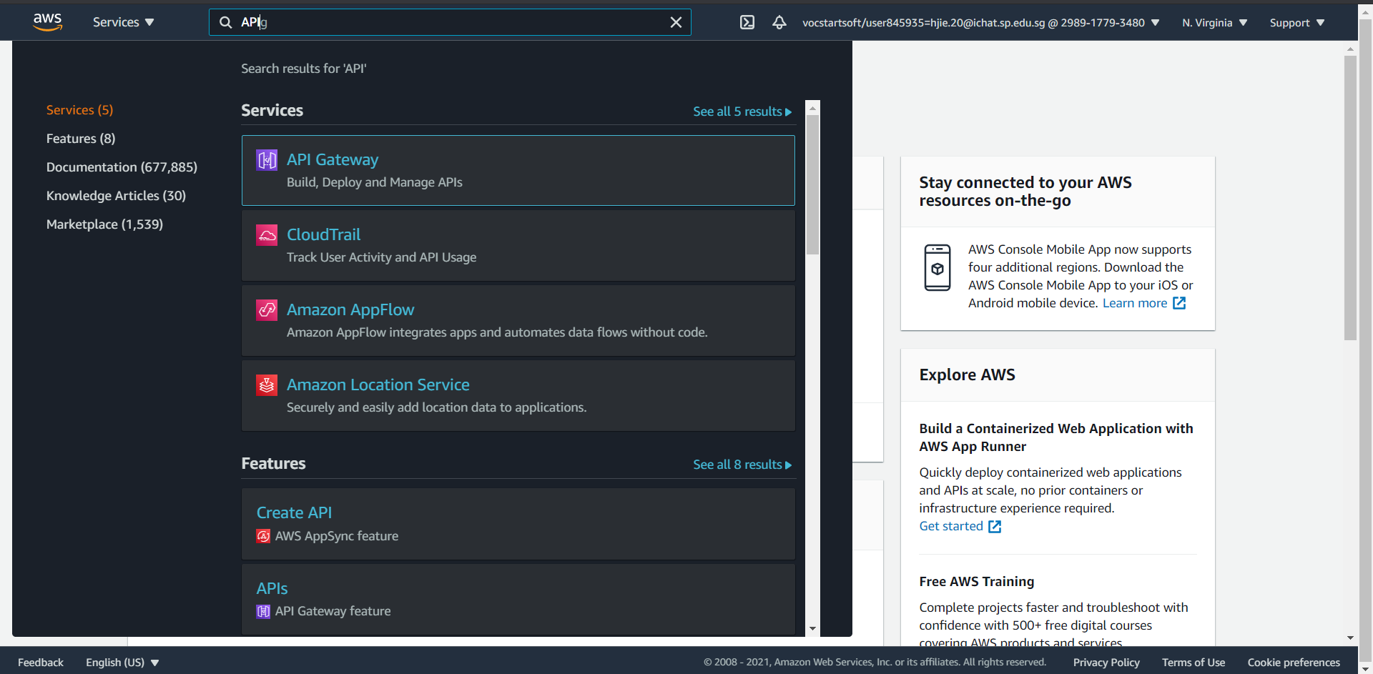

* Choose the REST API and click on Build

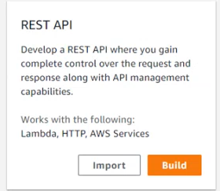

* Click on OK

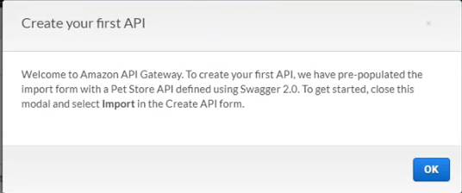

* Choose the REST
* Choose the New API
* At API name: input ‘esde_beedesign_api’
* Click on Create API

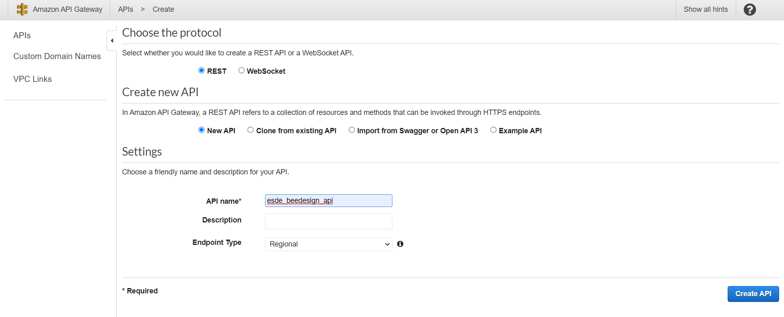

* Click on Actions and Create Method

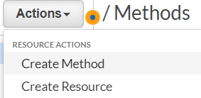

* Select the GET method

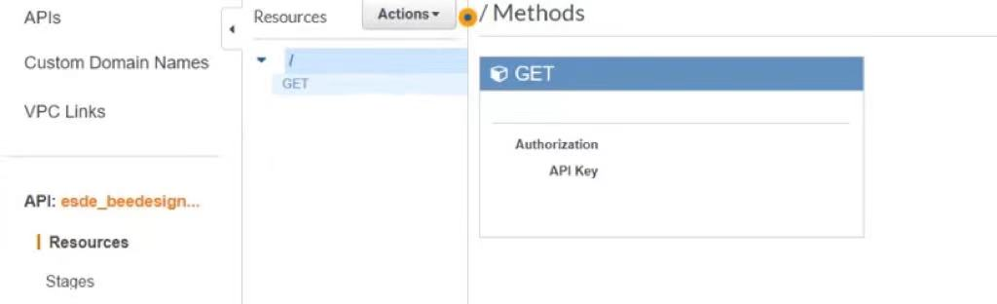

* Choose the Lambda Function
* Check the box Use Lambda Proxy integration
* At Lambda Region: select us-east-1
* At Lambda Function: input esde_beedesign_getDesignById
* Click Save

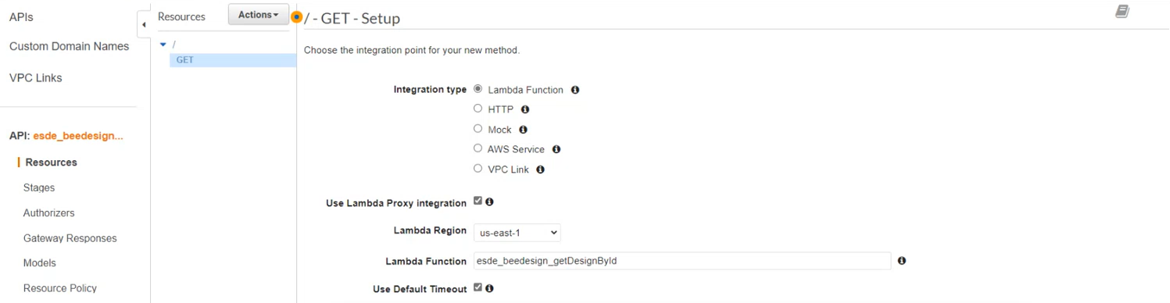

* Click on Integration Request

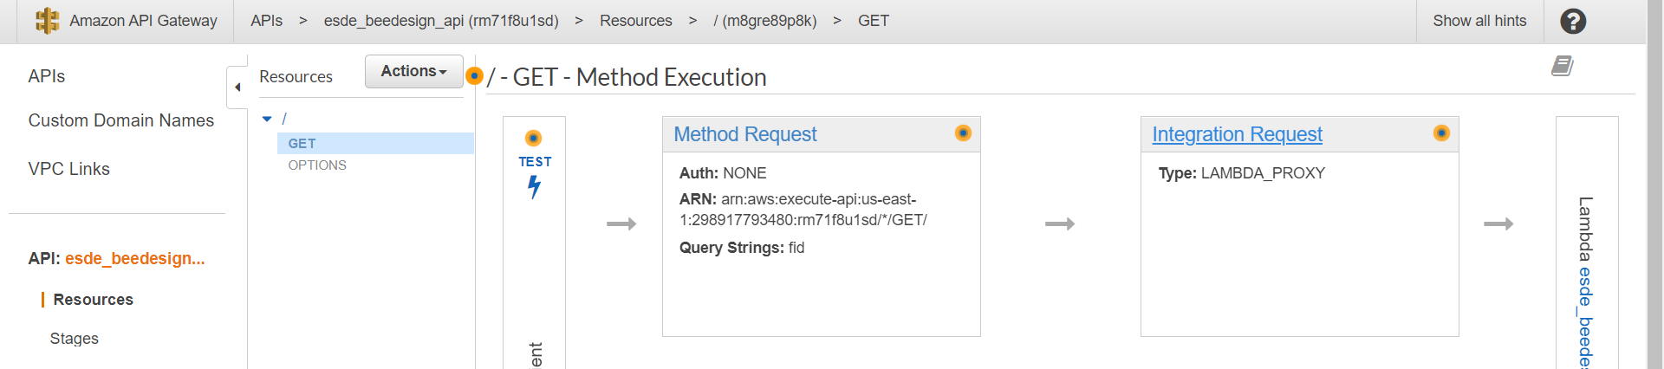

* Edit the Execution role by clicking the pencil icon

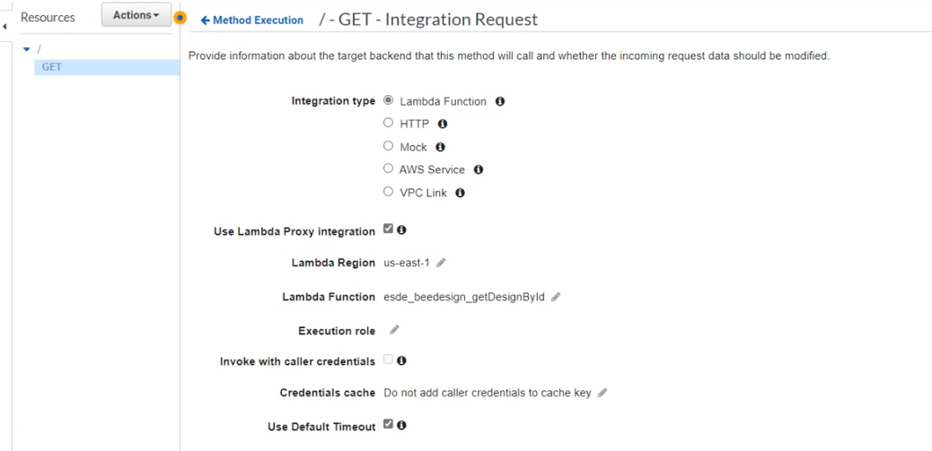

* Copy the Role ARN from IAM

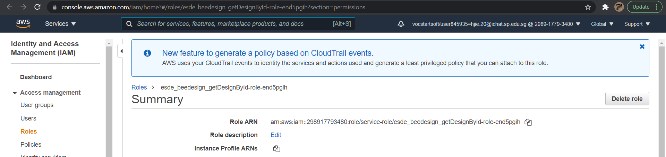

* Paste the Execution role

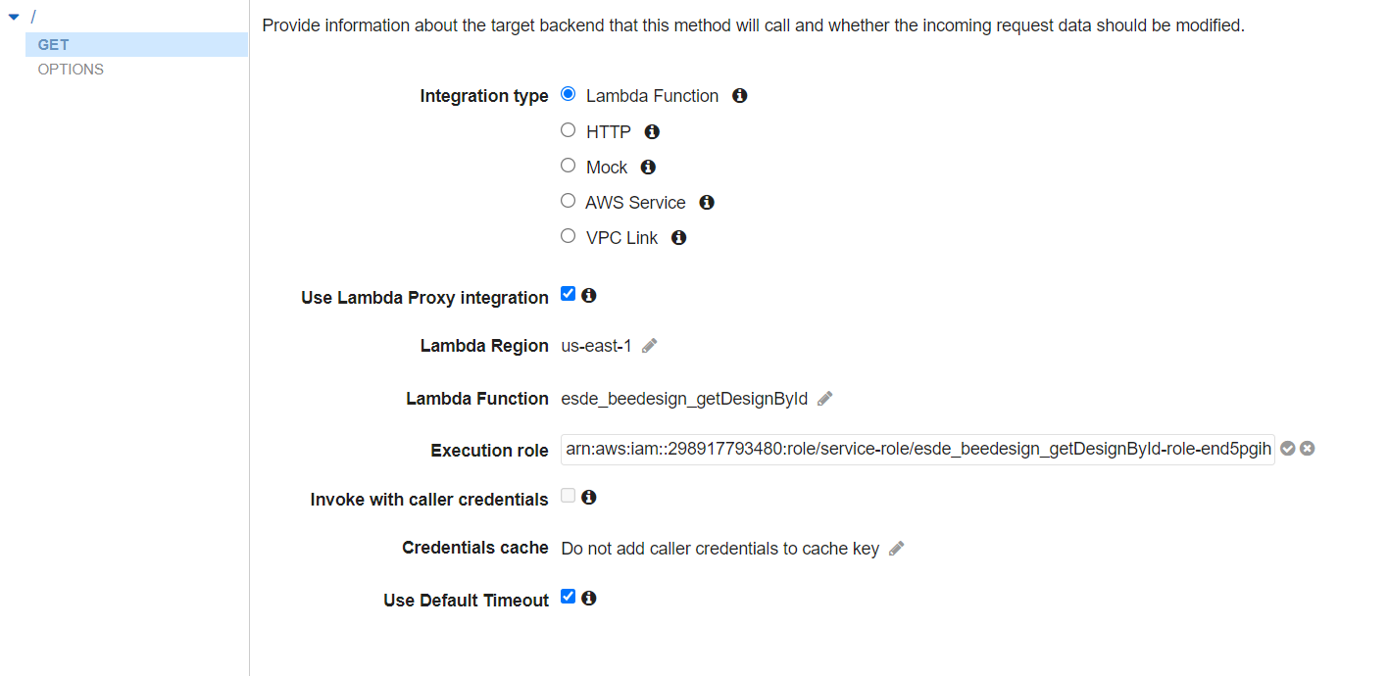

* Click the tick icon

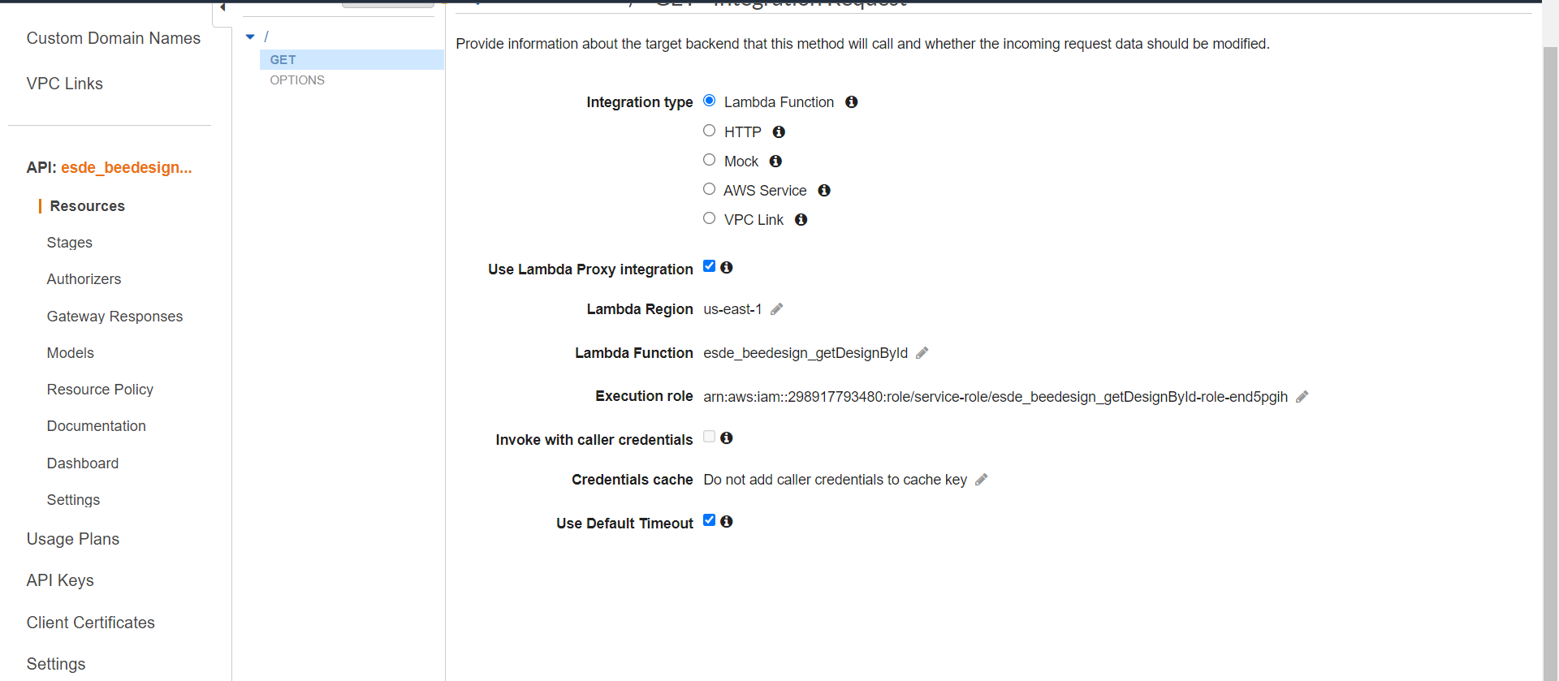

* Click on Actions
* Click on Enable CORS

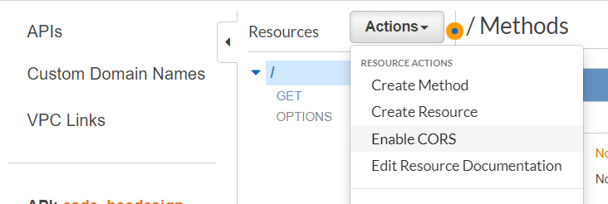

* Check the DEFAULT 4XX and DEFAULT 5XX box
* At Access-Control-Allow-Headers: add ‘user’
* Click on the Enable CORS and replace existing CORS headers

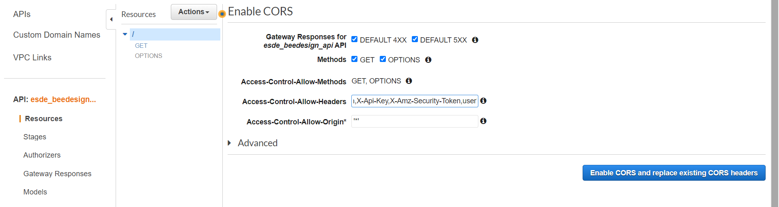

* Click on Actions
* Click on Deploy API

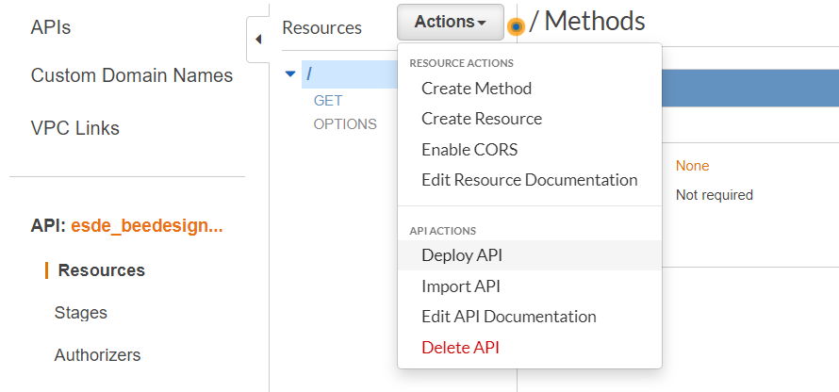

* At Deployment stage: choose New Stage
* At Stage name: input test
* Click on Deploy

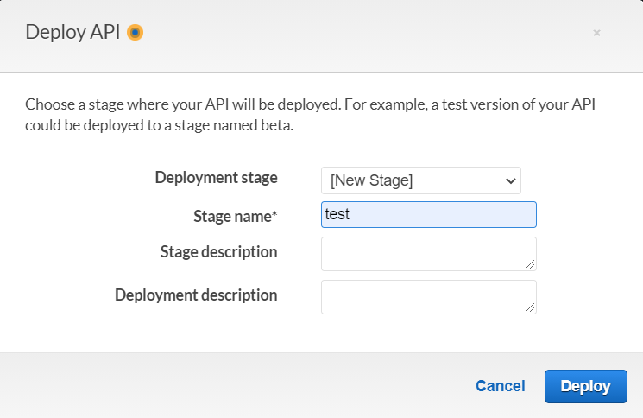

* It will show the test stage editor
* Copy the invoke URL

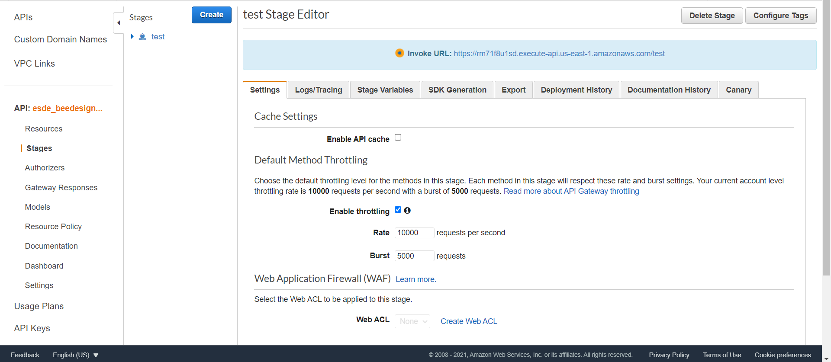

**Testing API (Optional)**

* Click on GET method

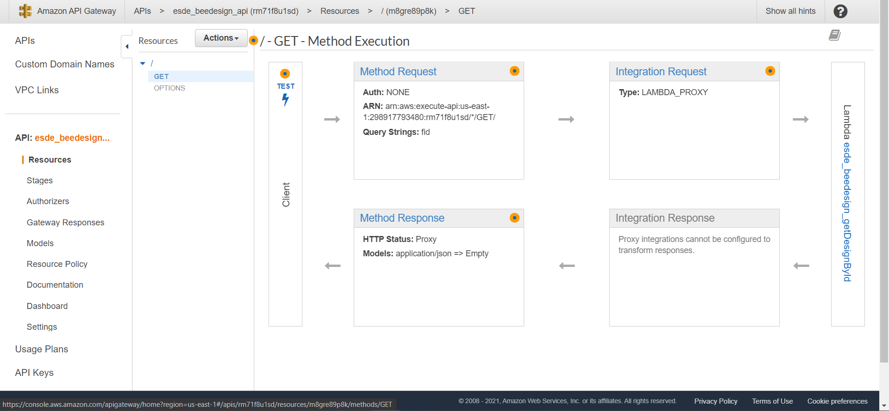

* Click on Method Request

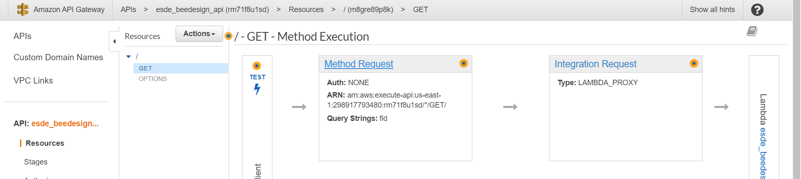

* Click on URL Query String Parameters

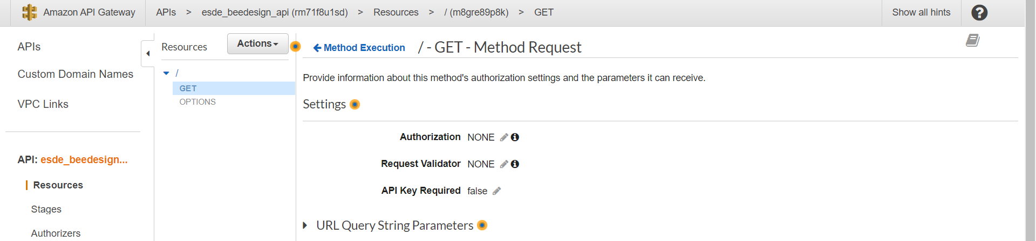

* Click on Add query string



* Add the Name: fid

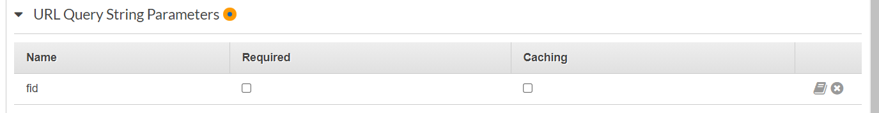

* Click the Method Execution



* Click on test icon

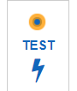

* Input the query Strings ‘fid=100’

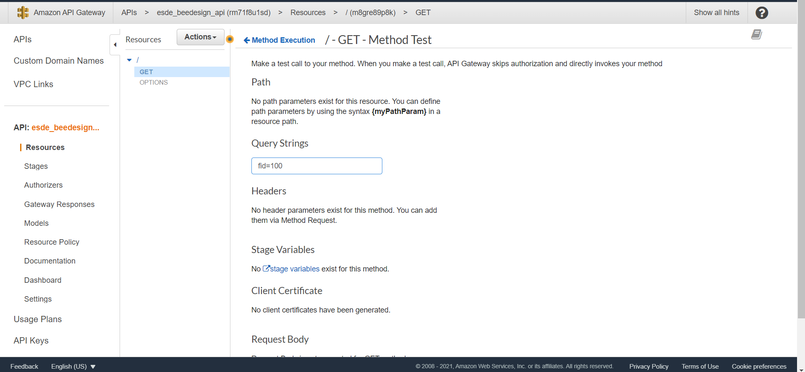

* Click on test



* It will show the result at the right side shown as below

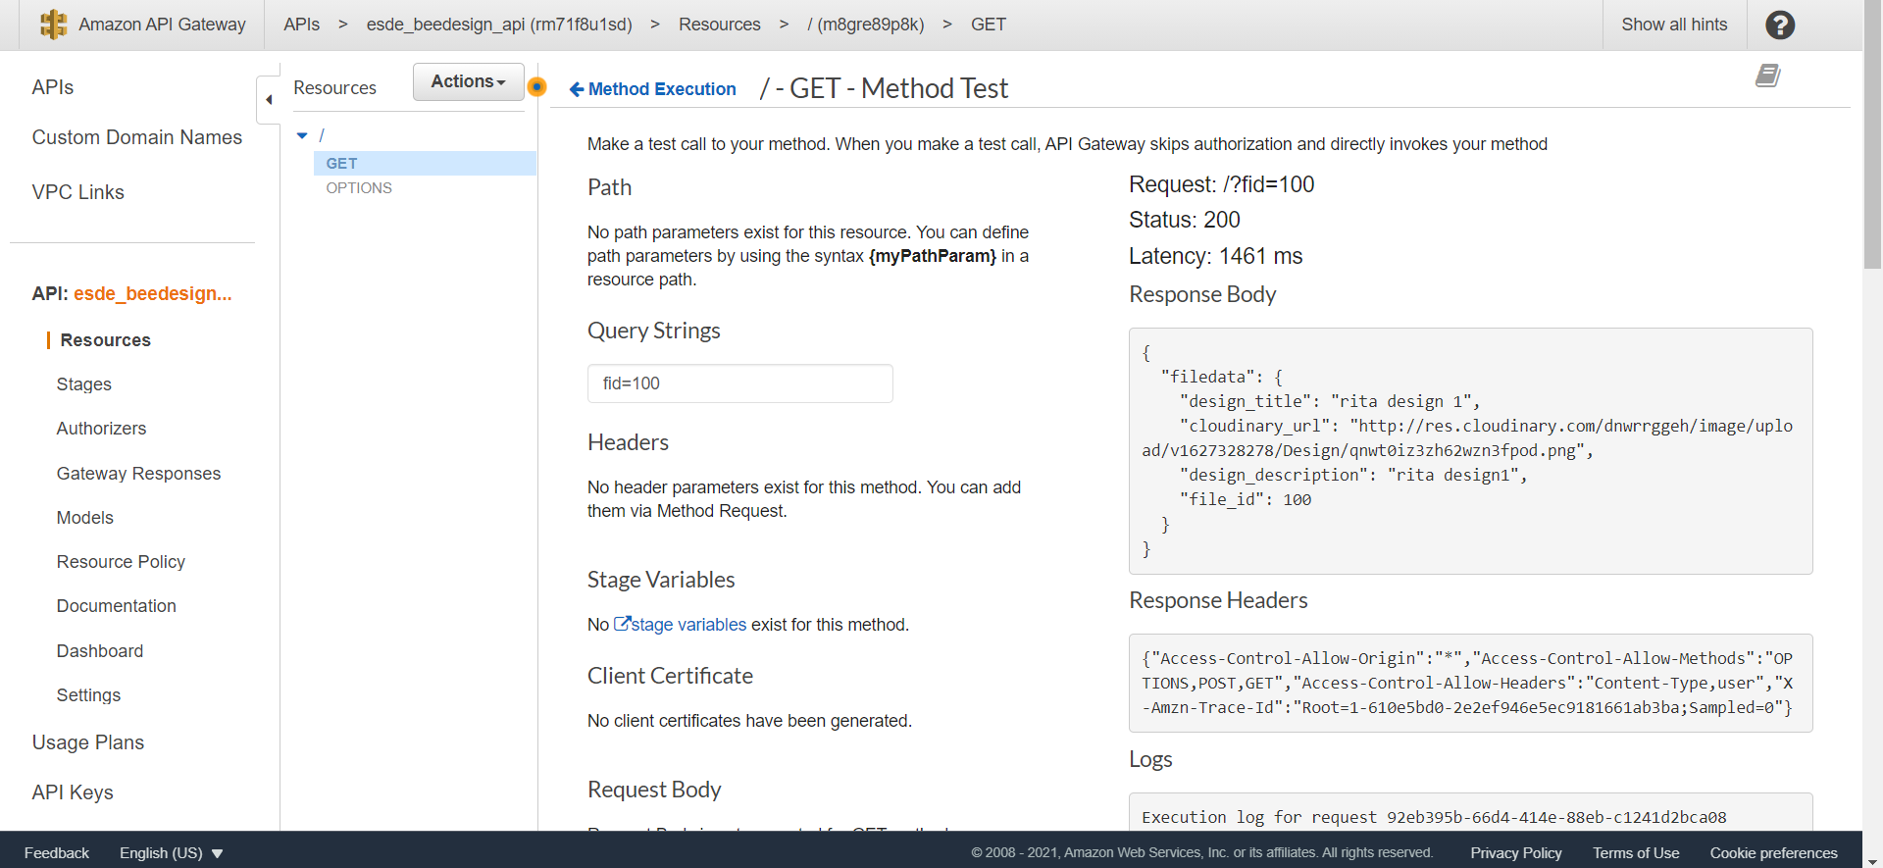

**Test retrieve data from web page**

* Click on stages

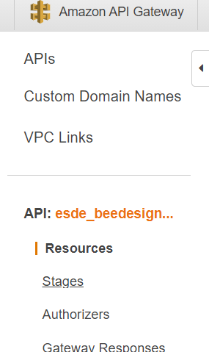

* Click on test

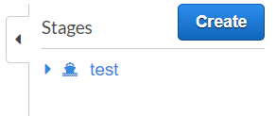

* Copy the Invoke URL link below



* In winSPC navigate ro update_design.js file at frontEnd

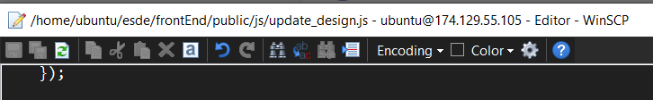

* Replace the url link from

‘url: baseUrl + '/api/user/design/' + fileId,’ to

‘url: 'https://rm71f8u1sd.execute-api.us-east-1.amazonaws.com/test?fid=' + fileId,’

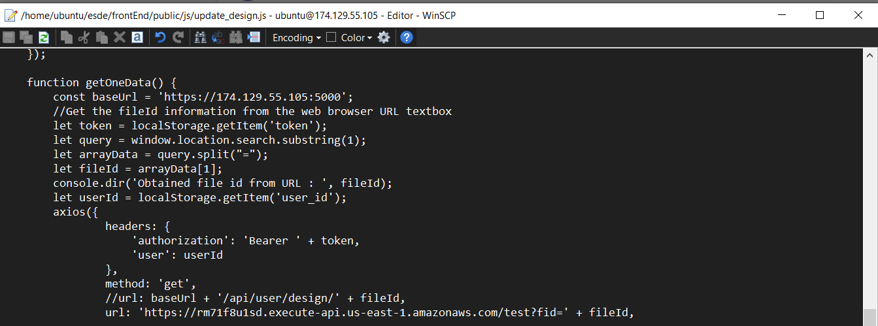

* Add the file id 102



* Retrieve the data from web page



**Try update from dynamodb**

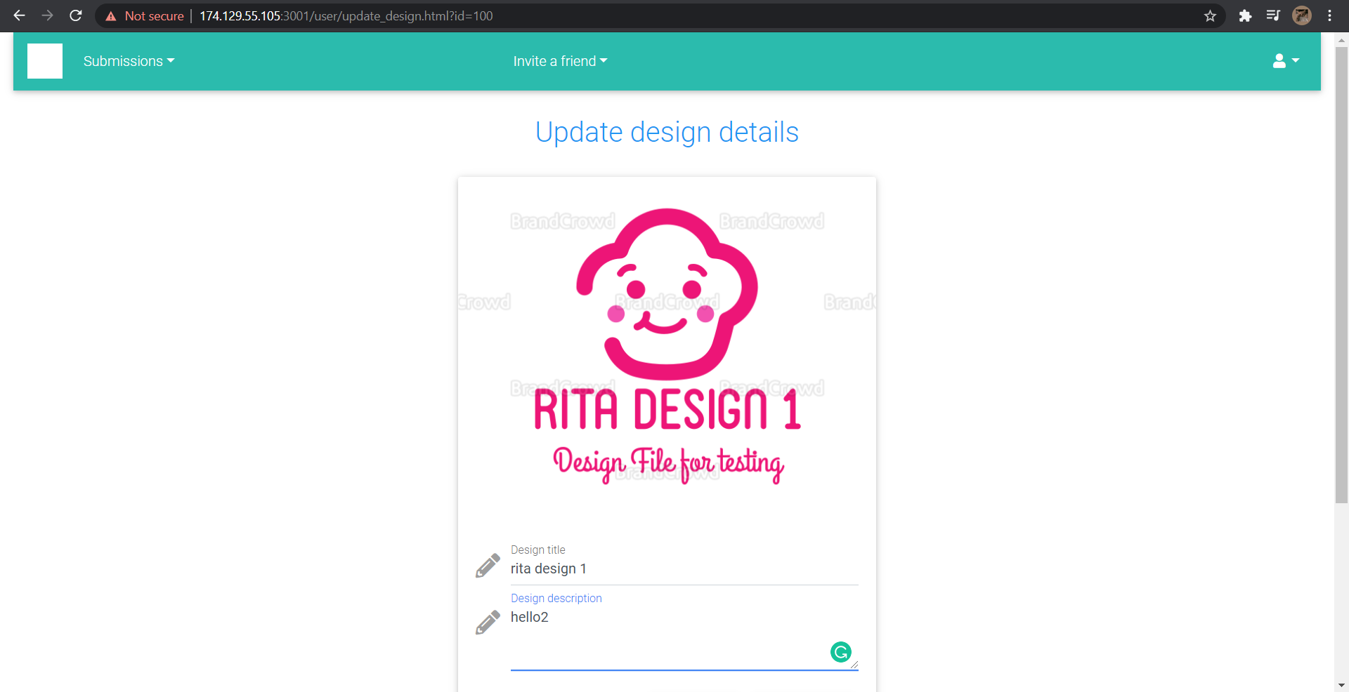

* Search for dynamodb at the search bar

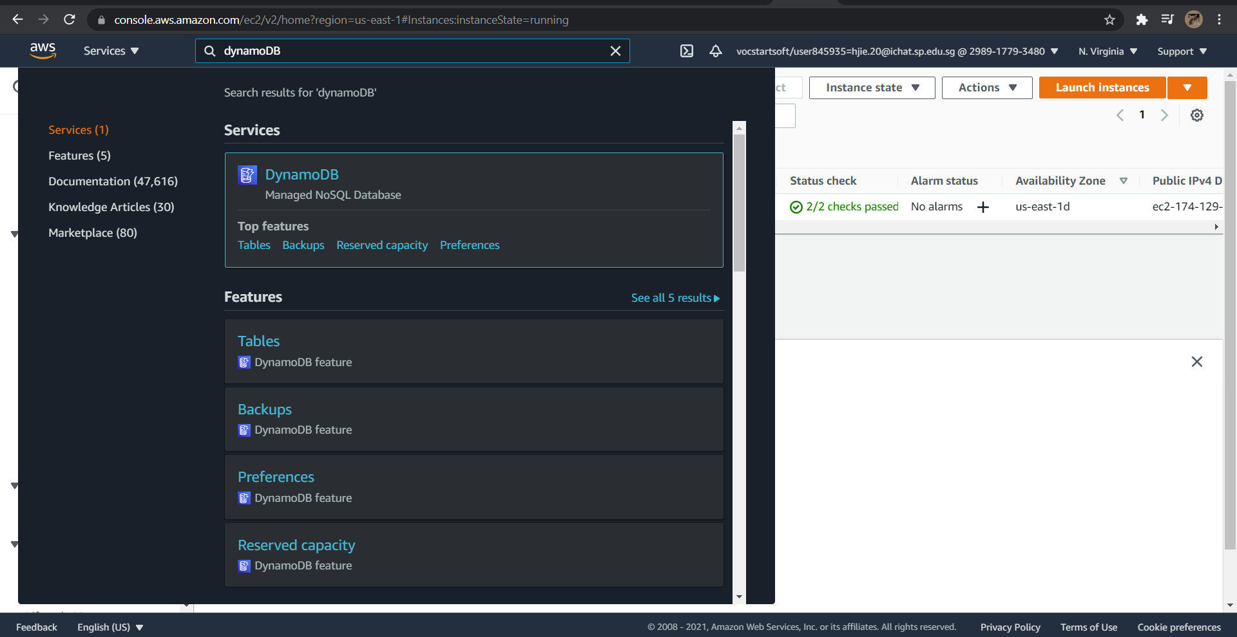

* Click on ‘Tables’

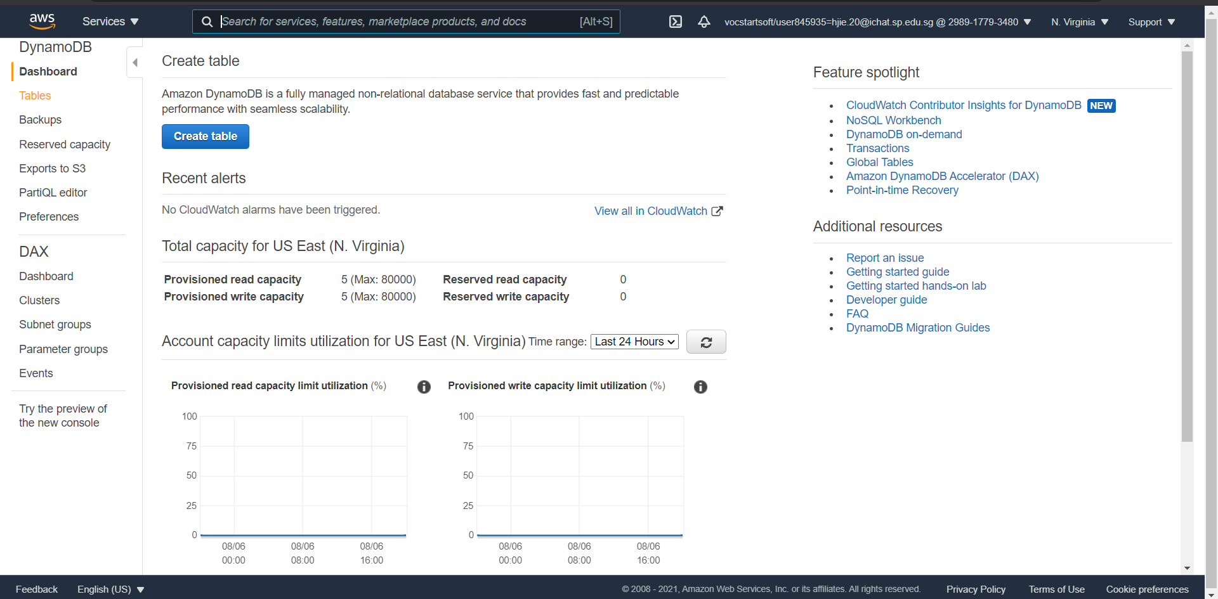

* Click on files

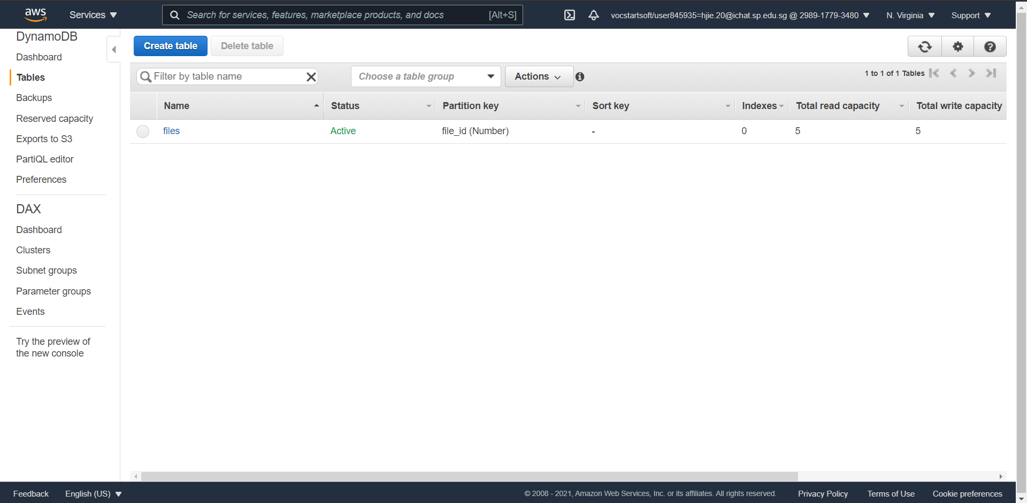

* Click on items tab

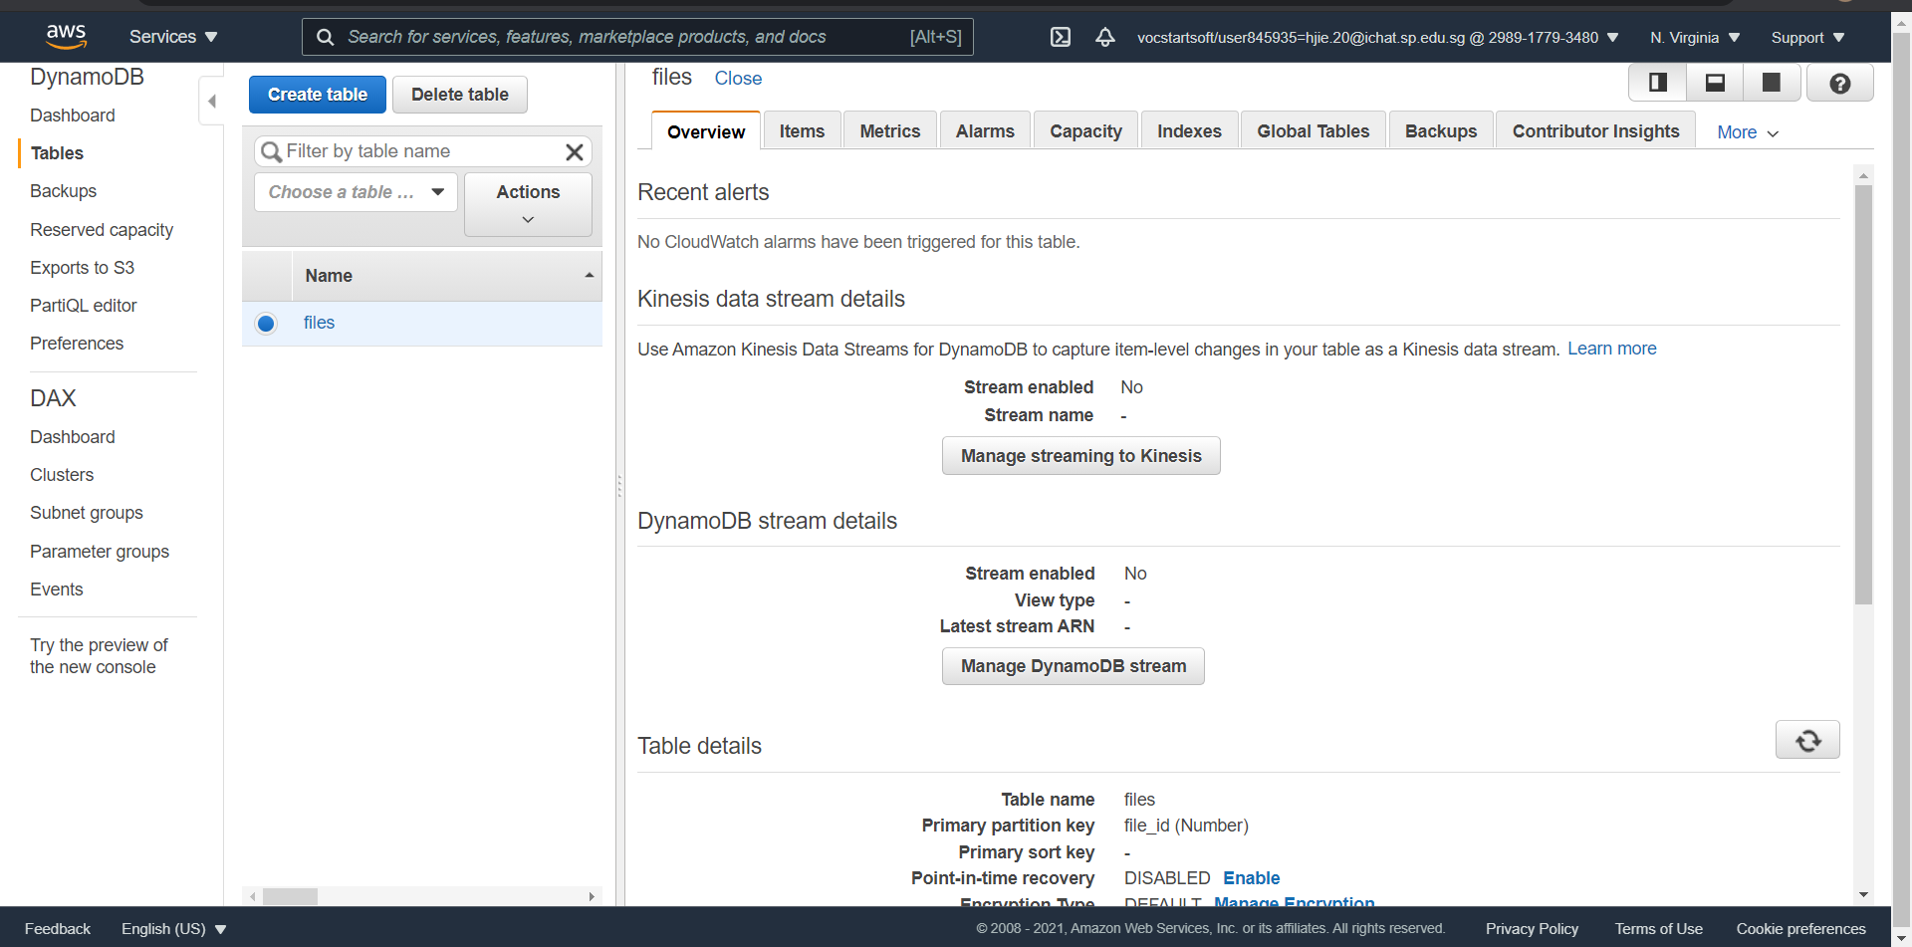

* Find the design_description column

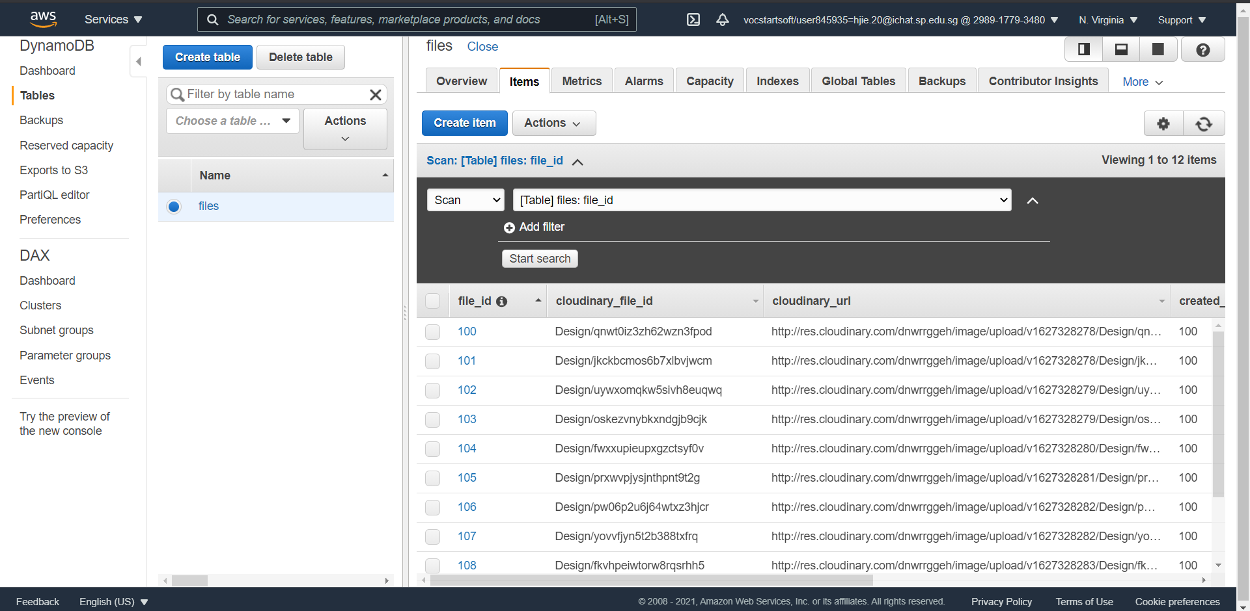

* Edit the ‘hello2’

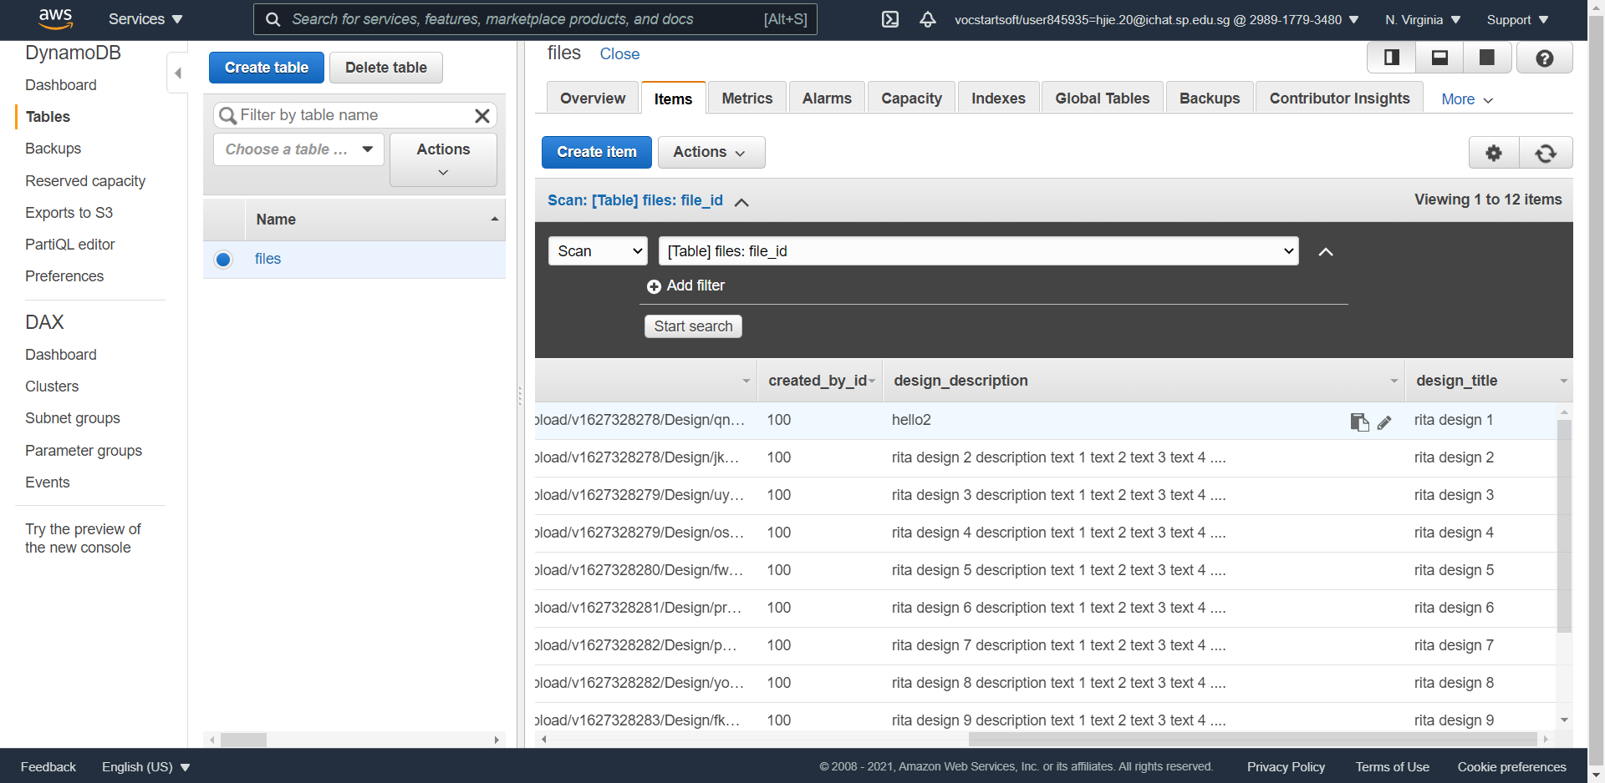

* Change to rita design1

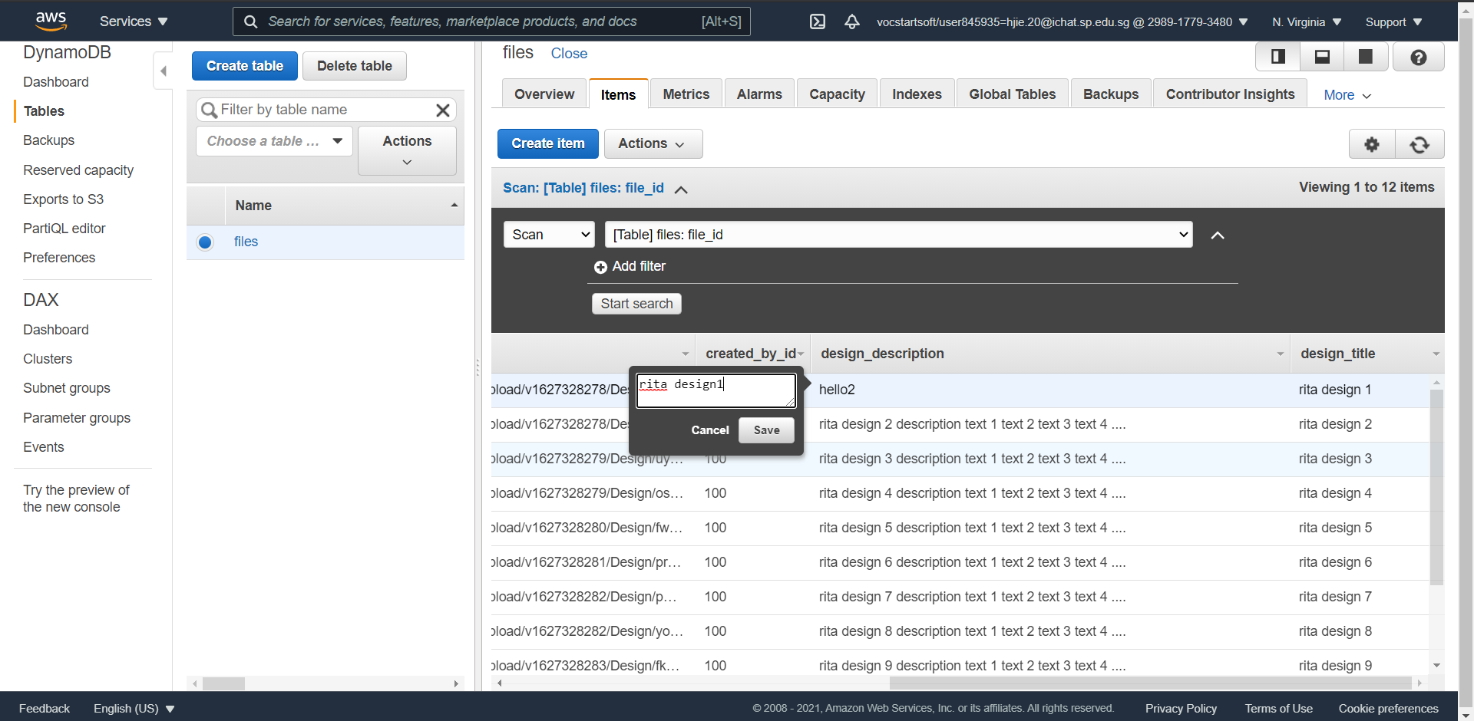

* Click on Save

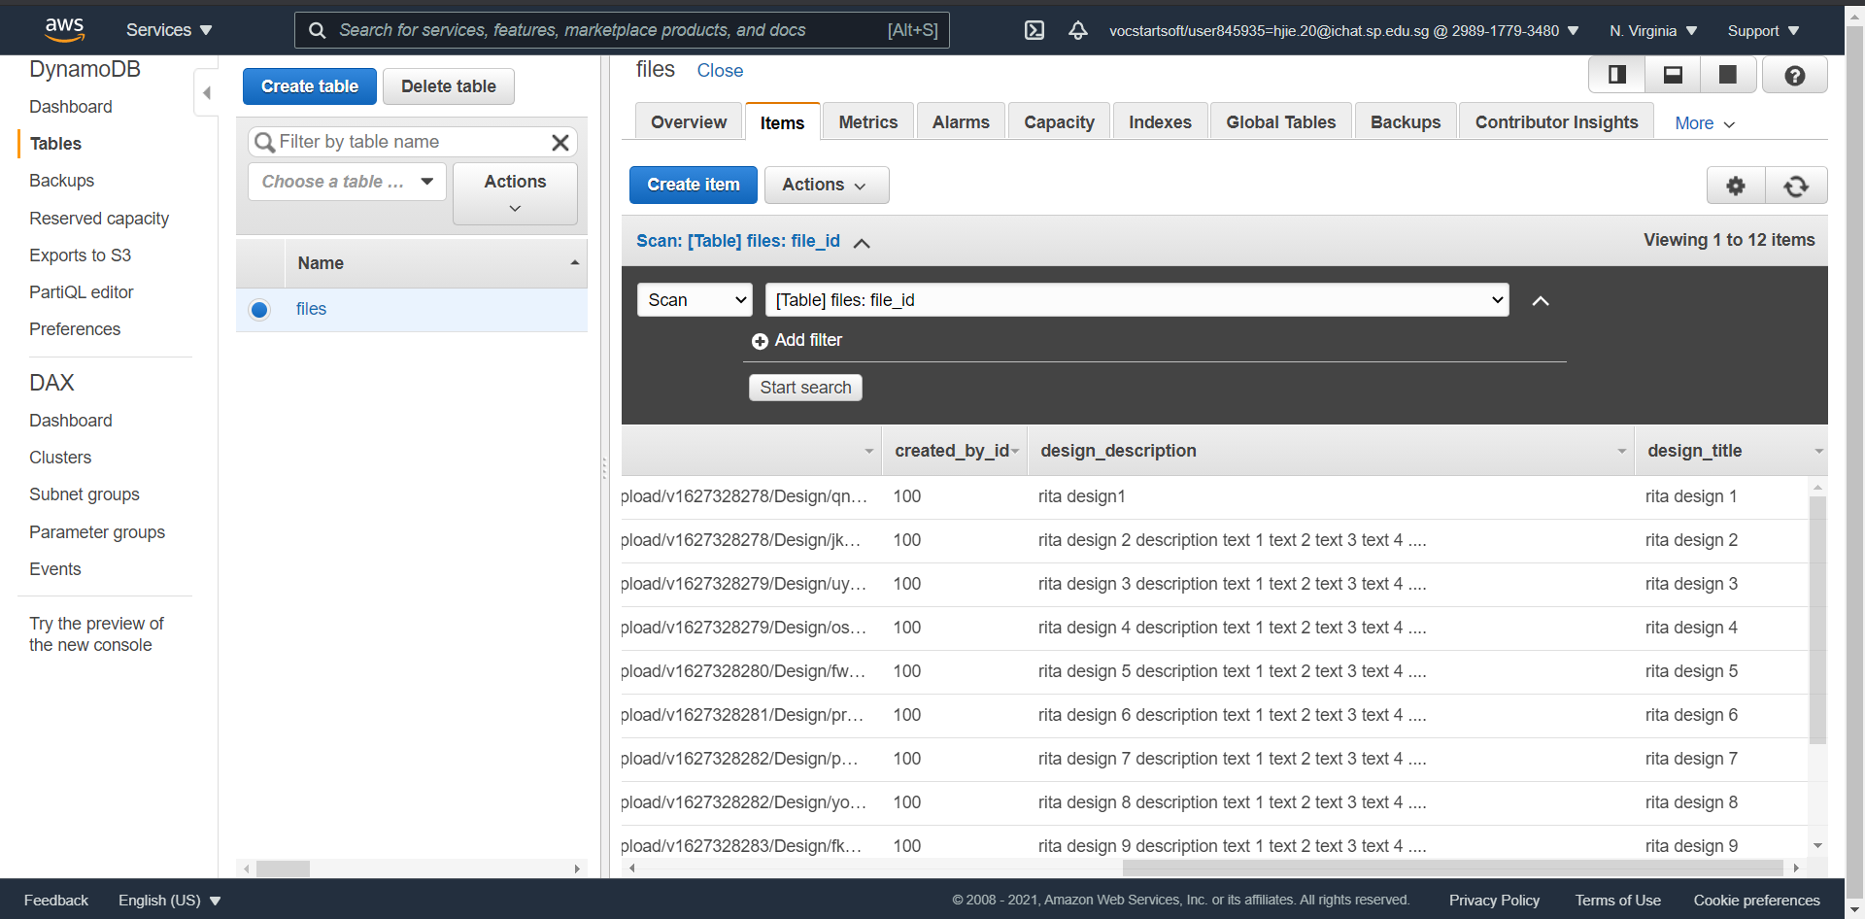

* Refresh the web page

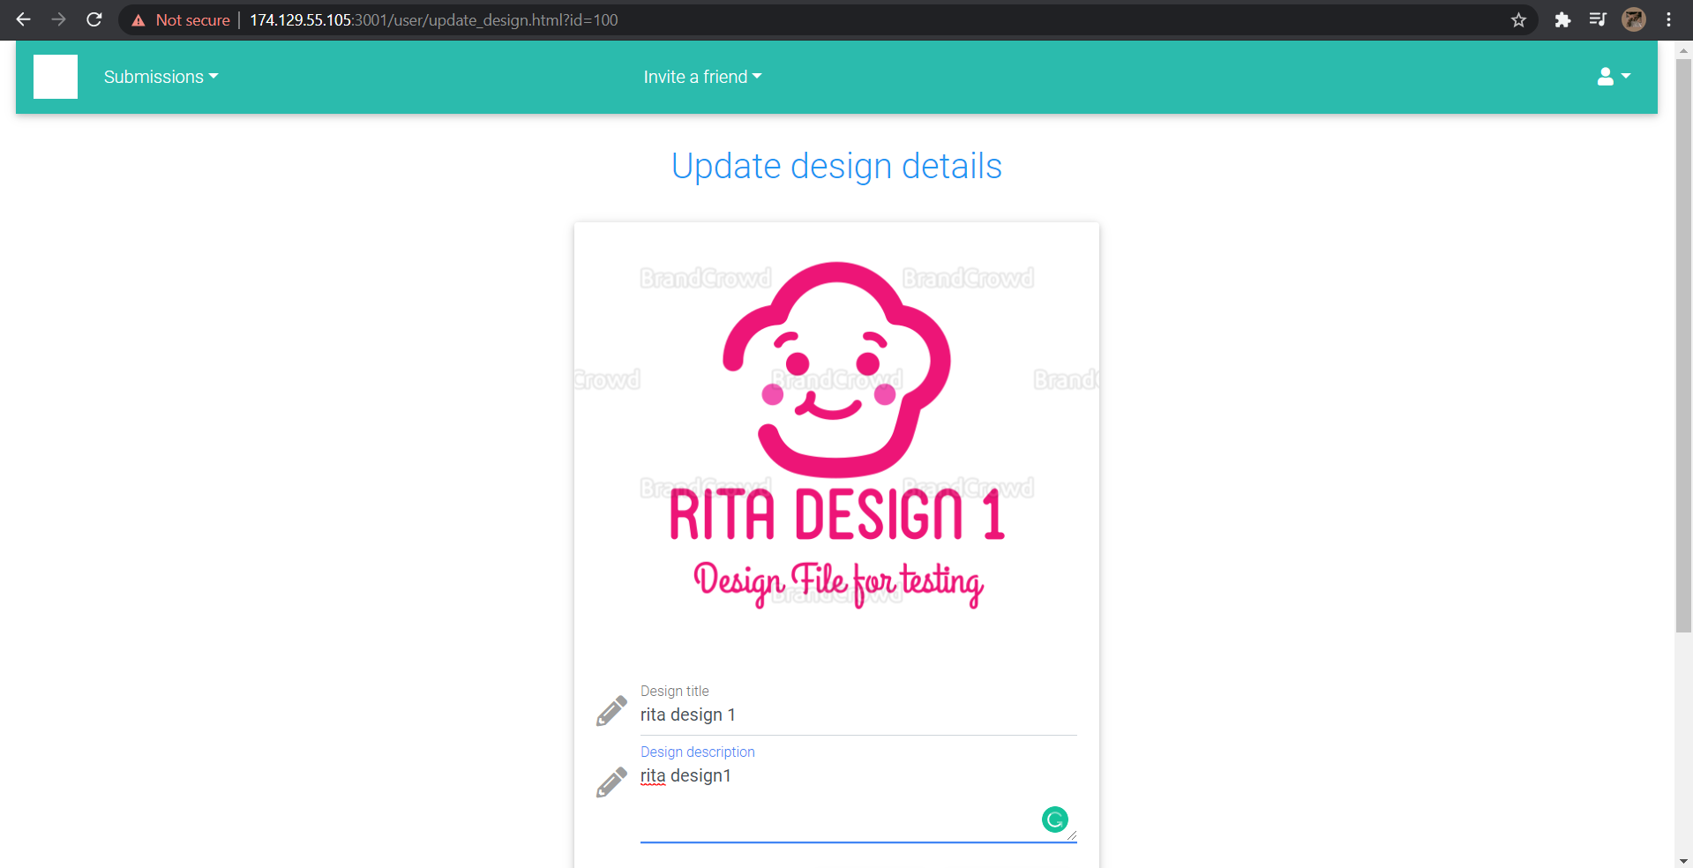

**Enable CloudWatch Logs for APIs in API Gateway**

* Search for API Gateway at the search bar

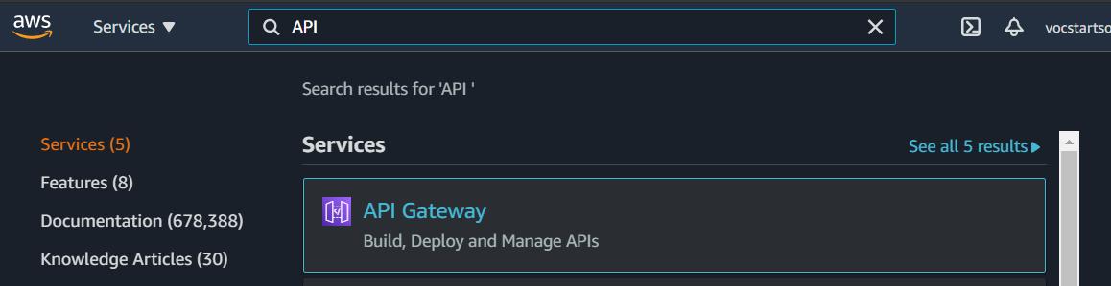

* Click on the ‘esde_beedesign_api’

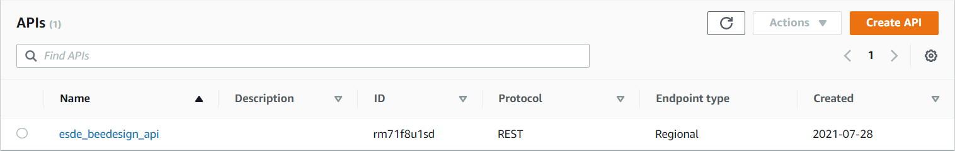

* Click on Actions
* Click on Deploy API

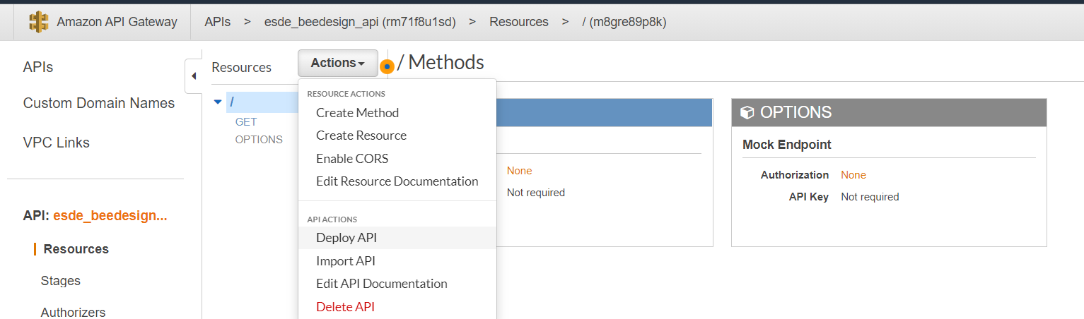

* At Deployment stage: choose the New Stage

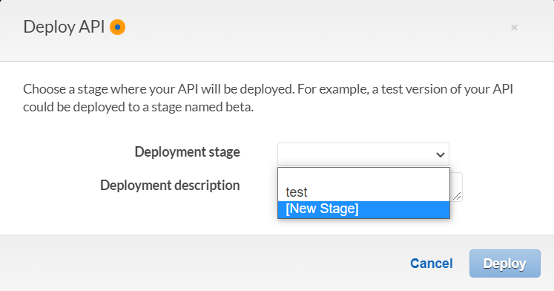

* At the Stage name: input qa
* Click on Deploy

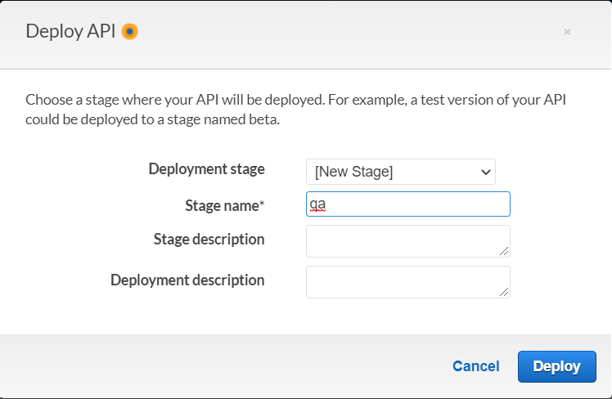

* It will show as below



* Click on Logs/Tracing tab

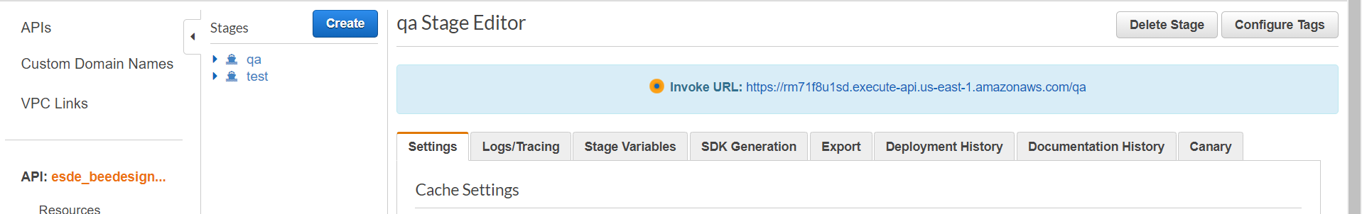

* Check the ‘Enable CloudWatch Logs’ box
* Check the ‘Log full requests/responses data’ box
* Click on save changes

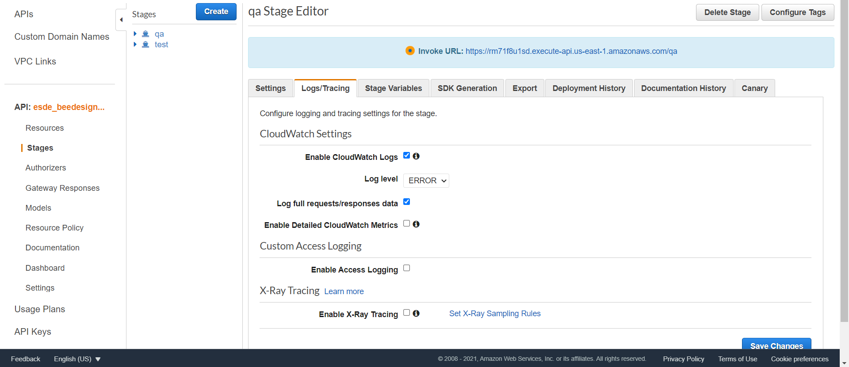

* It will prompt this error

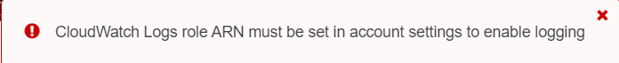

**To solve this error**

* Click on setting

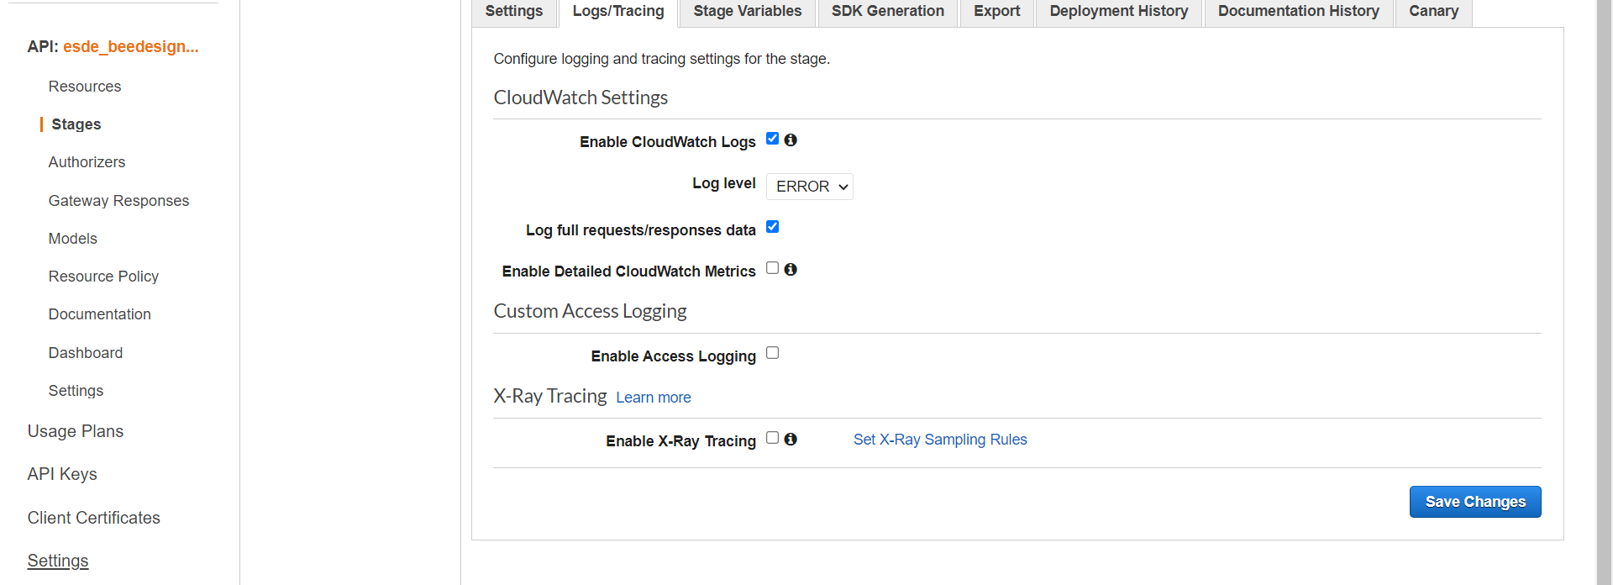

* You will see the CloudWatch role ARN is empty

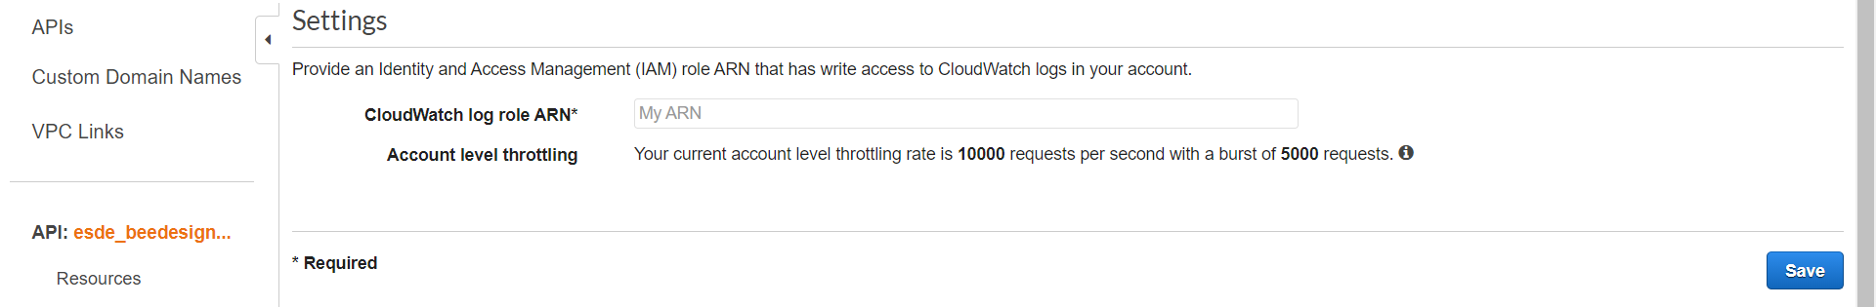

* Search IAM at the search bar

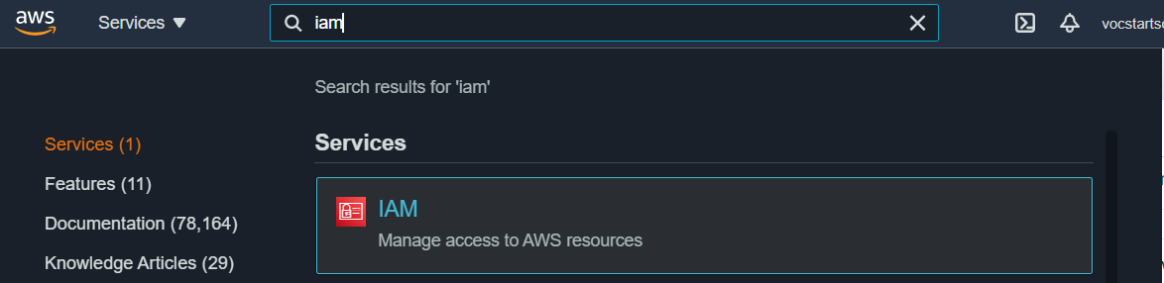

* Click on Roles

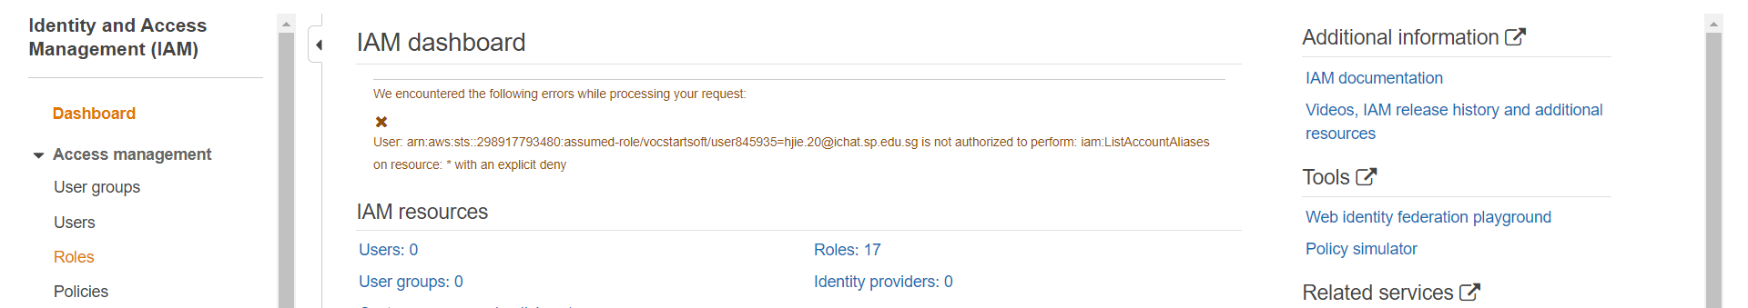



* Choose the API Gateway
* Click on Next

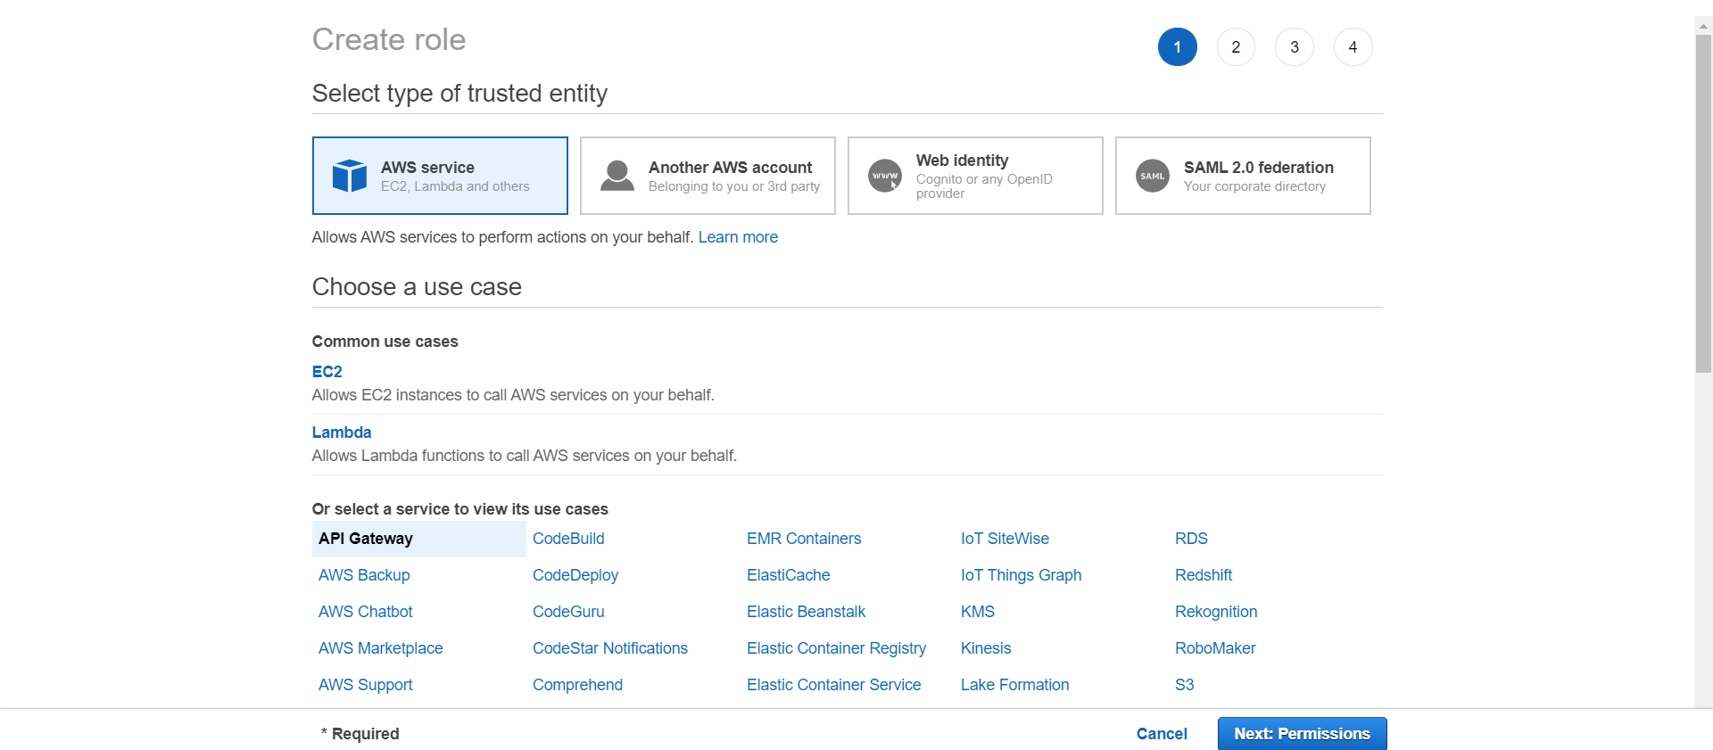

* You will see the policy name
* Click on Next

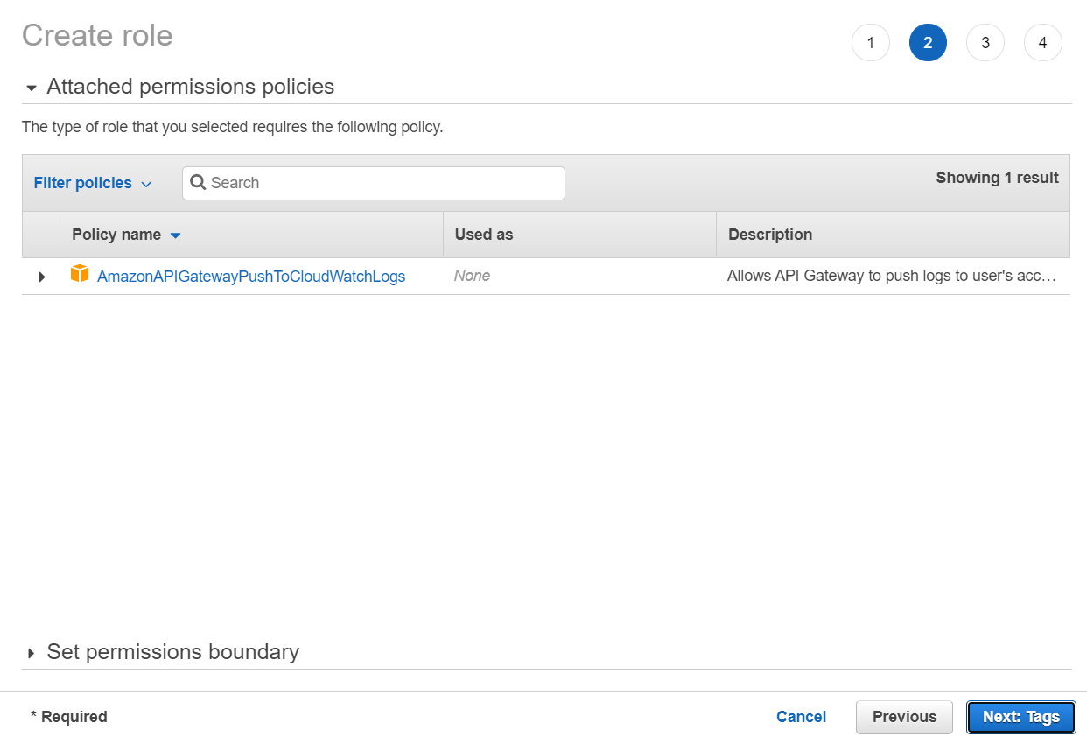

* This is optional so click on next

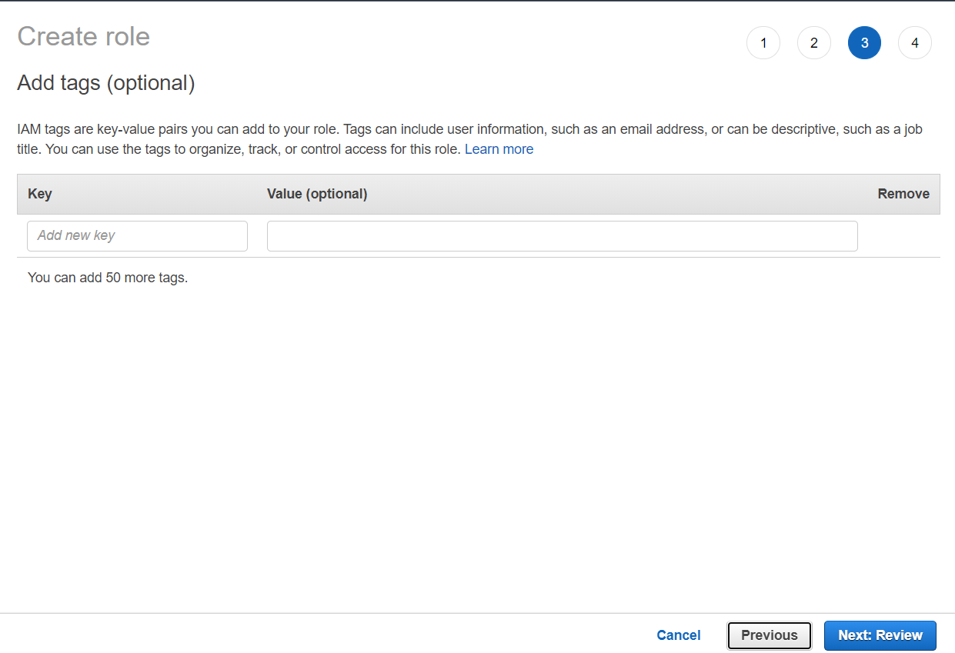

* At the Role name: input ‘ApiGatewayLogsRule’
* Click on create role

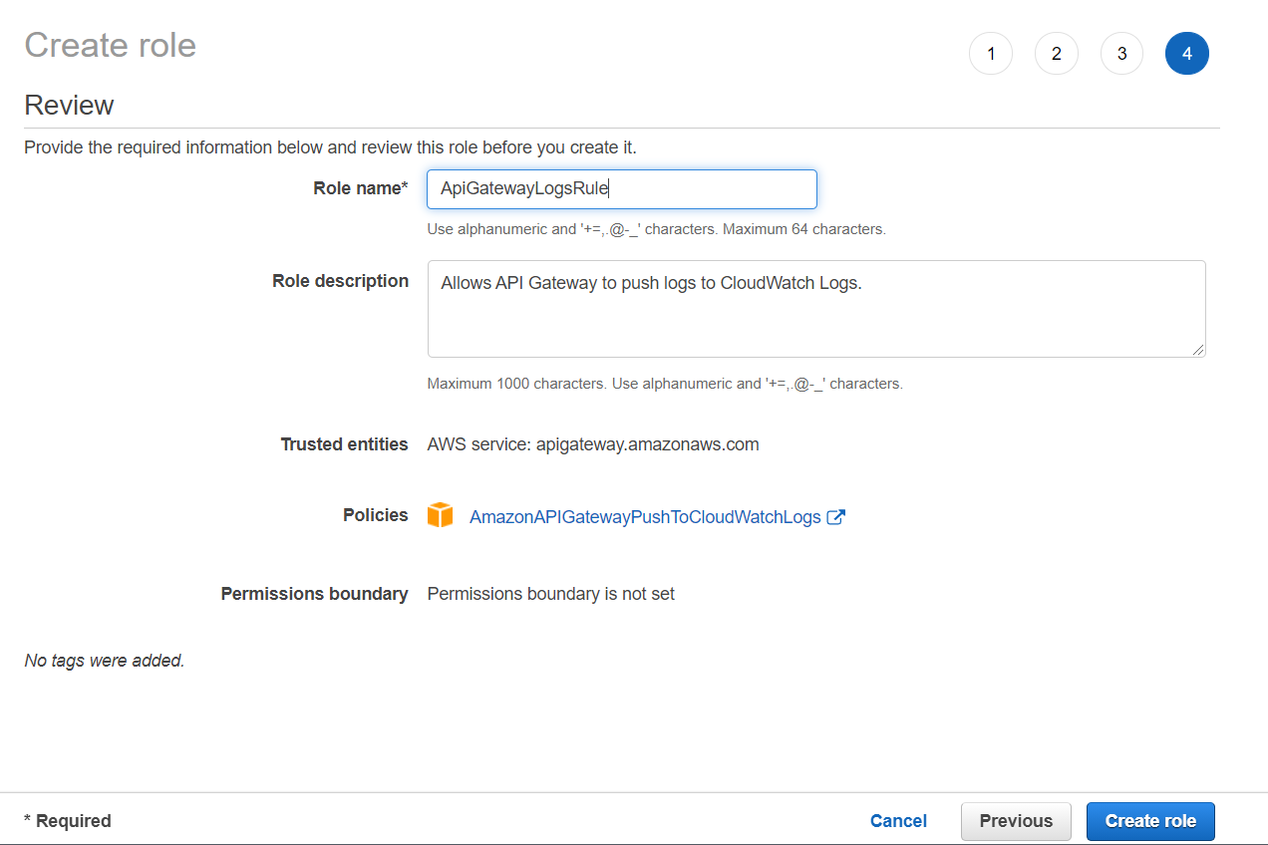

* Successfully create role
* Click on ApiGatewayLogsRule

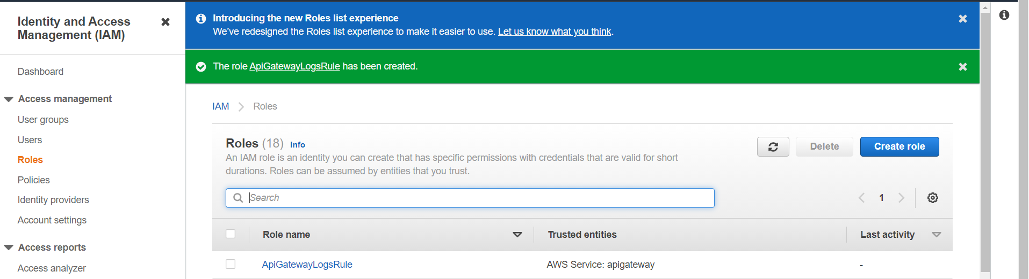

* Copy the Role ARN

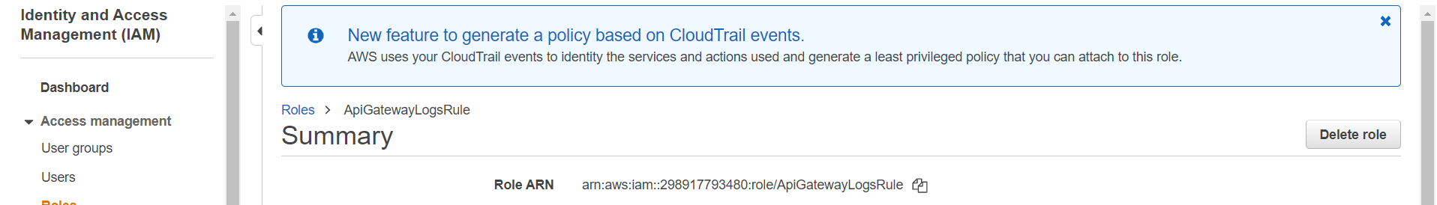

* Paste the role that copied just now
* Click on save

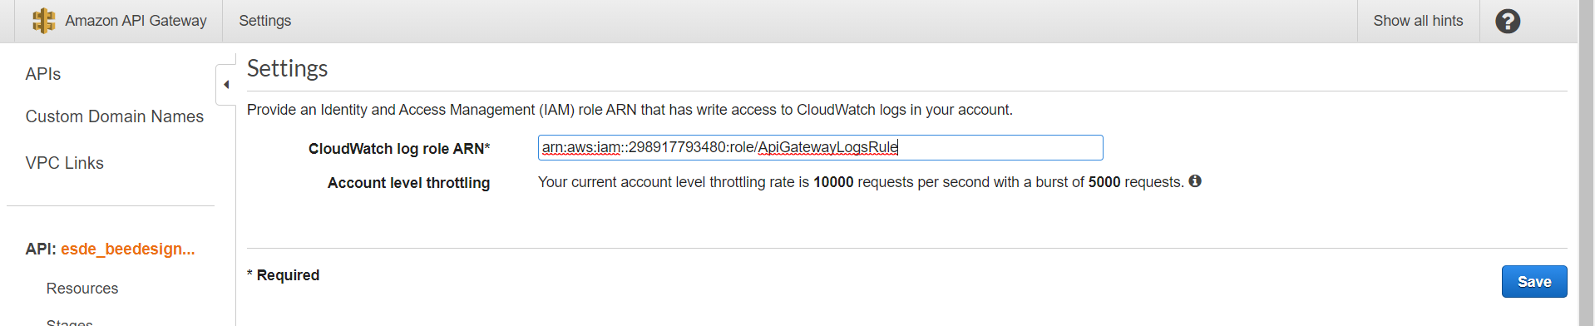

* Click on Stages
* Click on qa

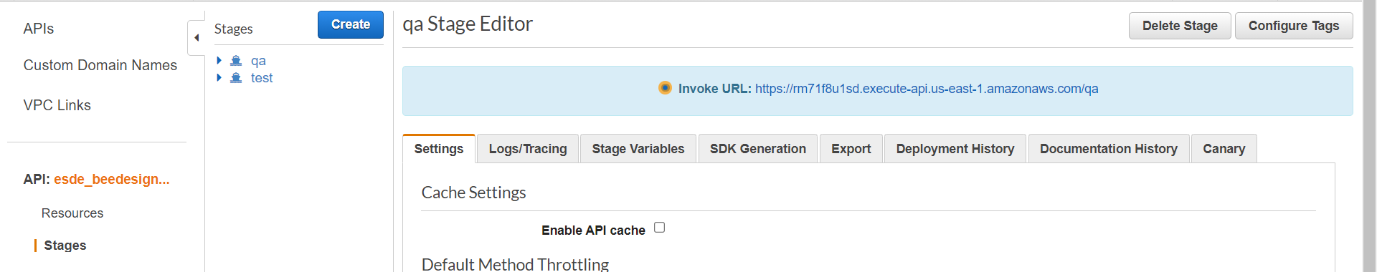

* Click on Logs/Tracing tab

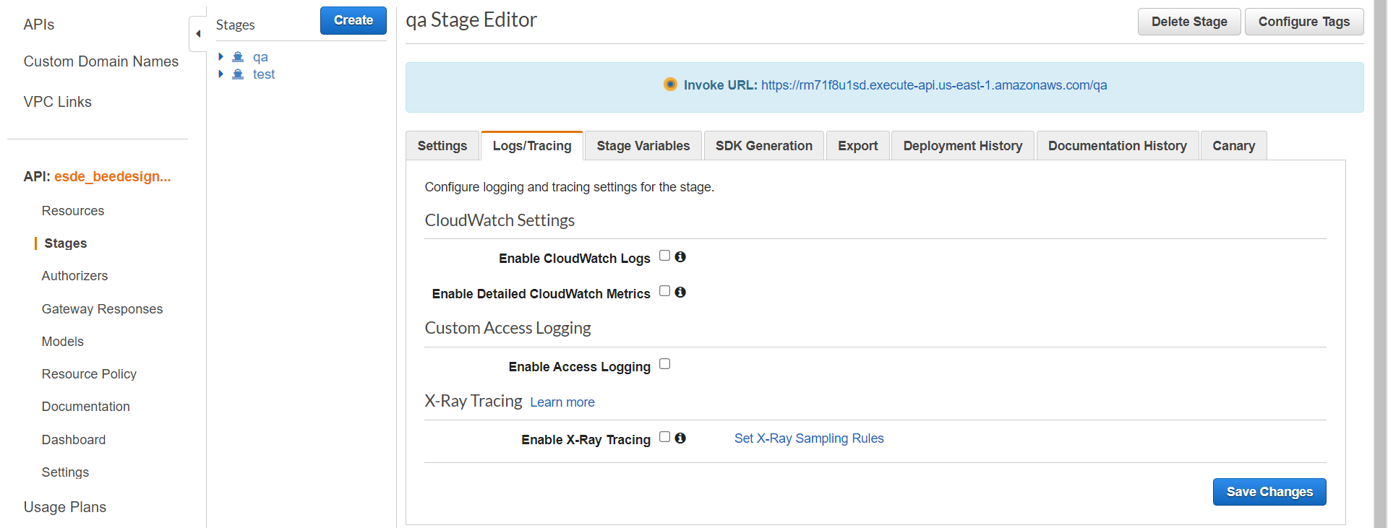

* Check the ‘Enable CloudWatch Logs’ box
* Check the ‘Log full requests/responses data’ box
* Click on save changes

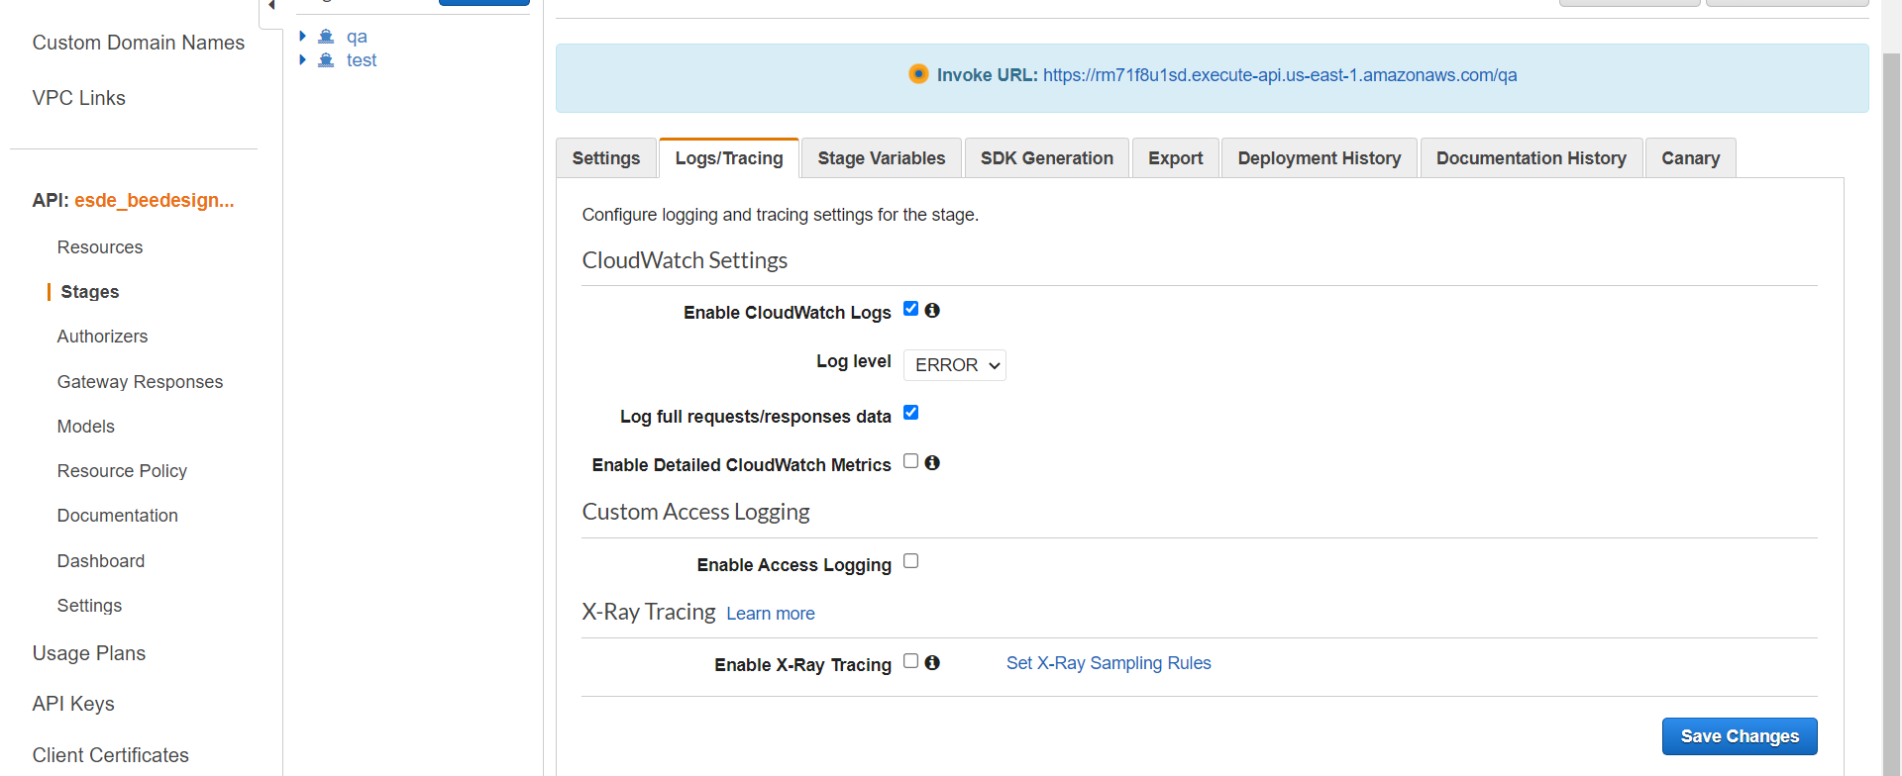

* Search for CloudWatch at the search bar

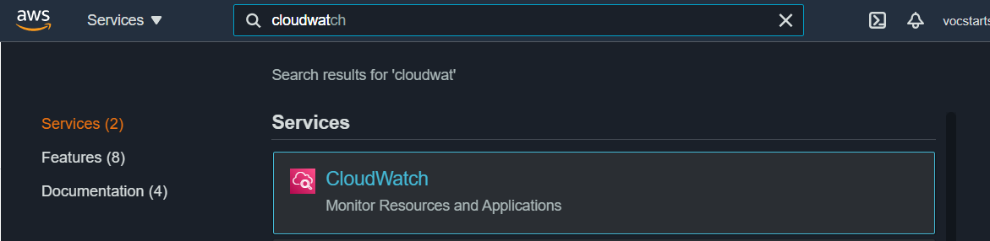

* Click on Logs
* Click on Log groups

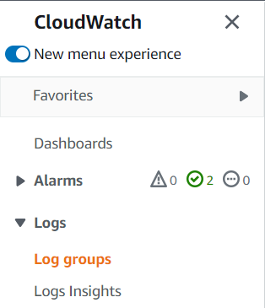

* Click on ‘API-Gateway-Execution-Logs_rm71f8u1sd/qa’

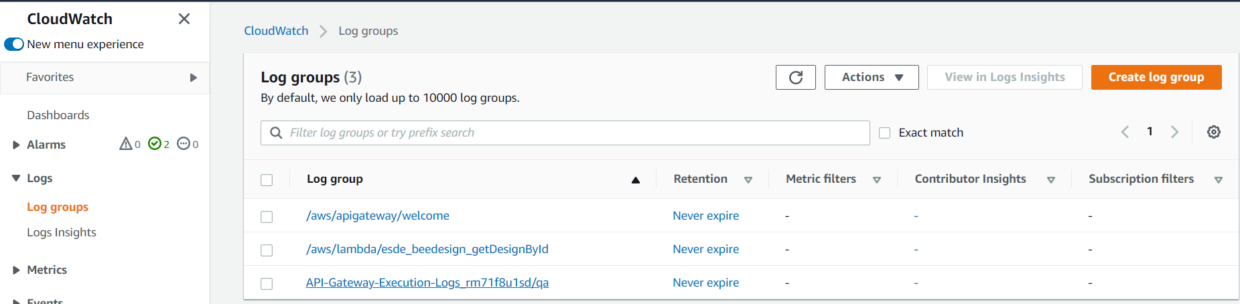

* There is nothing track in the log streams

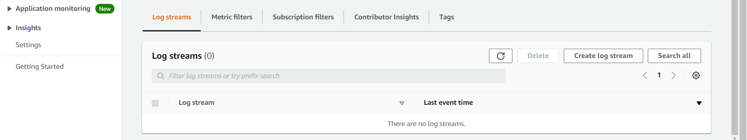

* Copy the invoke URL



* In winSPC navigate to update_design at frontEnd

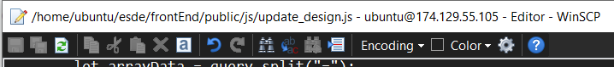

* Change the url to url: 'https://rm71f8u1sd.execute-api.us-east-1.amazonaws.com/qa?fid=' + fileId,

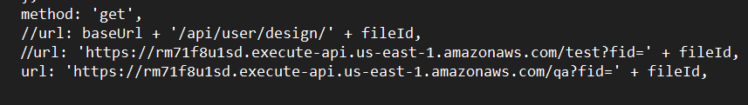

* Add the fid=100



* Paste it to web page and it will show the data



* Action will be track in log stream and click on it

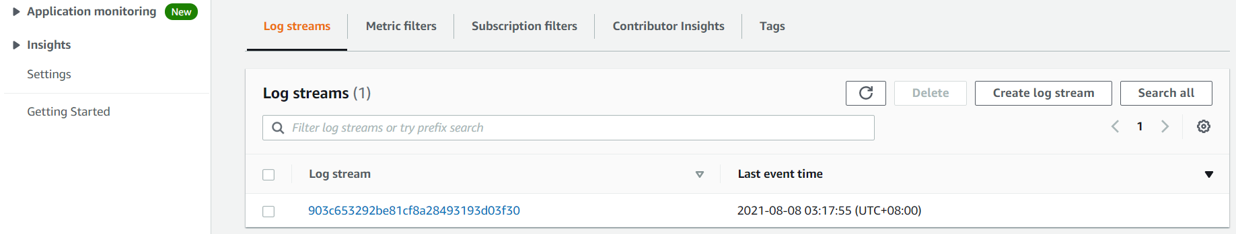

* It will show the log events

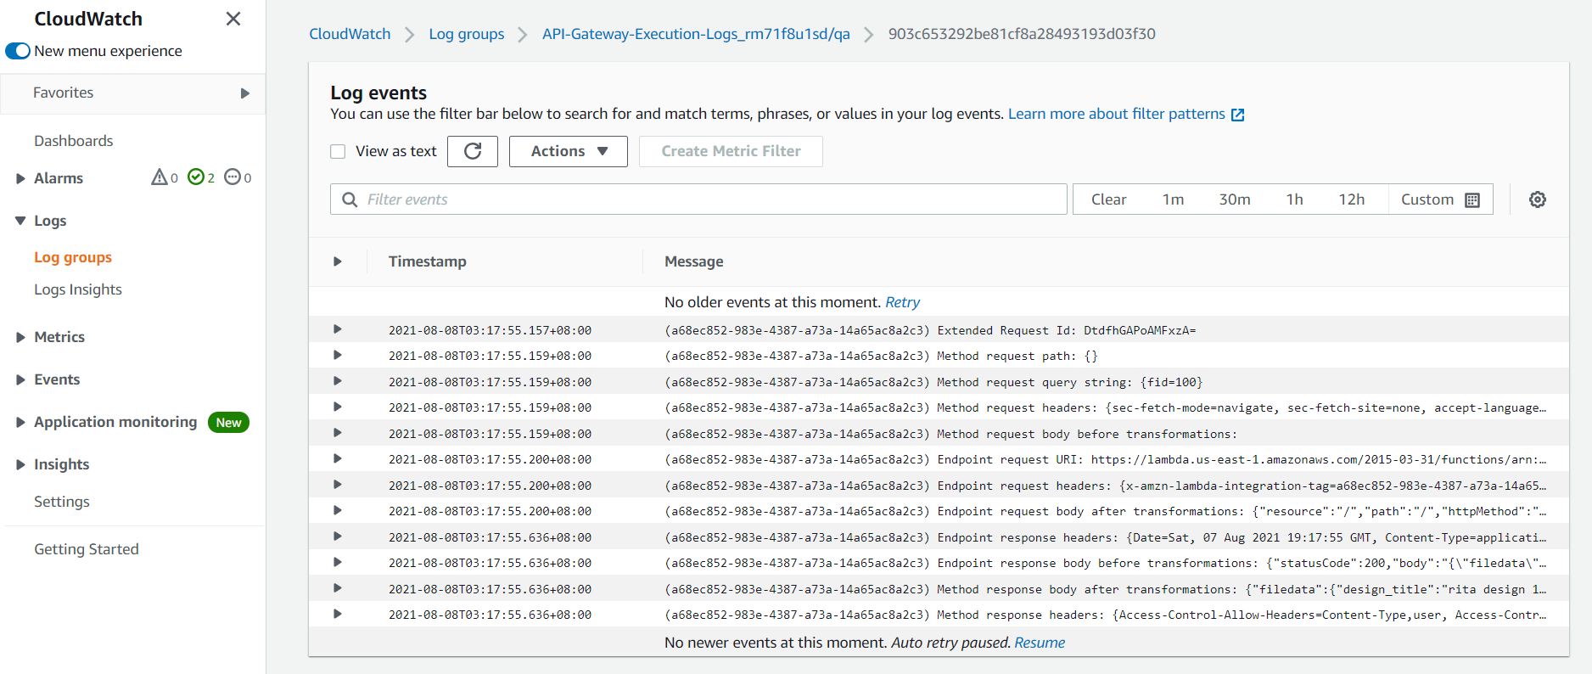

**RDS Logging**

* Search for RDS at the search bar

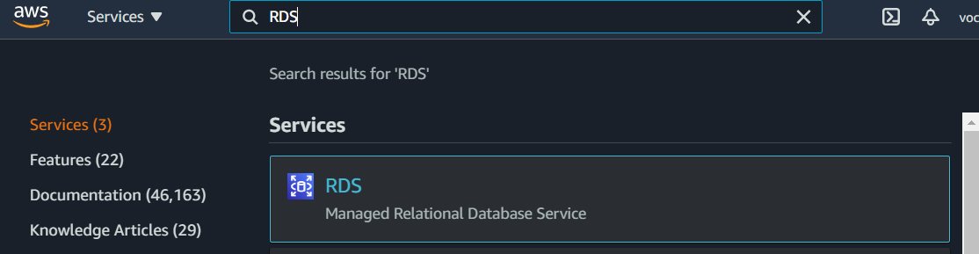

* Click on Databases

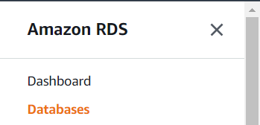

* Click on ‘database-1’

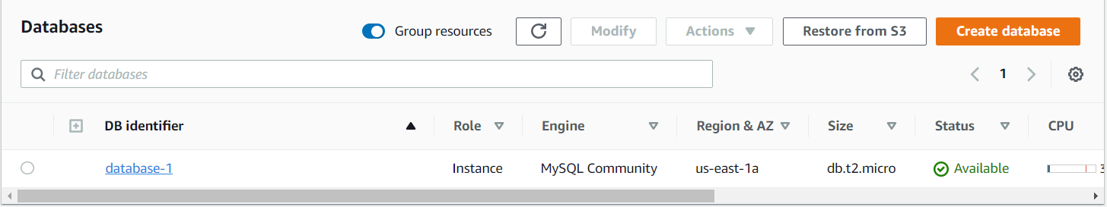

* Click on Logs&events

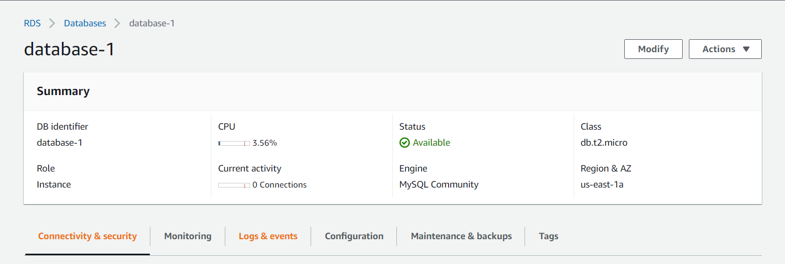

* It will show the recent events and the logs

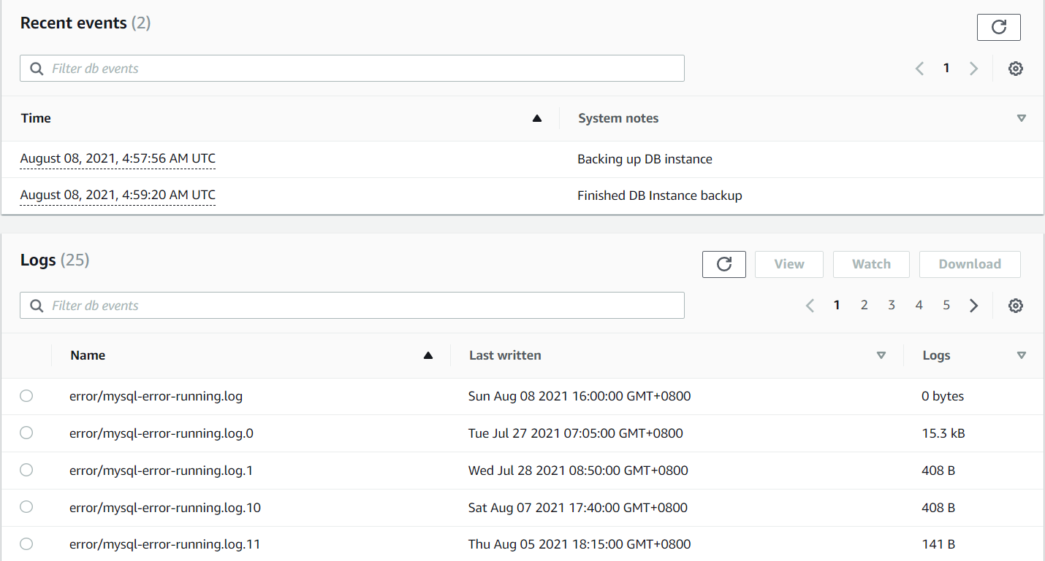

* In mysql workbench select ‘AWS Ec2 serve for ESDE’

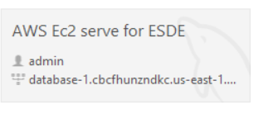

* Select the administration tab
* Select the Users and Privileges

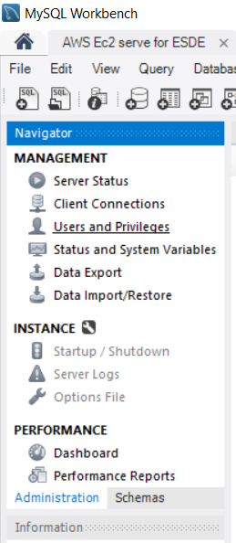

* Click on the ‘Add Account’ button

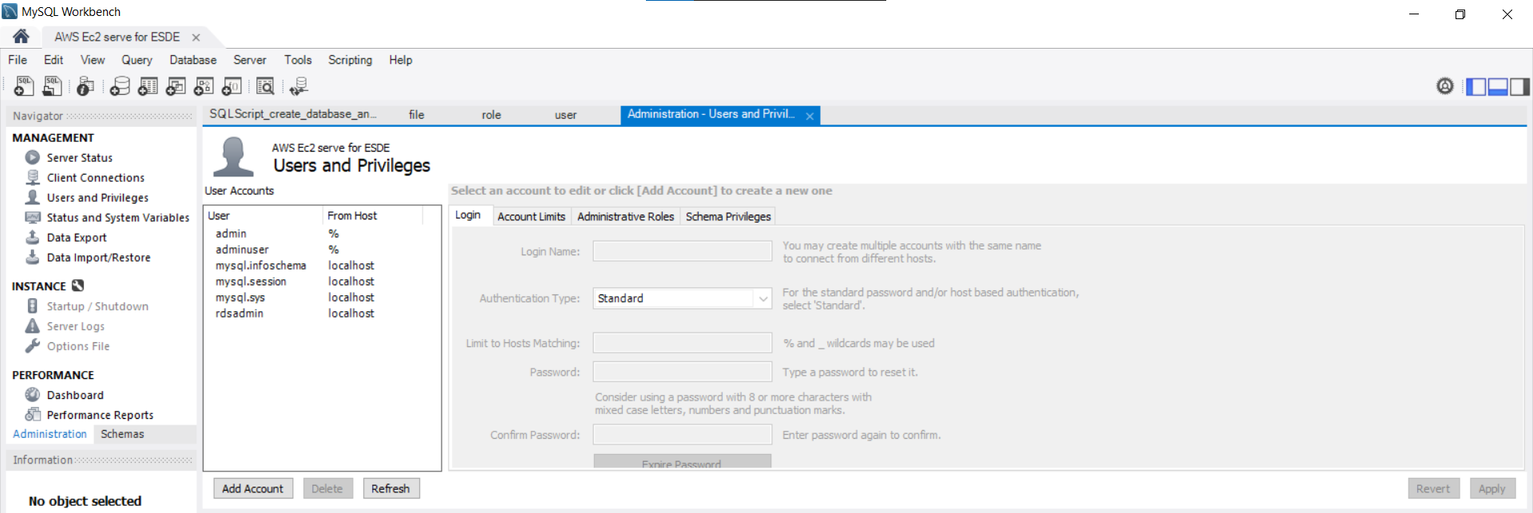

* At Login Name: input admin
* At Limit to Hosts Matching: input localhost
* At Password&Confirm Password: input password

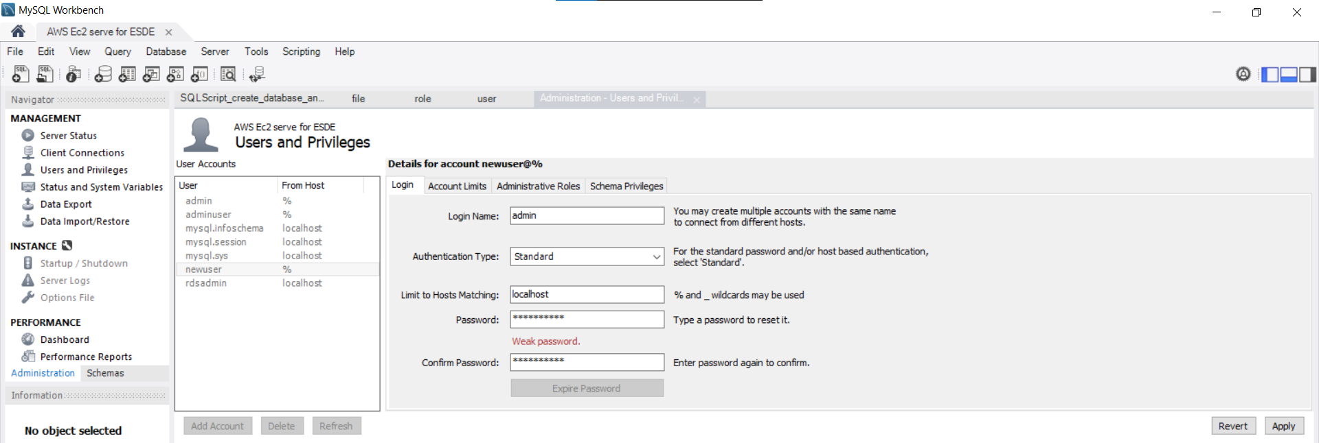

* Click on Schema Privileges
* Click on Add Entry…

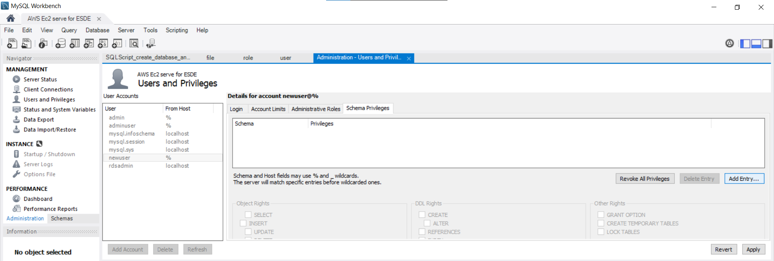

* Select ‘Selected schema’ option
* Click on OK

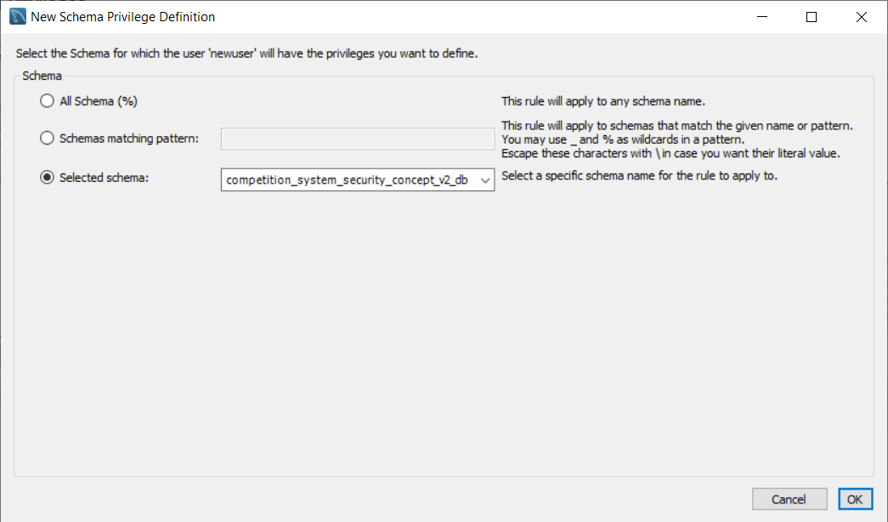

* Select below those boxes
* Click on Apply

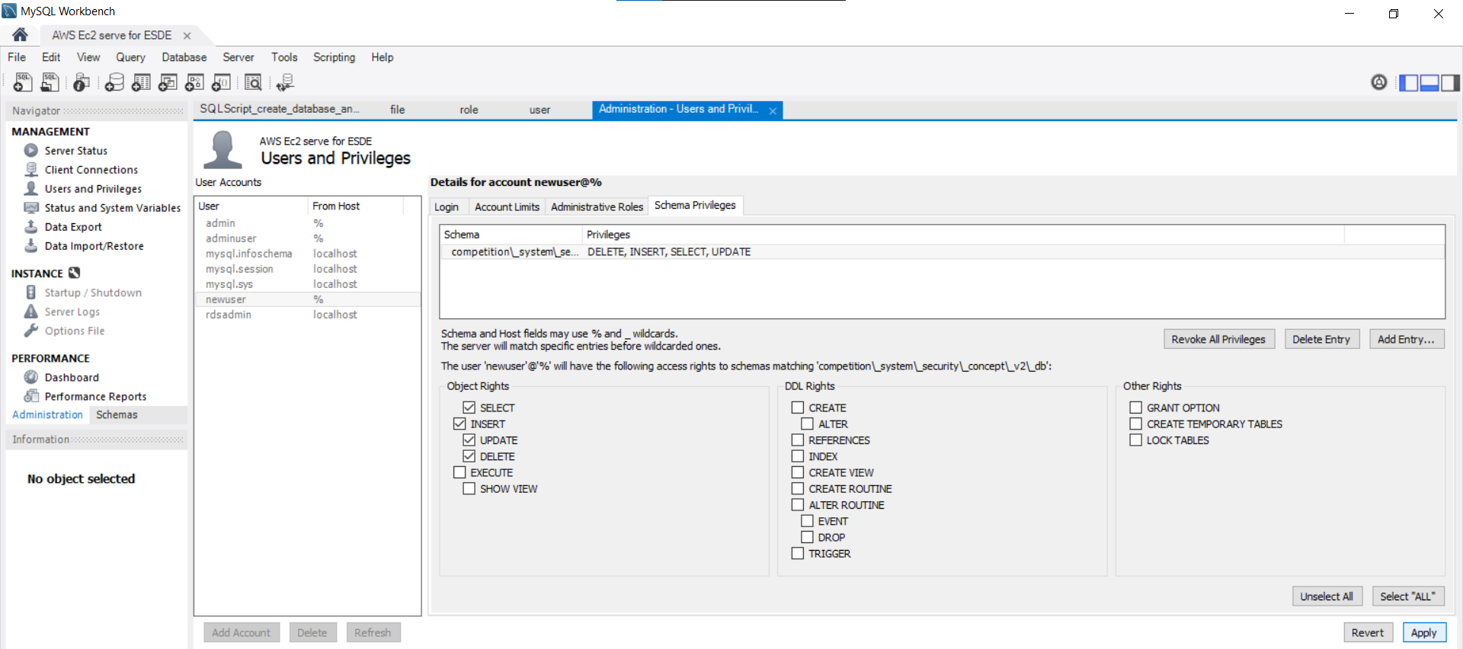

* You will see the new user account created

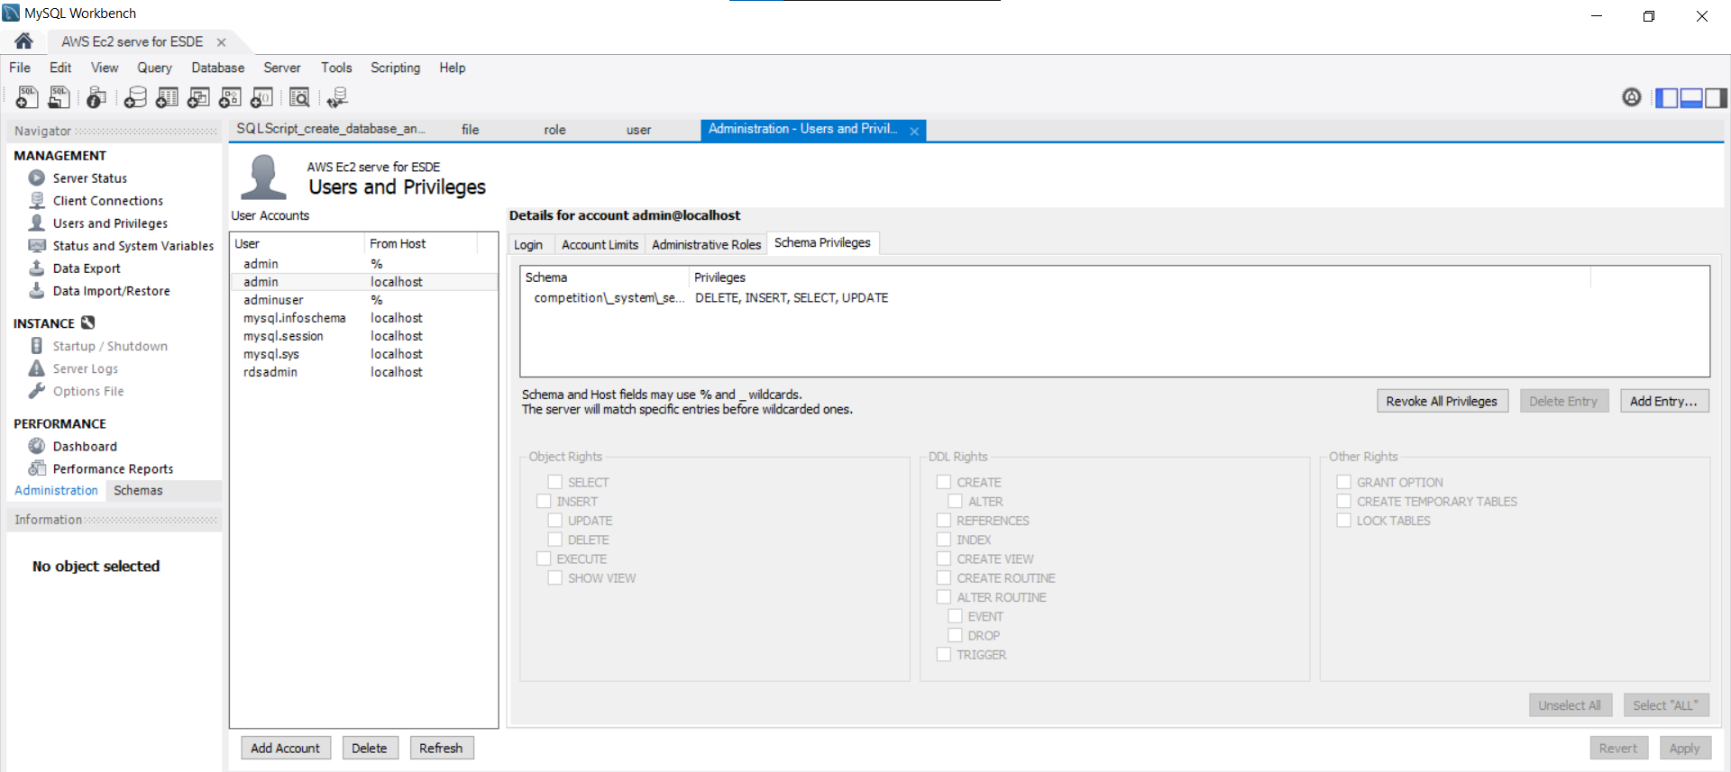

* In aws educate search for rds

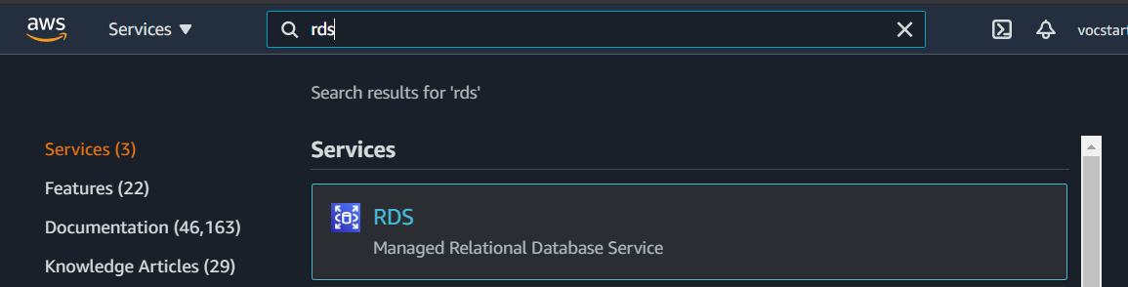

* Click on Databases

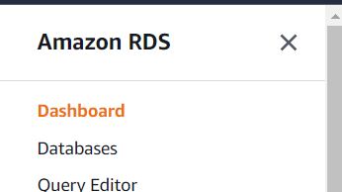

* Select the ‘database-1’
* Click on the Modify button

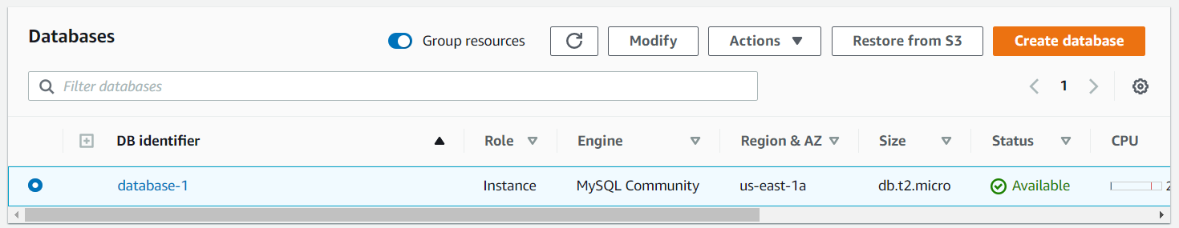

* Scroll down at the Log exports to check below those boxes

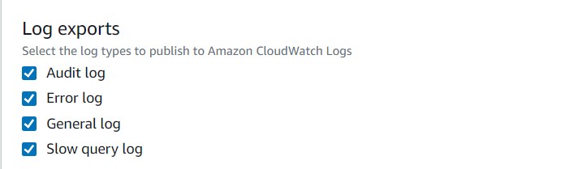

* Click on continue

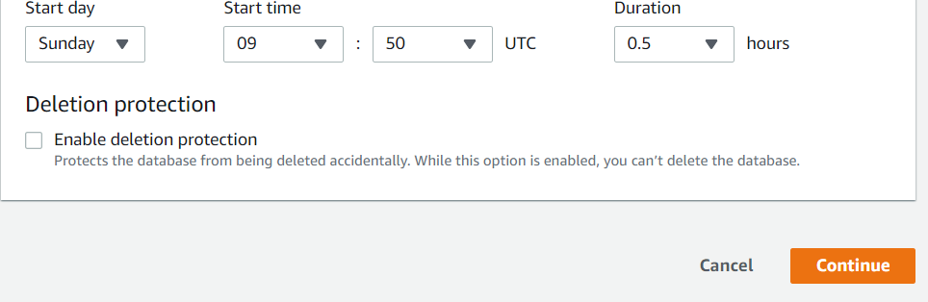

* Select ‘Apply immediately’
* Click on Modify DB instance

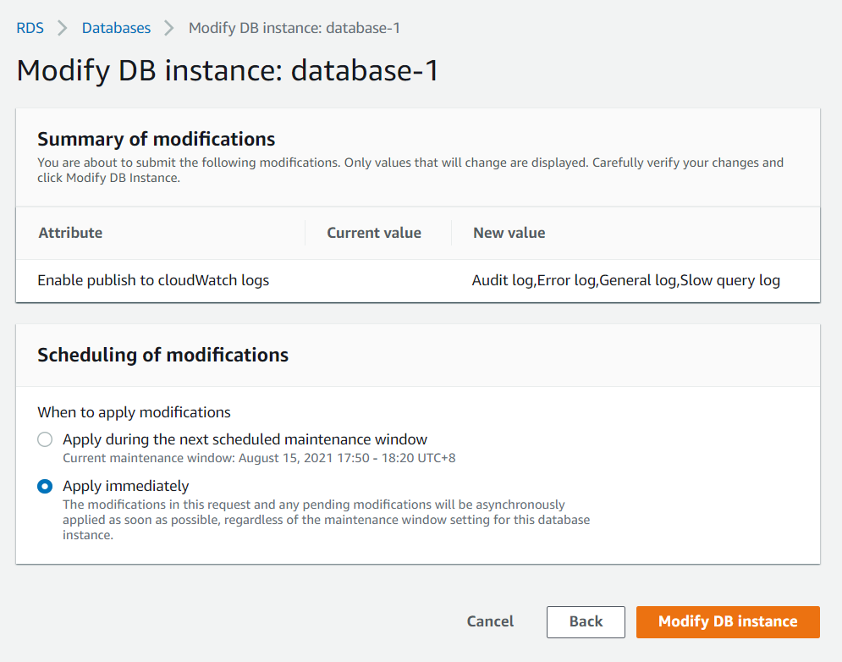

* Search for CloudWatch at the search bar

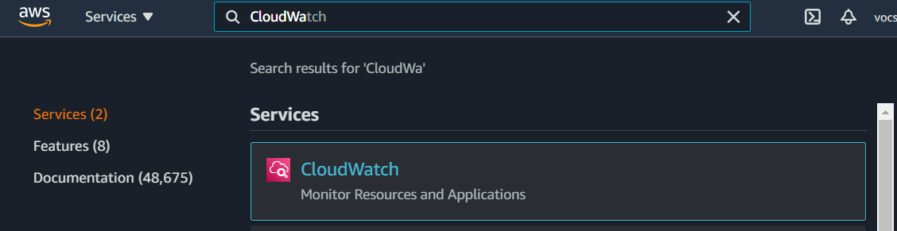

* Click on Logs
* Click on Log groups

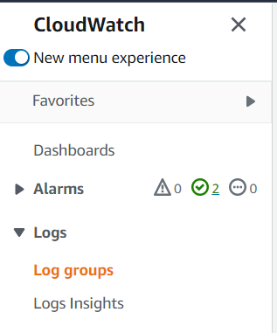

* Select the ‘/aws/rds/instance/database-1/error’

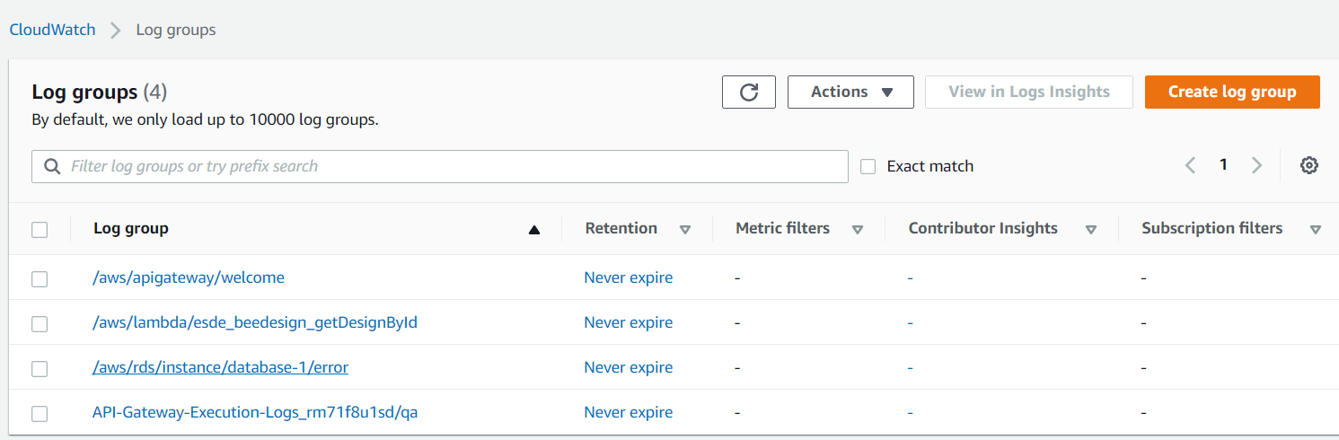

* Select the ‘database-1’

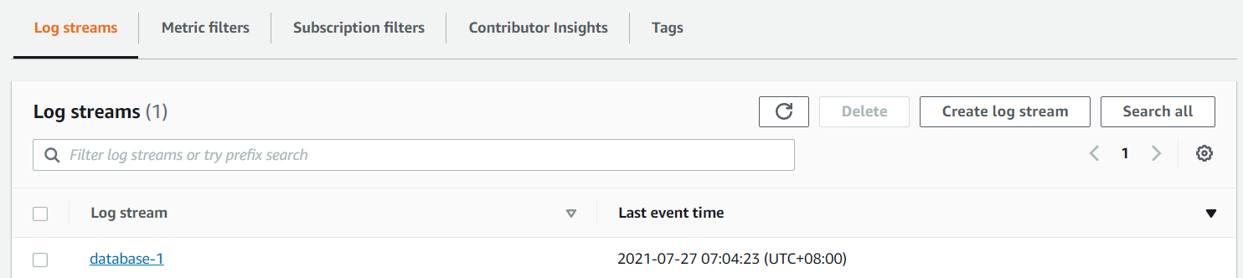

* You will see those Log events when u access the webpage

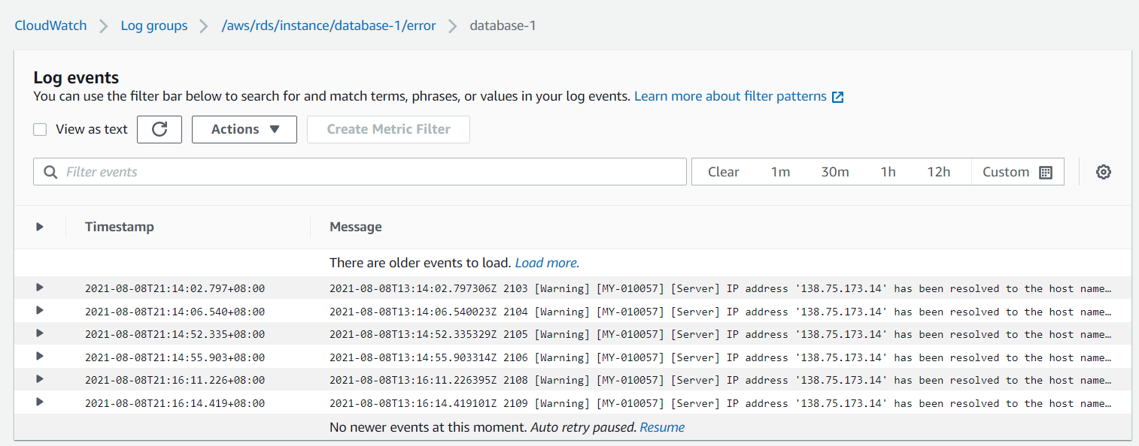

**Postman testing**

* First api

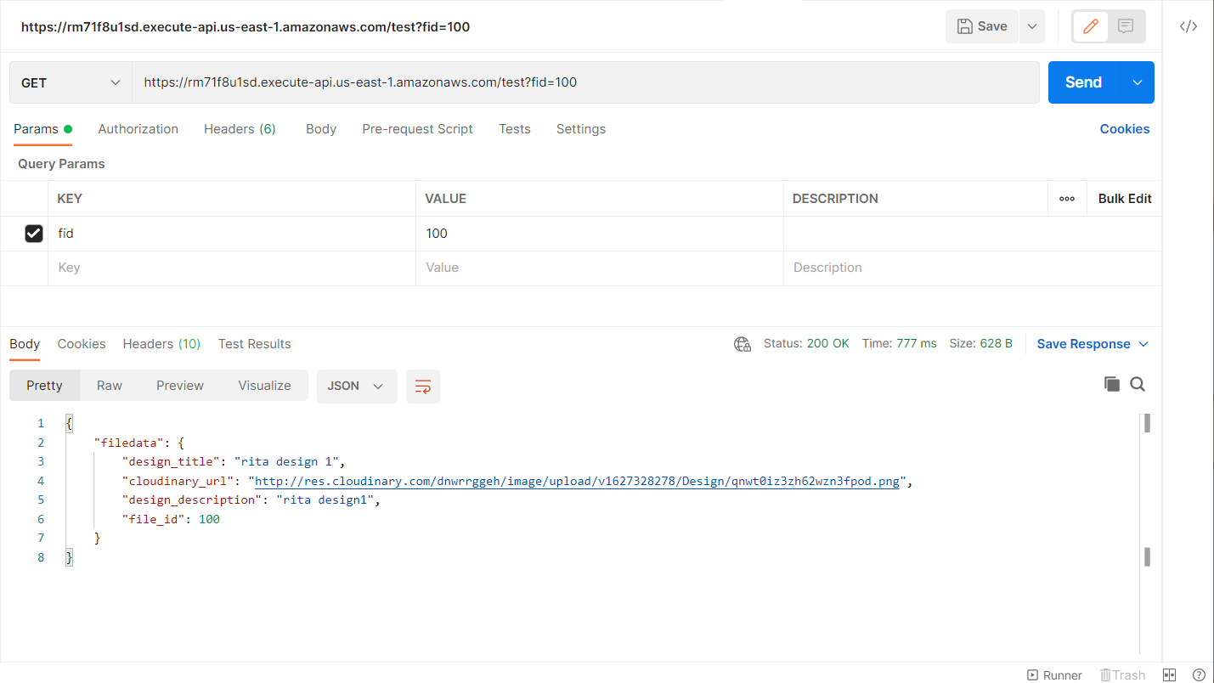

* Second api with CloudWatch

